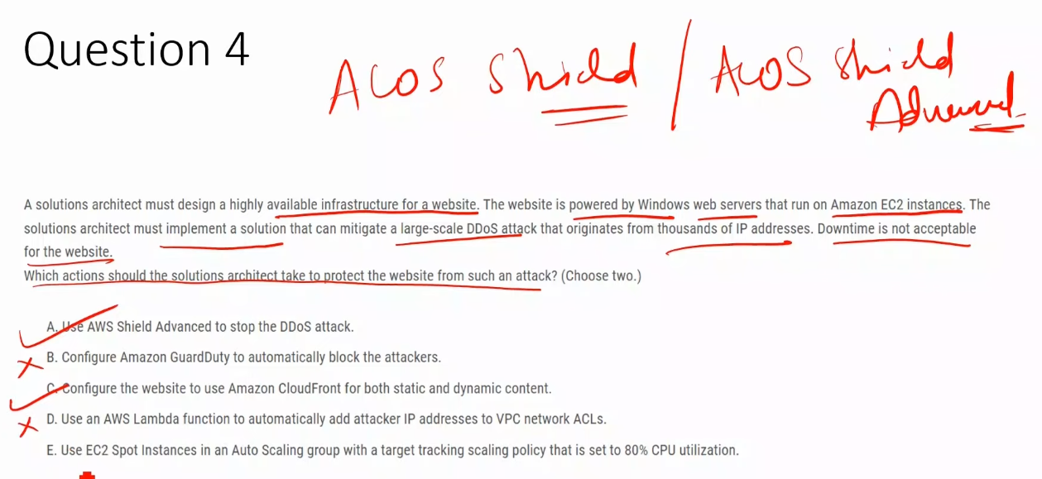

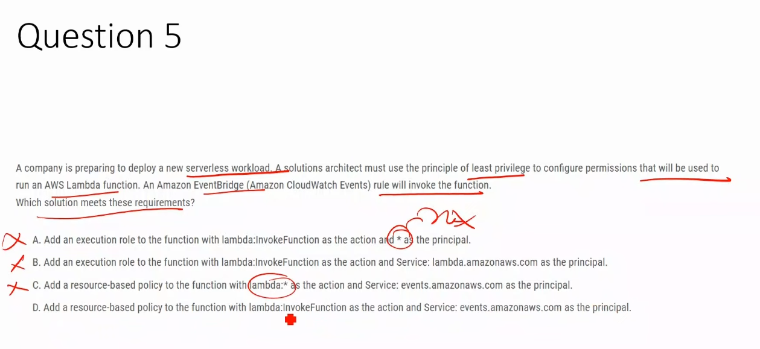

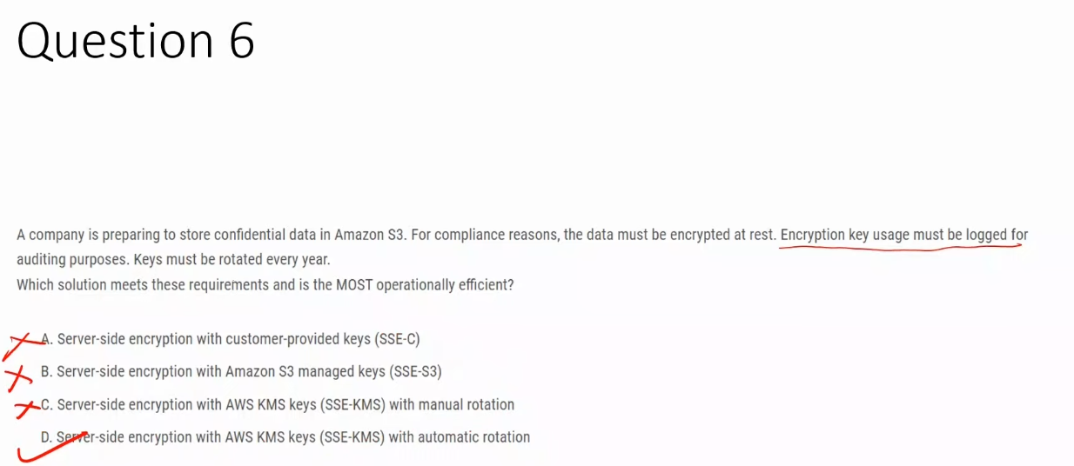

**A. SSE-C (Customer-provided keys)**  
 ❌ Key usage is **not logged by AWS**, and key management/rotation is fully customer-managed → **not operationally efficient**.

**B. SSE-S3 (S3-managed keys)**  
 ❌ Does **not provide CloudTrail logs for key usage** and offers **no customer control or visibility** over key rotation.

**C. SSE-KMS with manual rotation**  
 ❌ Meets security requirements but **fails “most operationally efficient”** due to **manual key rotation overhead**.

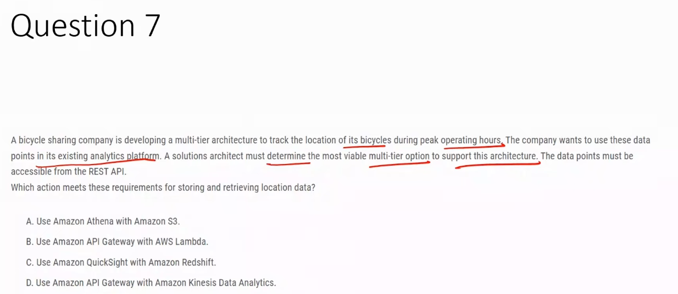

**A. Amazon Athena with Amazon S3**  
 ❌ Designed for batch or ad-hoc analytics; not suitable for real-time data ingestion or REST-based access.

**B. Amazon API Gateway with AWS Lambda** ✅  
 ✅ Supports scalable REST APIs with serverless compute, ideal for real-time location tracking during peak traffic.

**C. Amazon QuickSight with Amazon Redshift**  
 ❌ Business intelligence and data warehousing tools; not meant for real-time data storage or API-based retrieval.

**D. Amazon API Gateway with Amazon Kinesis Data Analytics**  
 ❌ Kinesis Data Analytics is for stream processing, not for storing data or serving REST API queries.

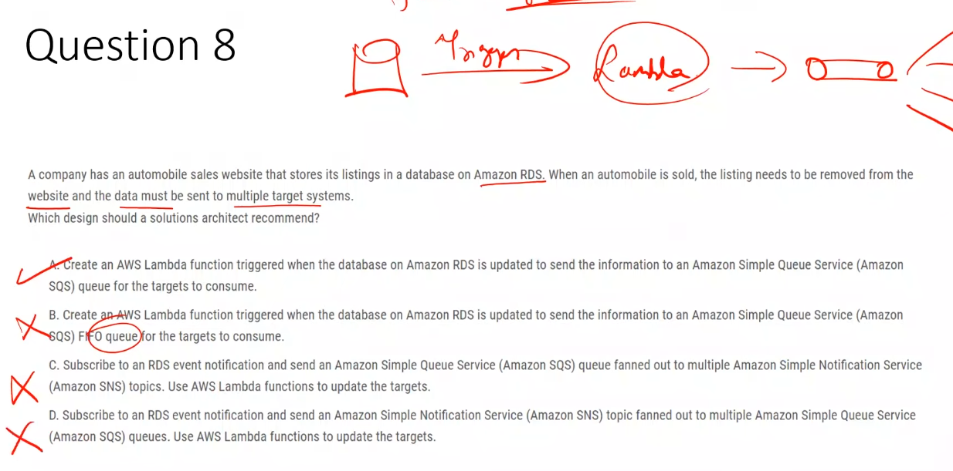

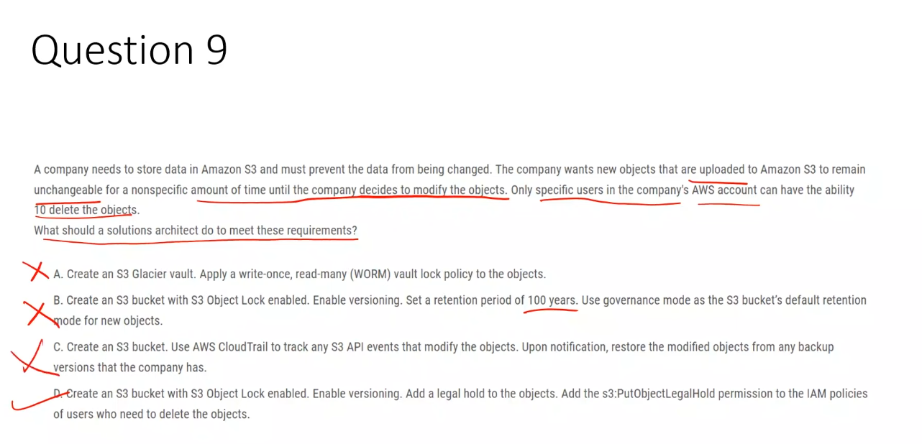

## **1️⃣ S3 Glacier Vault (Vault Lock / WORM)**

**What it is**

* Used for **long-term archival data**
* Part of **S3 Glacier (archive storage)**

**Core idea**

* **Compliance-grade WORM** (Write Once, Read Many)
* Once a **Vault Lock policy** is locked → **NO ONE can change or delete data**
* Even **root user cannot override**

**Key characteristics**

* ❌ No flexibility after lock
* ❌ No object-level control
* ❌ Slow retrieval (minutes to hours)
* ✅ Used for strict regulatory archives (financial, legal records)

**Use when**

* Regulations require **absolute immutability**
* Data will **never** be modified or deleted before expiry

## **2️⃣ S3 Object Lock**

**What it is**

* Applied at **S3 bucket level**
* Requires **versioning**
* Works on **individual objects**

**Core idea**

* Prevents deletion or overwrite of objects
* Supports **two protection mechanisms**:
  + Retention period
  + Legal hold

**Key characteristics**

* ✅ Fine-grained (per object)
* ✅ Works in standard S3 (not just Glacier)
* ✅ IAM-controlled overrides (Governance mode)

**Modes**

* **Governance mode** → privileged users *can* override
* **Compliance mode** → **no override**, even by root

**Use when**

* You want **controlled immutability**, not permanent lockdown

## **3️⃣ Legal Hold (part of Object Lock)**

**What it is**

* A **feature of S3 Object Lock**
* Applied **per object**

**Core idea**

* **Indefinite immutability**
* No expiry date
* Object stays protected **until legal hold is explicitly removed**

**Key characteristics**

* ✅ No time limit
* ✅ Can be removed by authorized IAM users
* ❌ No automatic expiration
* ❌ Not time-based like retention

**Use when**

* You don’t know **how long** data must be protected
* Common in audits, investigations, litigation

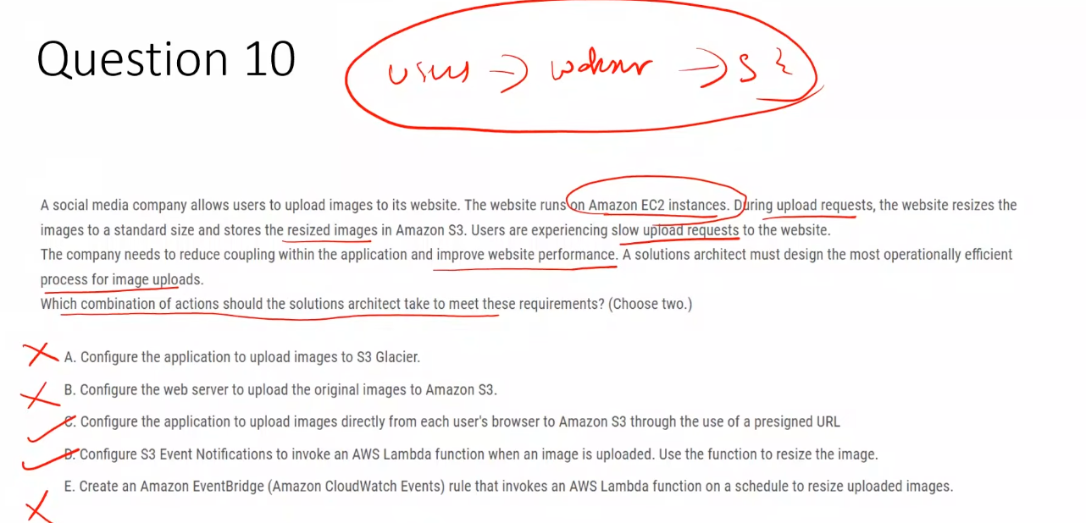

### **A. Configure the application to upload images to S3 Glacier**

❌ Glacier is designed for archival storage and is unsuitable for real-time uploads or processing.

### **B. Configure the web server to upload the original images to Amazon S3**

❌ EC2 remains in the upload path, causing bottlenecks and tight coupling.

### **C. Upload images directly from the user’s browser to S3 using a presigned URL ✅**

✅ Removes EC2 from the upload path, reducing latency and improving scalability.

### **D. Use S3 Event Notifications to invoke a Lambda function to resize images ✅**

✅ Enables asynchronous, event-driven image processing with minimal operational overhead.

### **E. Use EventBridge on a schedule to resize images**

❌ Schedule-based processing is inefficient and introduces unnecessary delays.

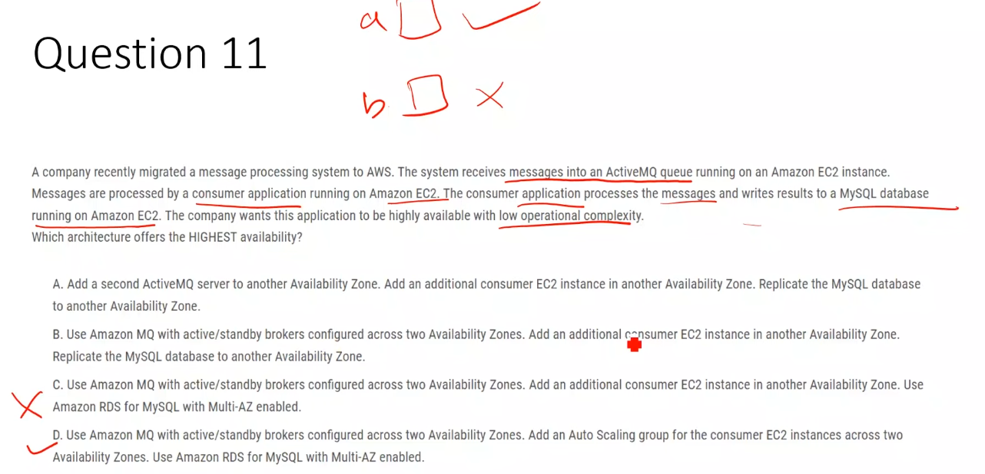

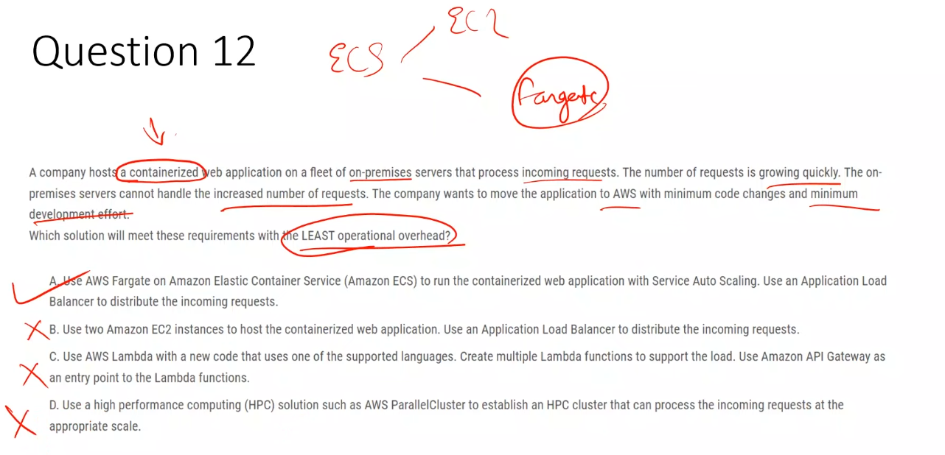

## **What is AWS ParallelCluster?**

**AWS ParallelCluster** is an **open-source AWS tool** that lets you **quickly deploy and manage High Performance Computing (HPC) clusters** on AWS.

In simple terms:

It automatically creates a **cluster of EC2 instances** that work **in parallel** to run **compute-heavy workloads**.

## **Why it’s called *Parallel* Cluster**

* Tasks are split
* Executed **simultaneously**
* Results combined
* Reduces execution time from **days → hours/minutes**

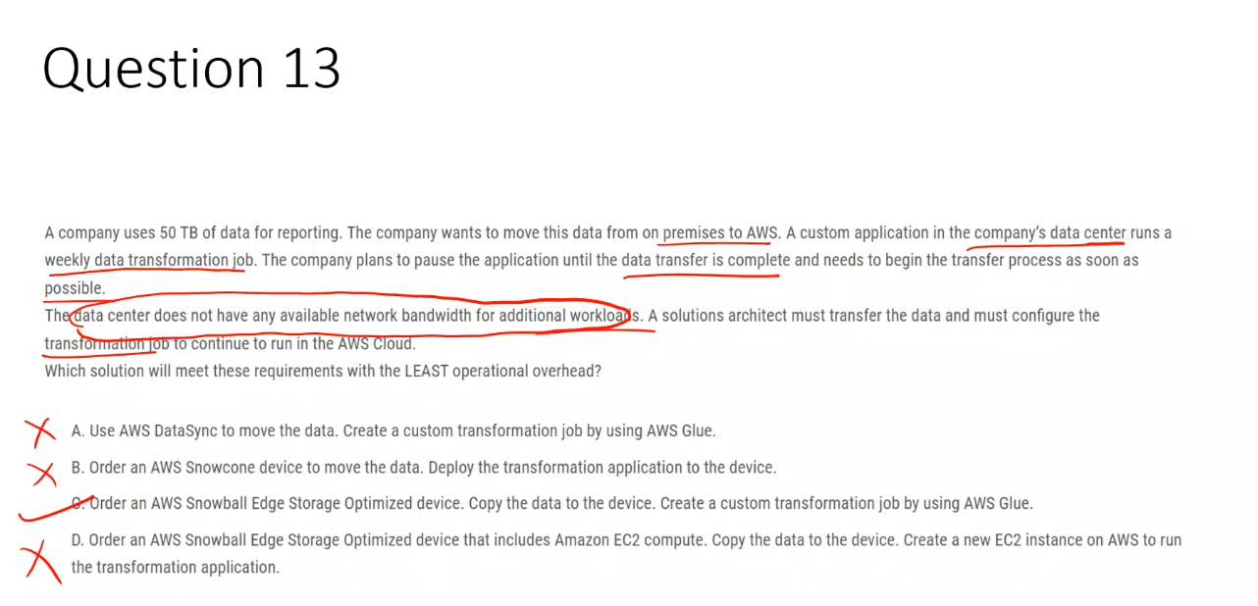

|  |  |  |
| --- | --- | --- |
| **Snow Device** | **Usable Storage** | **Typical Use** |
| Snowcone | ~8 TB | Small / edge / remote |
| Snowball Edge (Storage Optimized) | ~80 TB | Large data transfer |
| Snowball Edge (Compute Optimized) | ~42 TB | Data + compute |
| Snowmobile | Up to 100 PB | Data center migration |

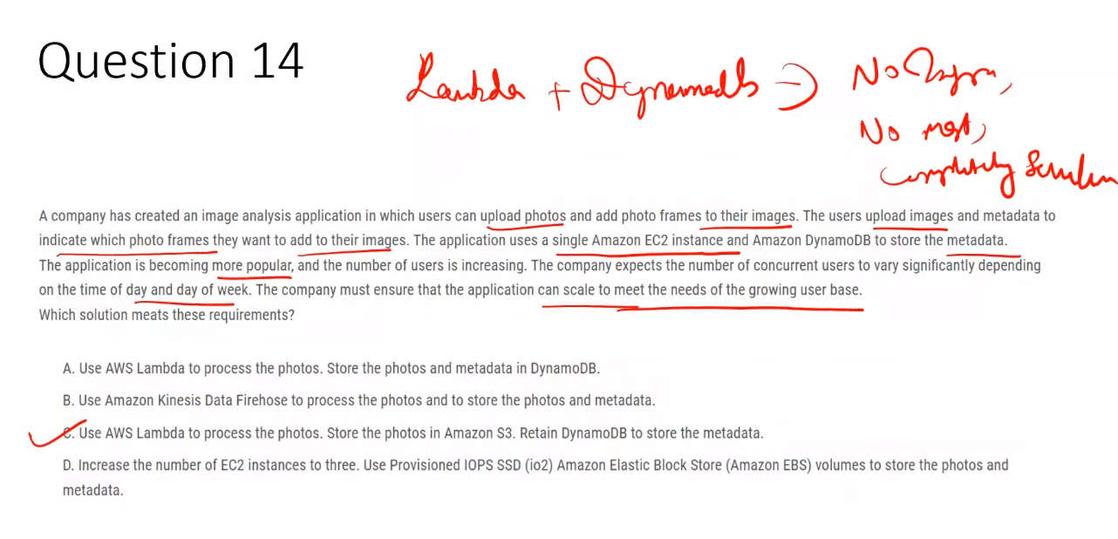

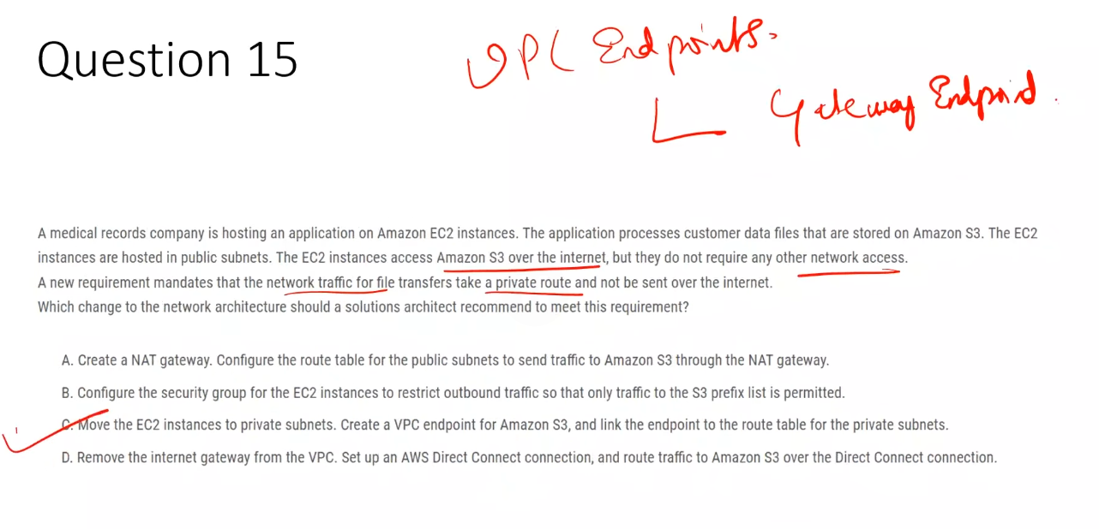

## **What is a VPC Endpoint (general use)**

**VPC Endpoint** allows resources **inside a VPC** to privately connect to **AWS services** **without using the internet**, **NAT Gateway**, or **Internet Gateway**.

👉 Traffic **stays on the AWS private network**.

## **Why VPC Endpoints are used (exam mindset)**

Use a VPC endpoint when:

* You must **avoid internet traffic**
* You want **private routing**
* You want **better security + compliance**
* You want to **remove NAT Gateway cost**
* You see keywords like:
  + *private route*
  + *no internet*
  + *compliance*
  + *S3 / DynamoDB access*

## **Types of VPC Endpoints (ONLY 2 – memorize this)**

### **1️⃣ Gateway Endpoint**

**What it is**

* A **route-table based** endpoint
* Adds a route to the VPC route table

**Supported services**

* **Amazon S3**
* **Amazon DynamoDB**

**How it works**

Route table:  
S3 prefix list → Gateway Endpoint

**Key points**

* No ENI
* No security groups
* Free (no hourly charge)
* Scales automatically

**When to use**

* Private access to **S3 or DynamoDB**
* High throughput, low cost

### **2️⃣ Interface Endpoint (PrivateLink)**

**What it is**

* An **ENI with a private IP** in your subnet
* Uses **PrivateLink**

**Supported services**

* Most AWS services (EC2 API, KMS, SNS, SQS, etc.)
* AWS Marketplace services
* Your own services (VPC Endpoint Service)

**Key points**

* Uses **security groups**
* Has hourly + data processing cost
* DNS-based access

**When to use**

* Private access to **non-S3/DynamoDB services**
* Fine-grained access control needed

|  |  |  |
| --- | --- | --- |
| **Feature** | **Gateway Endpoint** | **Interface Endpoint** |
| Connection type | Route table | ENI |
| Services | S3, DynamoDB | Most AWS services |
| Security groups | ❌ No | ✅ Yes |
| Cost | Free | Paid |
| Use NAT/IGW | ❌ No | ❌ No |

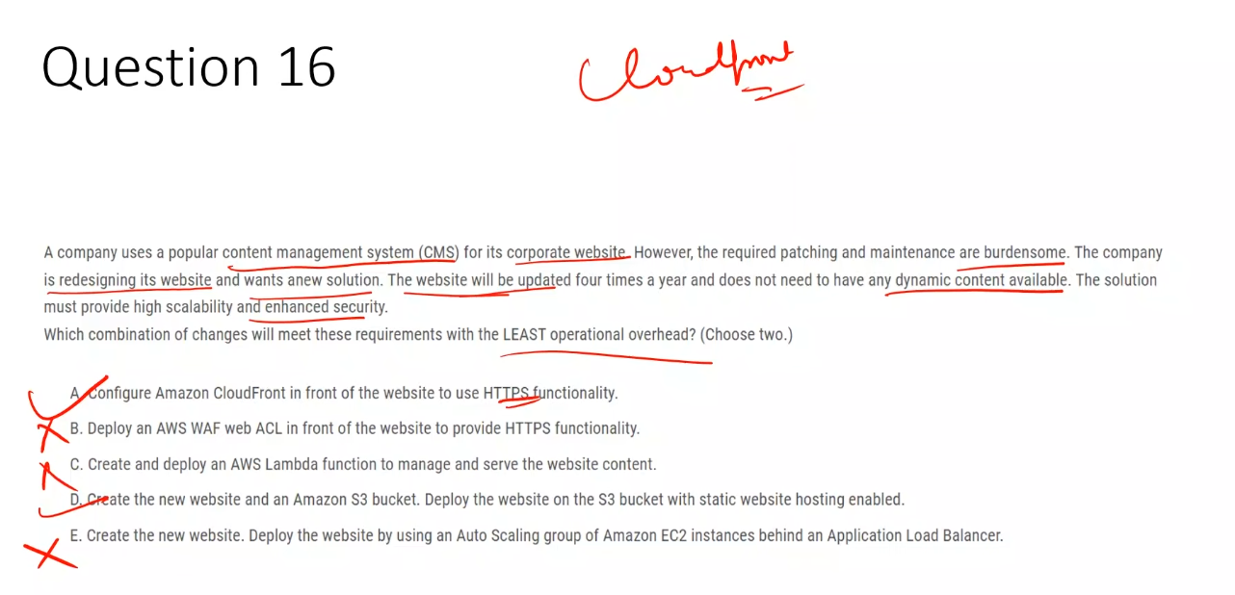

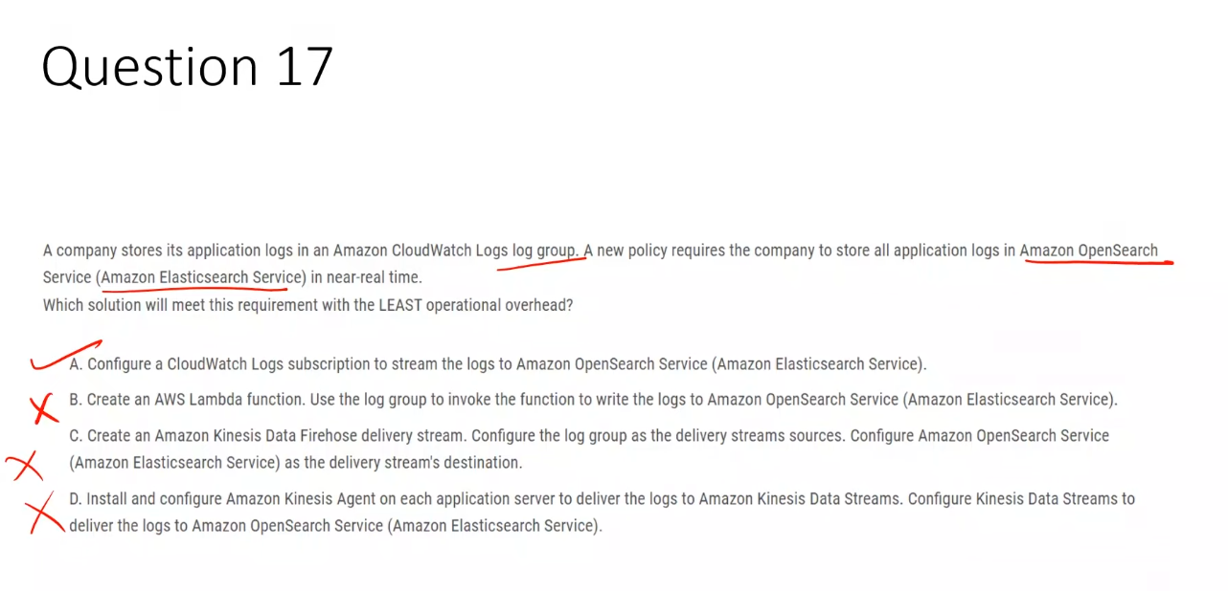**CloudWatch Logs → Subscription → ONLY 3 destinations**  
 **OpenSearch | Kinesis Data Streams | Lambda**

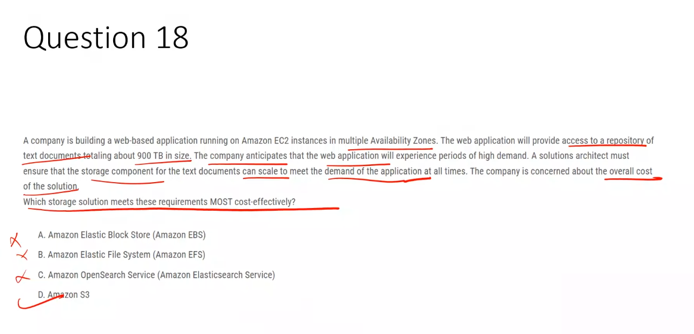

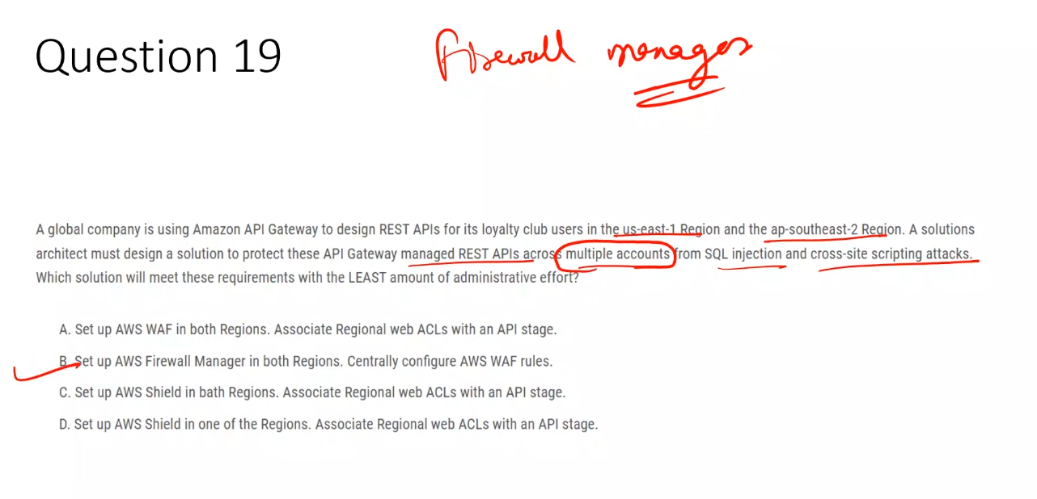

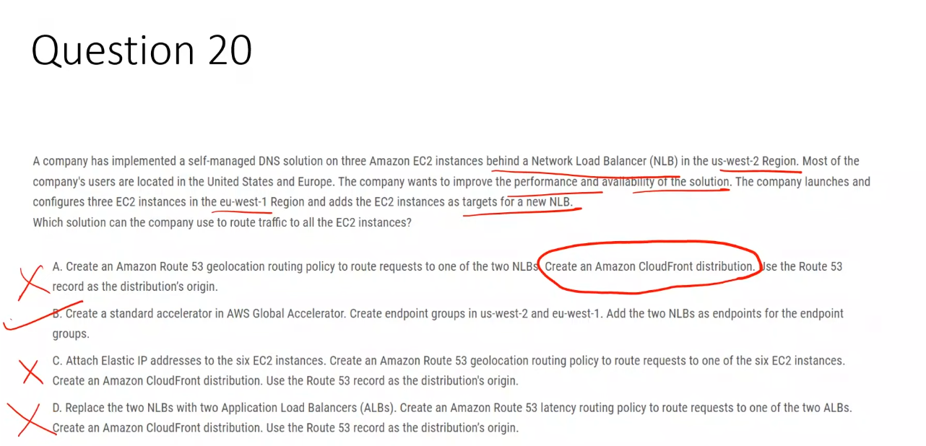

**A. Route 53 geolocation routing + CloudFront**  
 ❌ CloudFront supports only HTTP/HTTPS and cannot front DNS traffic or NLBs.

**B. AWS Global Accelerator with NLB endpoints** ✅  
 ✅ Provides global, low-latency routing for TCP/UDP traffic and routes users to the nearest healthy NLB.

**C. Elastic IPs + Route 53 + CloudFront**  
 ❌ Removes load balancing and scalability; CloudFront does not support DNS traffic.

**D. ALB + Route 53 latency routing + CloudFront**  
 ❌ ALBs do not support UDP and cannot be used for DNS workloads.

### **✅ NLB**

* Supports **TCP and UDP**
* Perfect for DNS

### **✅ Global Accelerator**

* Works at **Layer 4 (TCP/UDP)**

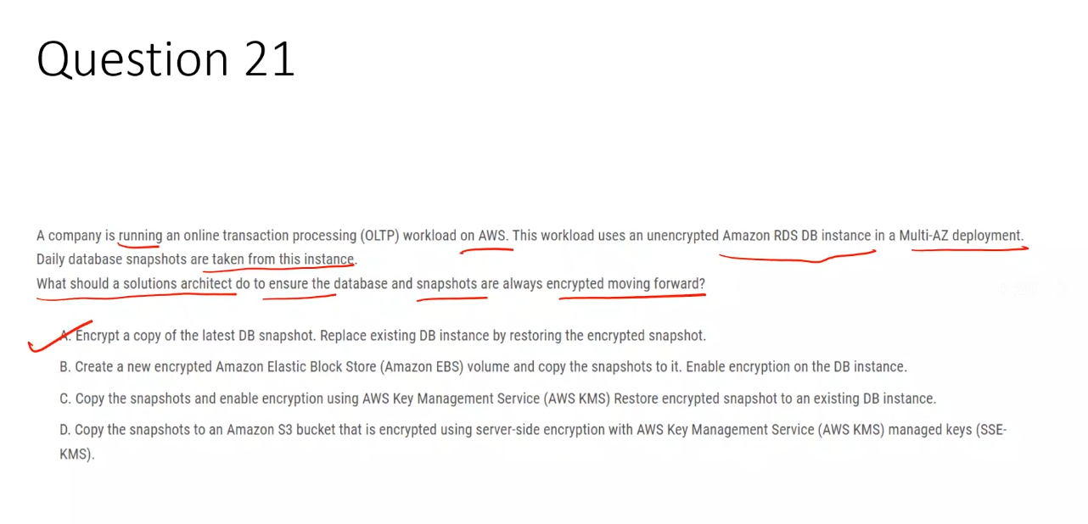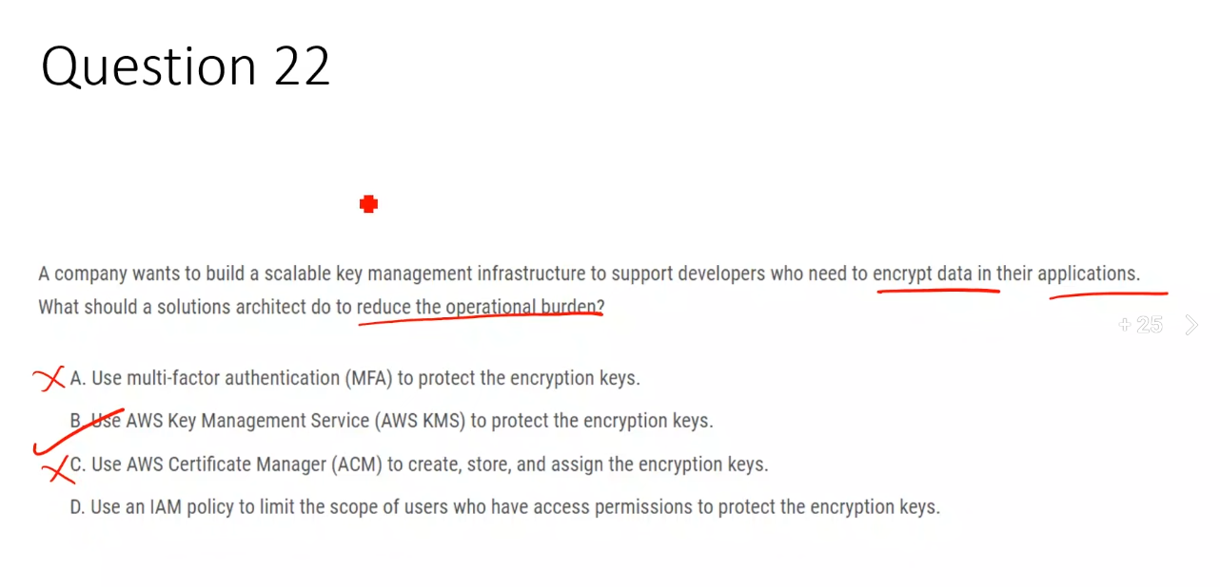

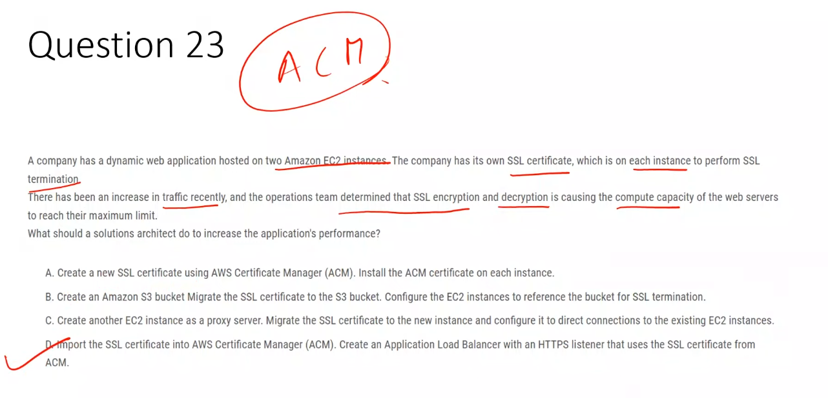

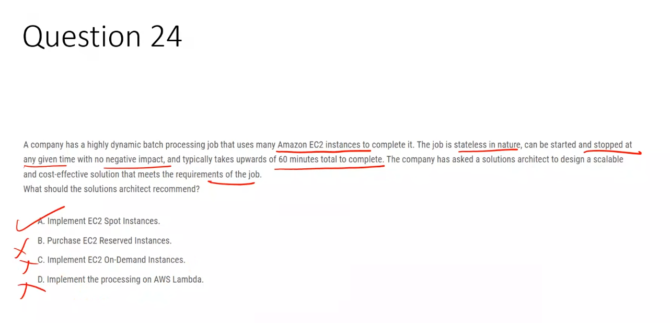

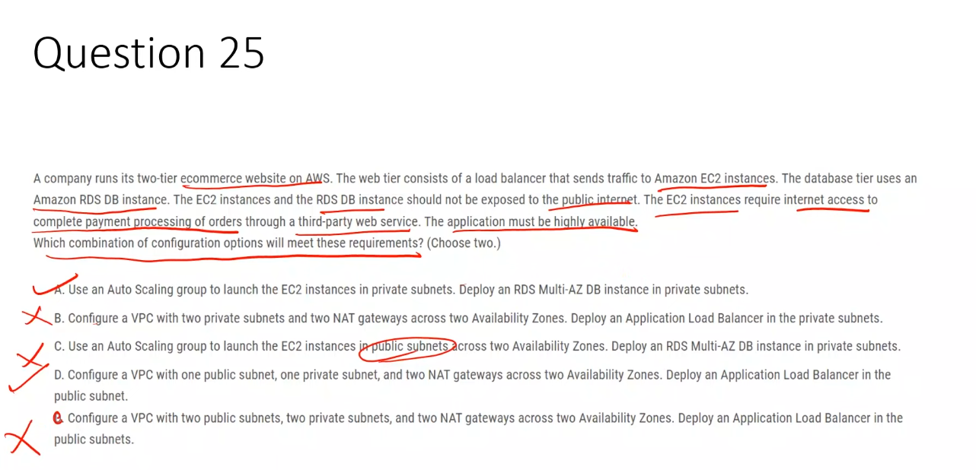

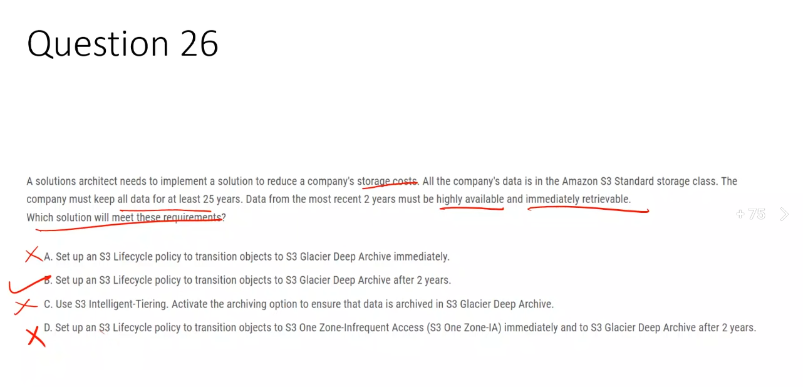

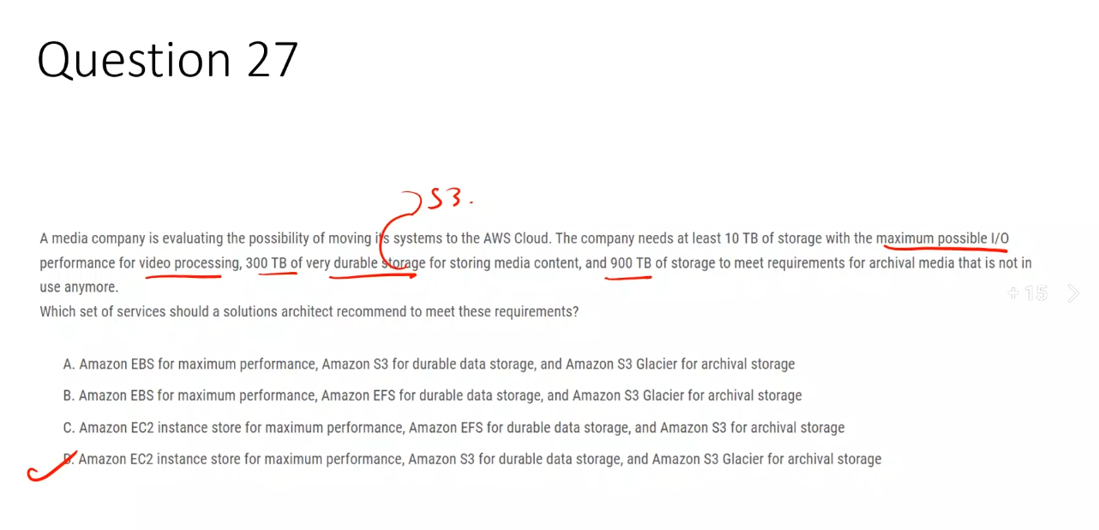

**Yes, EC2 instance store *can* provide 10 TB or more**, depending on the **instance type**, and AWS exams assume you know this.

Now the full logic 👇

## **1️⃣ Instance store capacity depends on instance type**

EC2 instance store is **not a fixed-size disk**.  
 Capacity comes from **local NVMe SSDs attached to the host**.

Examples (real AWS specs, rounded):

* **i3.4xlarge** → ~7.6 TB instance store
* **i3.8xlarge** → ~15.2 TB instance store
* **i3en.6xlarge** → ~15 TB
* **i3en.12xlarge** → ~30 TB
* **i3en.24xlarge** → ~60 TB

👉 So **10 TB is absolutely achievable** with a **single instance**, or trivially with multiple instances.

**A. Amazon EBS, Amazon S3, Amazon S3 Glacier**  
 ❌ EBS does not provide the maximum possible I/O performance compared to EC2 instance store.

**B. Amazon EBS, Amazon EFS, Amazon S3 Glacier**  
 ❌ Amazon EFS is not cost-effective or optimal for storing hundreds of terabytes of durable media data.

**C. Amazon EC2 instance store, Amazon EFS, Amazon S3**  
 ❌ Amazon S3 is not an archival storage service; Amazon S3 Glacier is required for inactive archival data.

**D. Amazon EC2 instance store, Amazon S3, Amazon S3 Glacier** ✅  
 ✅ Matches maximum I/O performance, highly durable large-scale storage, and low-cost archival storage requirements.

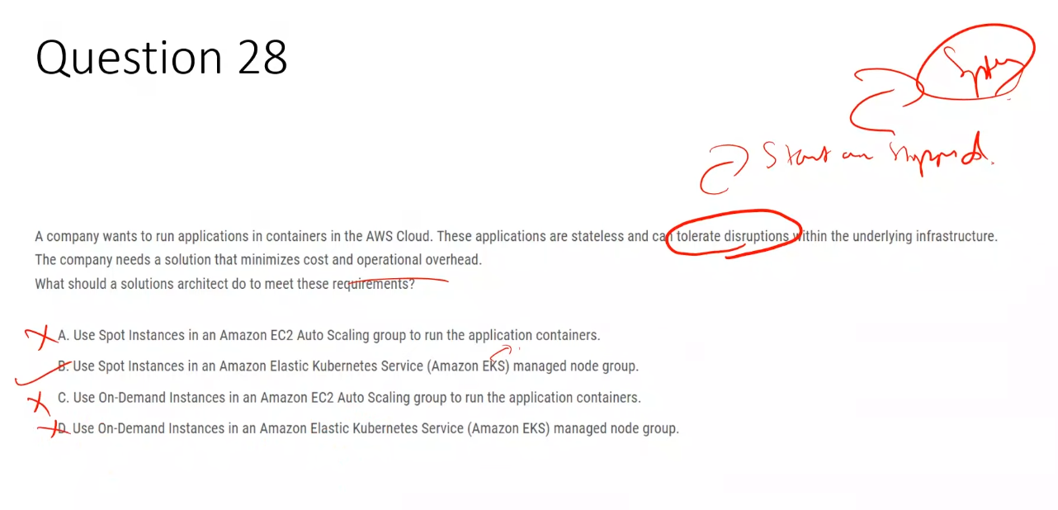

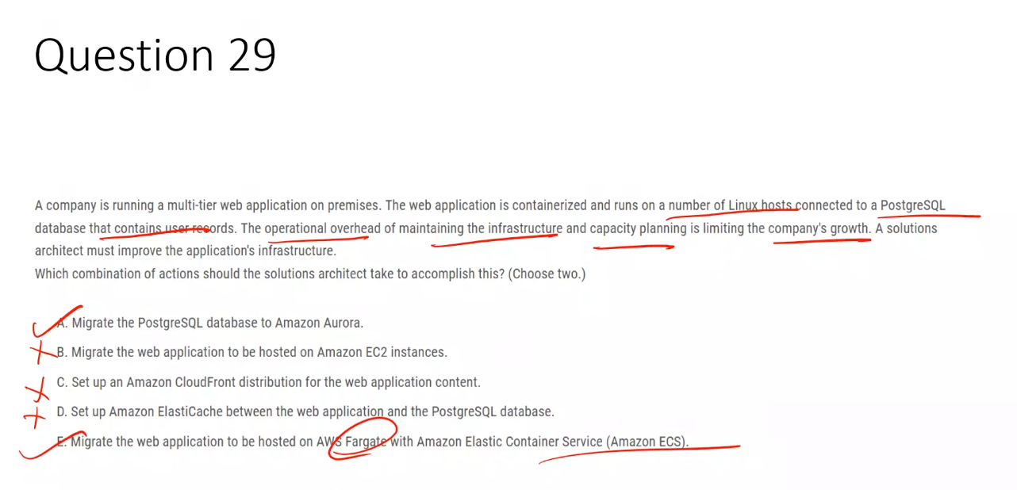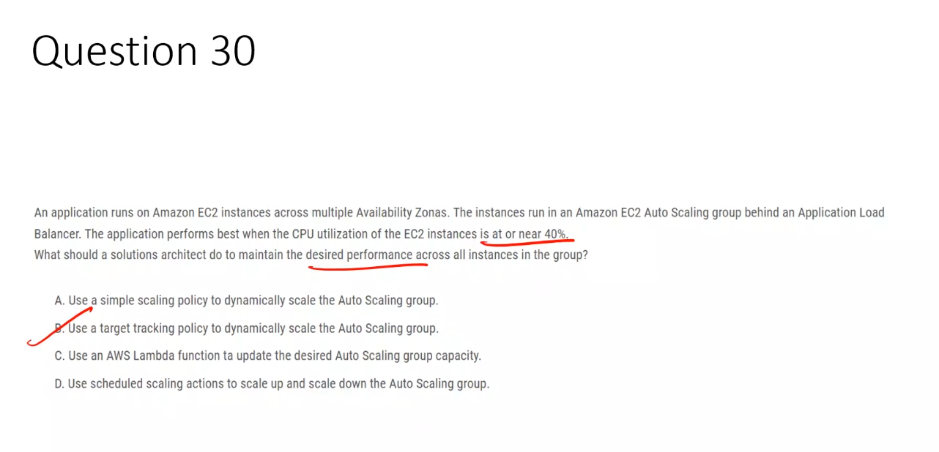

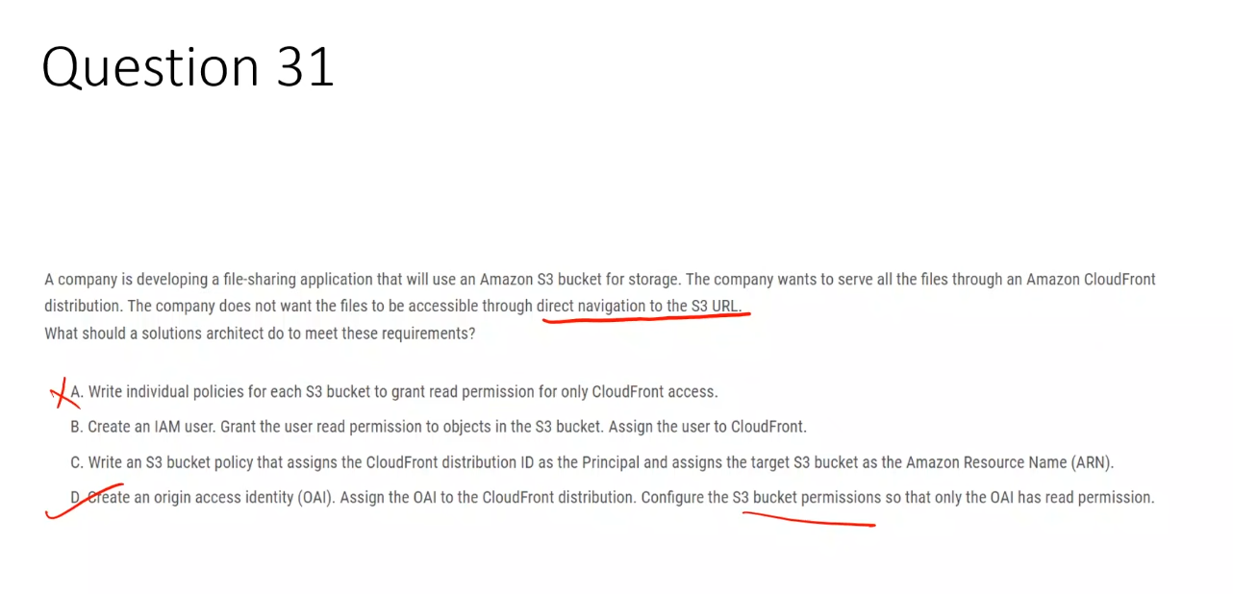

## **1️⃣ What is OAI (Origin Access Identity)?**

**OAI = Origin Access Identity**

It is a **special CloudFront identity** that CloudFront uses to **privately access an S3 bucket**.

### **In simple terms:**

OAI acts like a **virtual IAM user for CloudFront**.

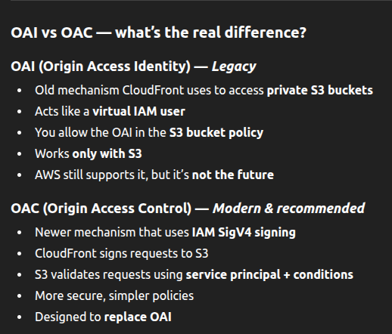

**A. S3 bucket policies allowing “CloudFront access”**  
 ❌ CloudFront is not a valid IAM principal and cannot be directly referenced without OAI/OAC.

**B. IAM user assigned to CloudFront**  
 ❌ CloudFront cannot assume IAM users; IAM users are not used for origin access.

**C. CloudFront distribution ID as Principal**  
 ❌ Distribution IDs are not valid principals in S3 bucket policies.

**D. Origin Access Identity (OAI)** ✅  
 ✅ Allows only CloudFront to read from the S3 bucket and prevents direct S3 URL access.

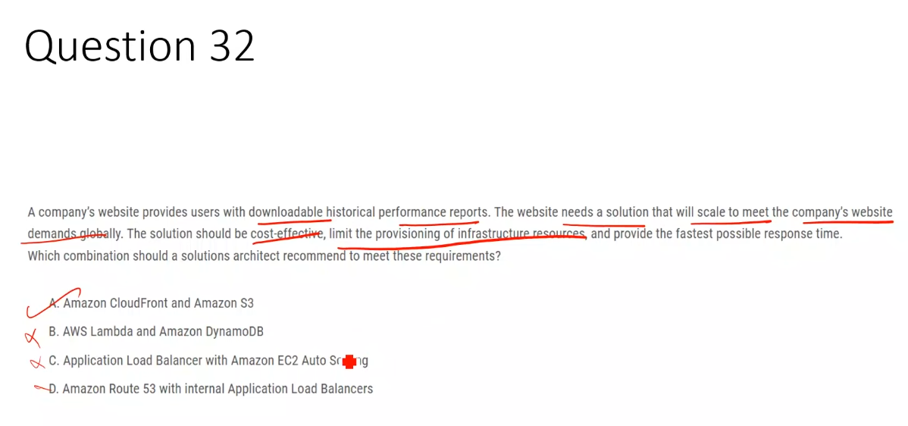

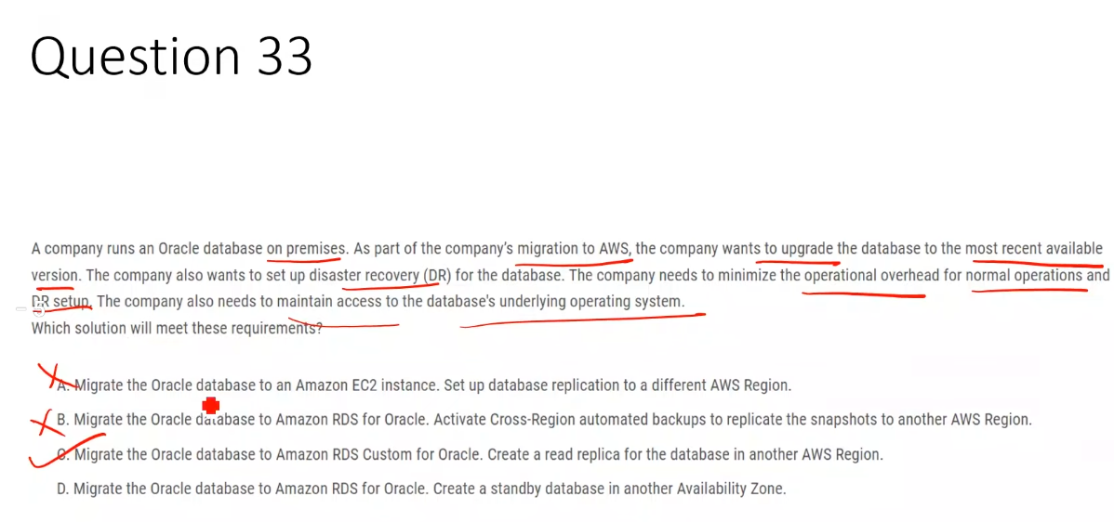

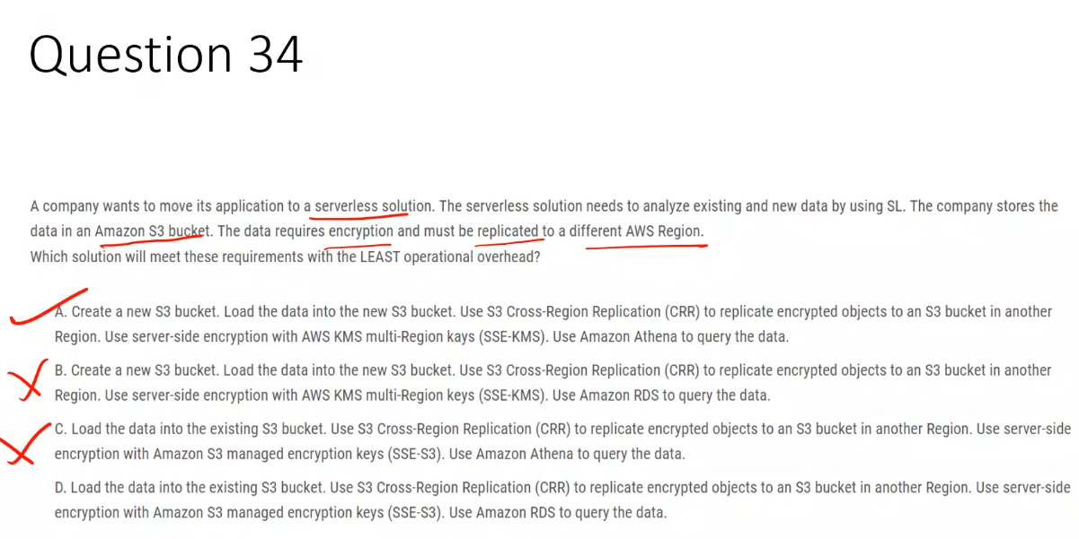

**A. VPC peering between company and provider VPC**  
 ❌ Provides full network-level access and cannot restrict connectivity to only the target service.

**B. Virtual private gateway with AWS PrivateLink**  
 ❌ Virtual private gateways are for VPN/Direct Connect and do not support service-level access via PrivateLink.

**C. NAT gateway with route table updates**  
 ❌ Uses the internet and does not provide private or service-restricted connectivity.

**D. AWS PrivateLink with a provider VPC endpoint service** ✅  
 ✅ Enables private, one-way, service-level connectivity restricted to the target service only.

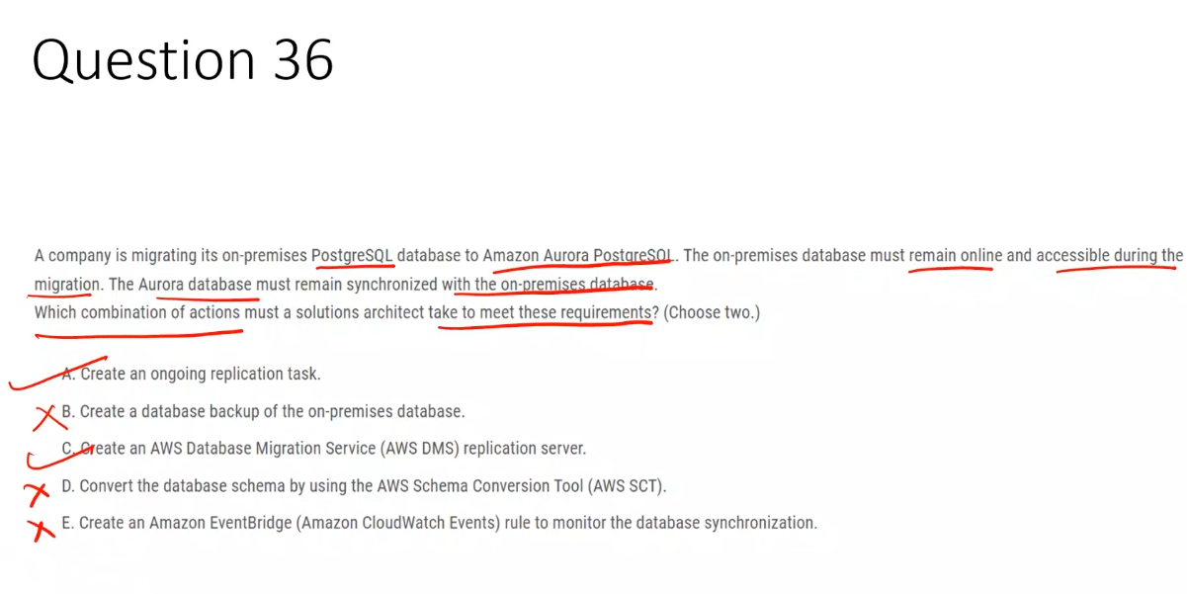

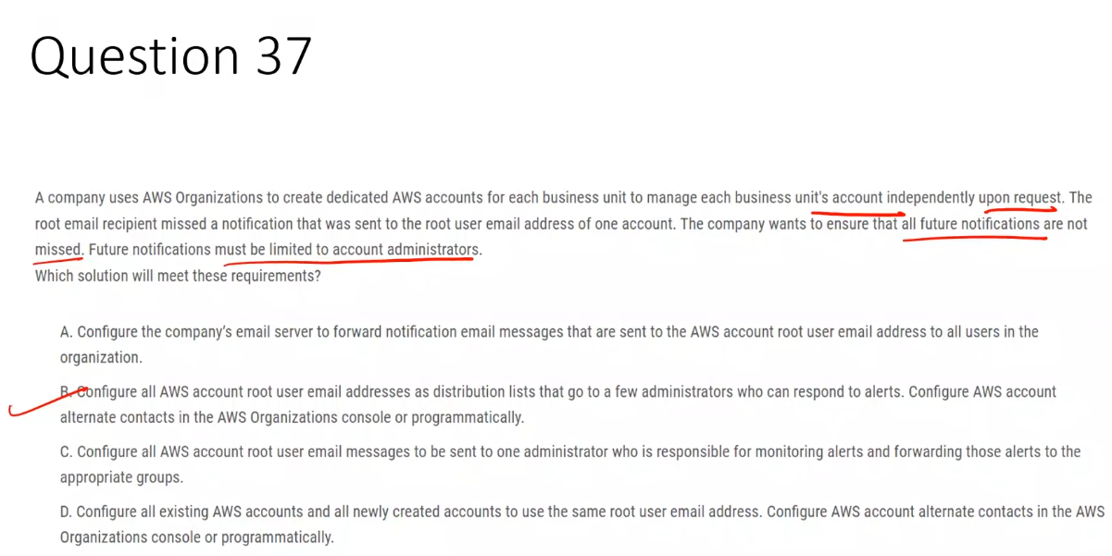

**Correct Answer – B**  
 ✅ Use AWS account alternate contacts and root email distribution lists to ensure critical notifications reach account administrators without relying on a single root user.

**A. Forward root emails to all users**  
 ❌ Sends sensitive notifications to non-admin users and violates least-privilege principles.

**C. Send root emails to one administrator**  
 ❌ Creates a single point of failure and does not ensure notifications are reliably received.

**D. Use the same root email for all accounts**  
 ❌ Breaks account isolation and is against AWS security best practices.

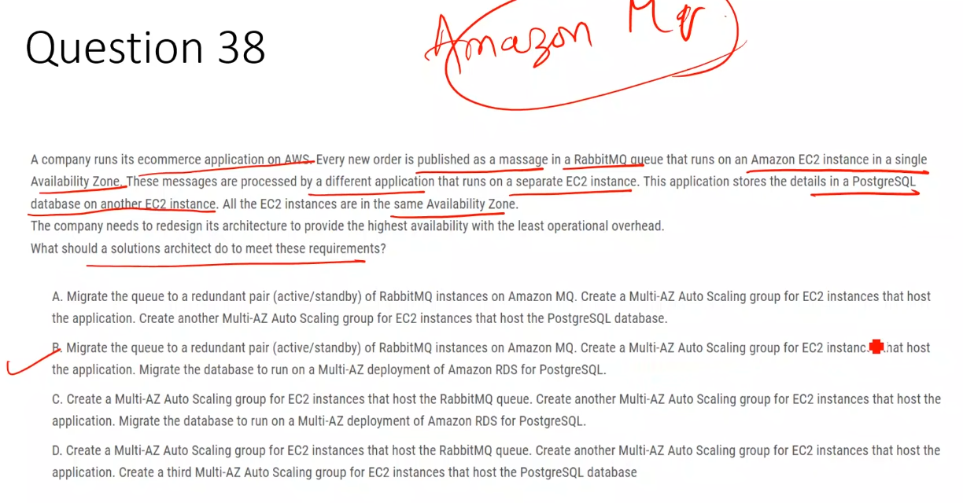

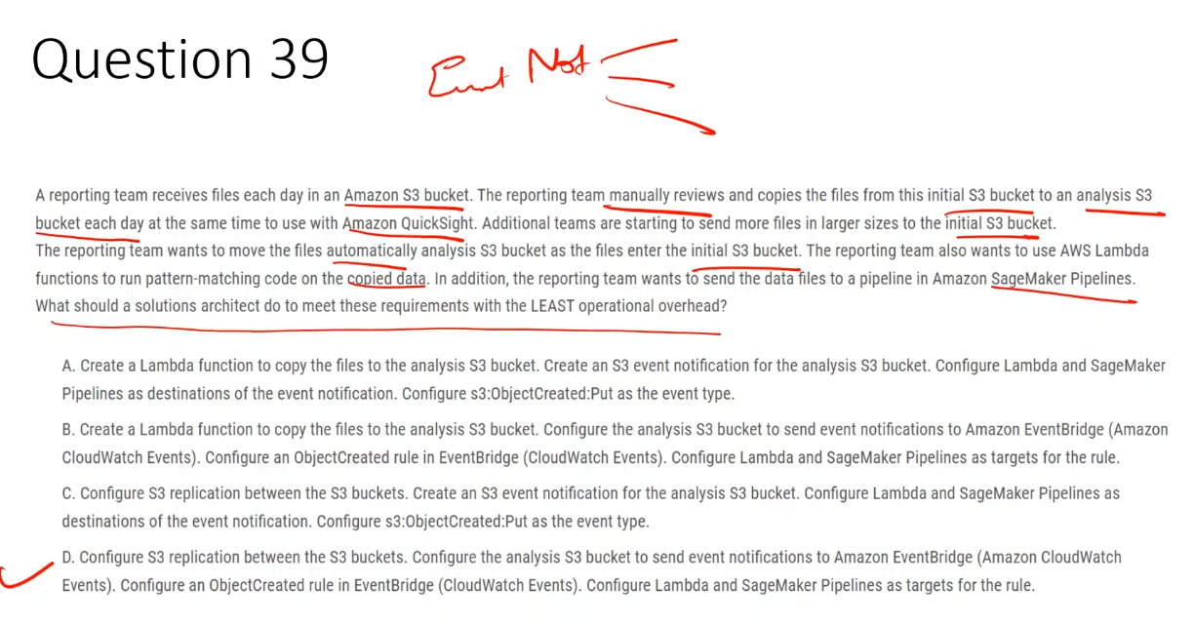

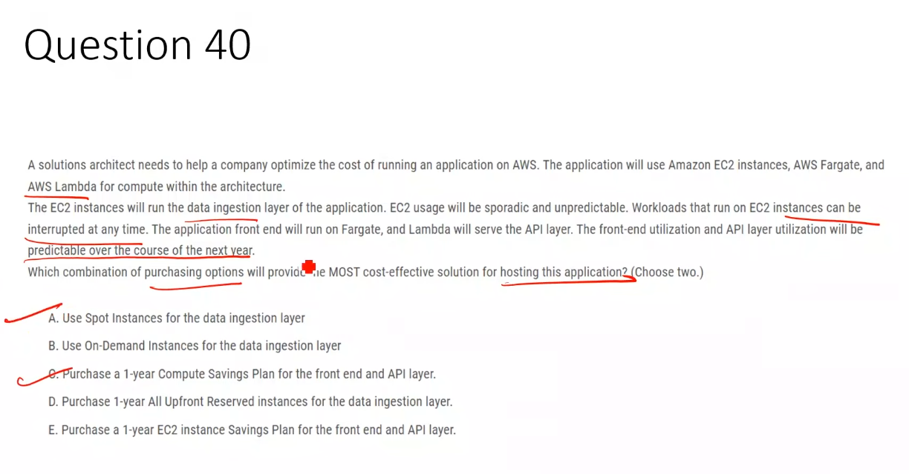

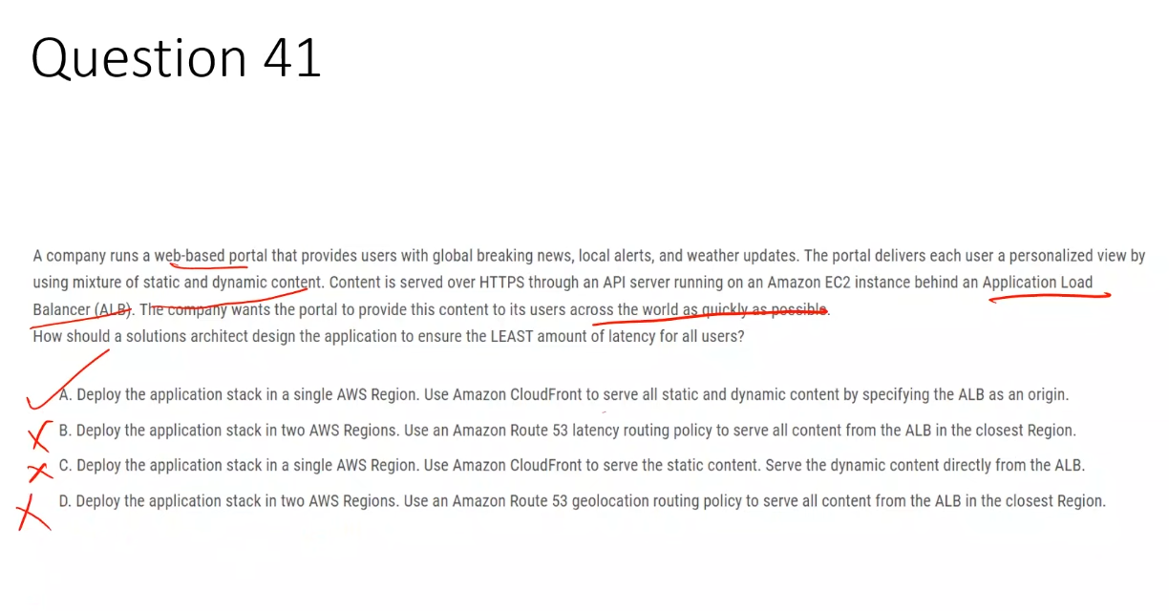

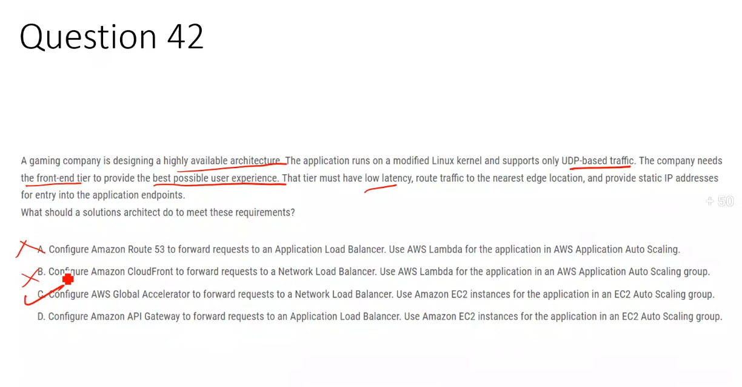

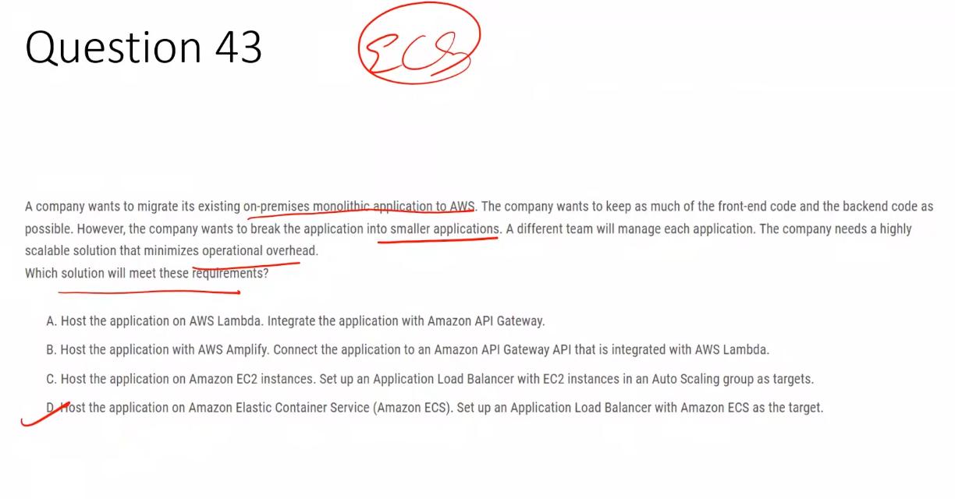

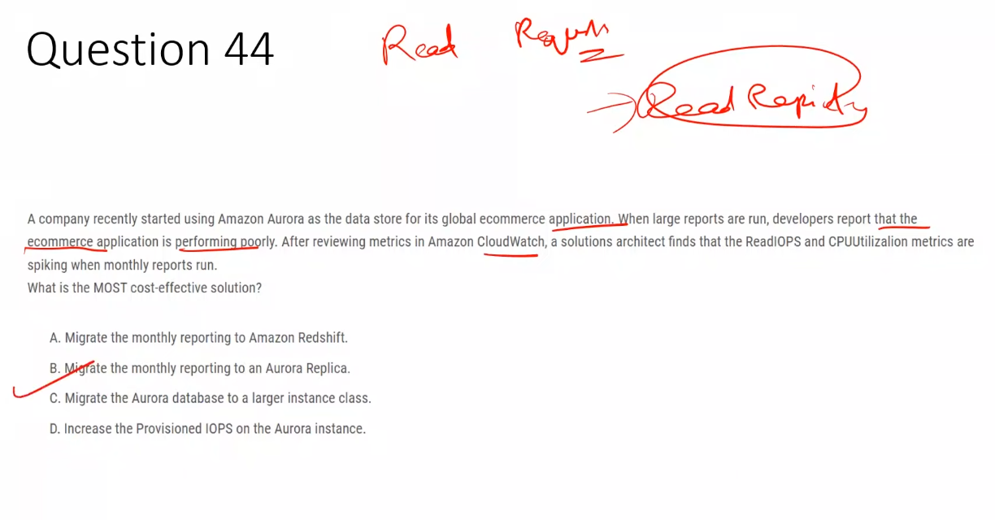

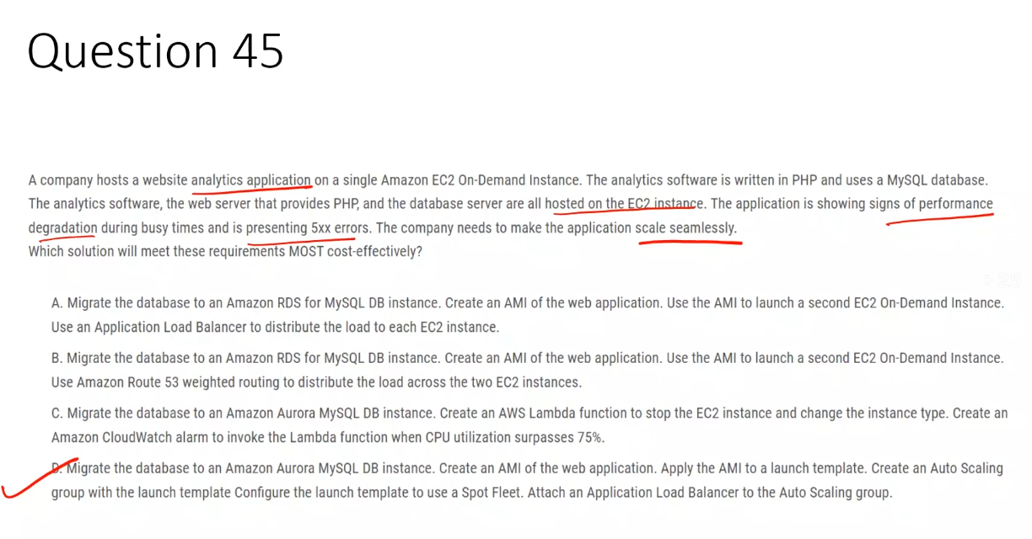

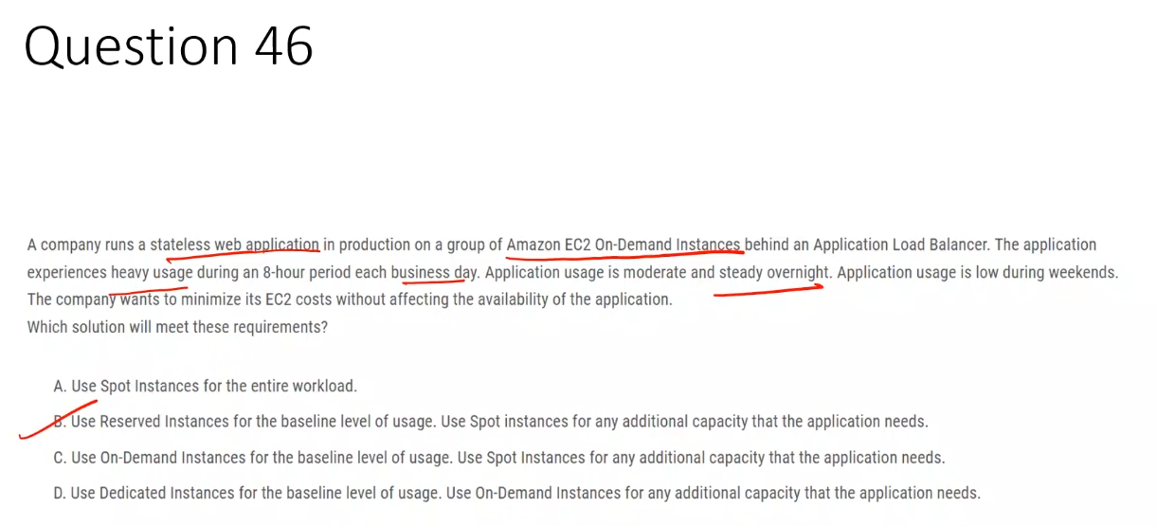

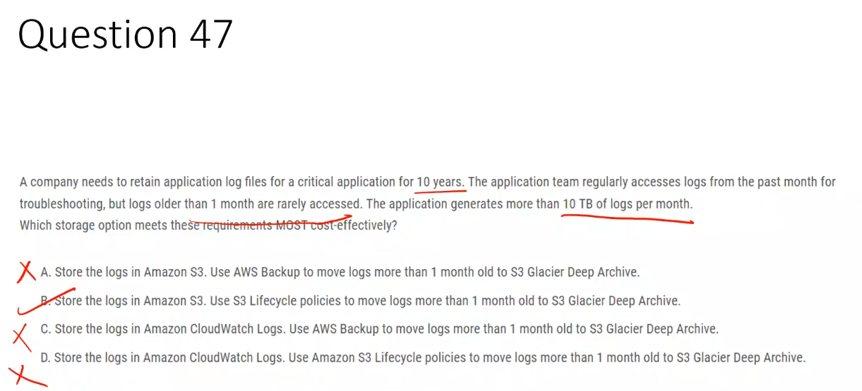

**A. Amazon S3 + AWS Backup**  
 ❌ AWS Backup is unnecessary for log lifecycle management and increases cost and operational overhead.

**B. Amazon S3 + S3 Lifecycle policies** ✅  
 ✅ Provides low-cost, automated long-term retention by transitioning infrequently accessed logs to Glacier Deep Archive.

**C. Amazon CloudWatch Logs + AWS Backup**  
 ❌ CloudWatch Logs is not cost-effective for long-term retention and AWS Backup does not manage logs this way.

**D. Amazon CloudWatch Logs + S3 Lifecycle policies**  
 ❌ S3 lifecycle policies cannot be applied to CloudWatch Logs and the solution is not cost-effective.

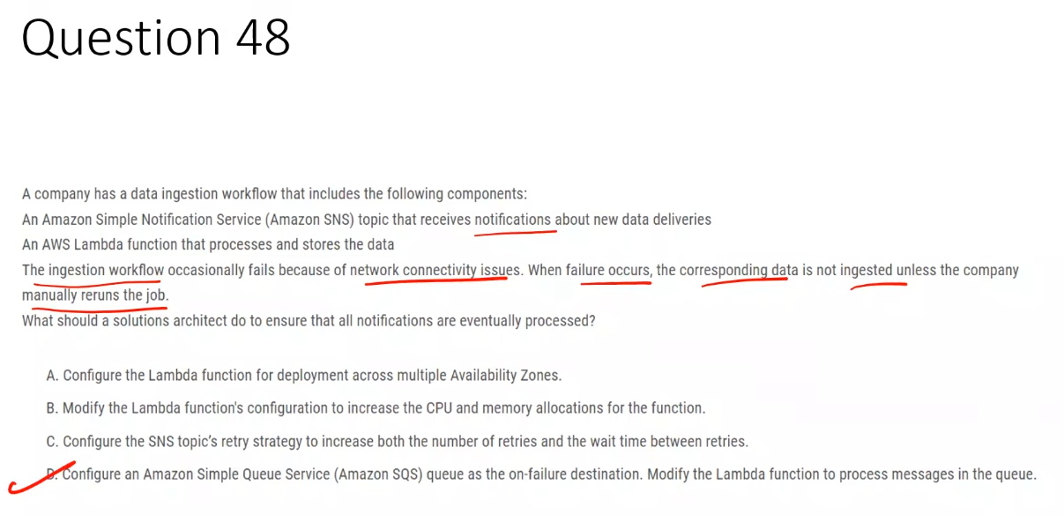

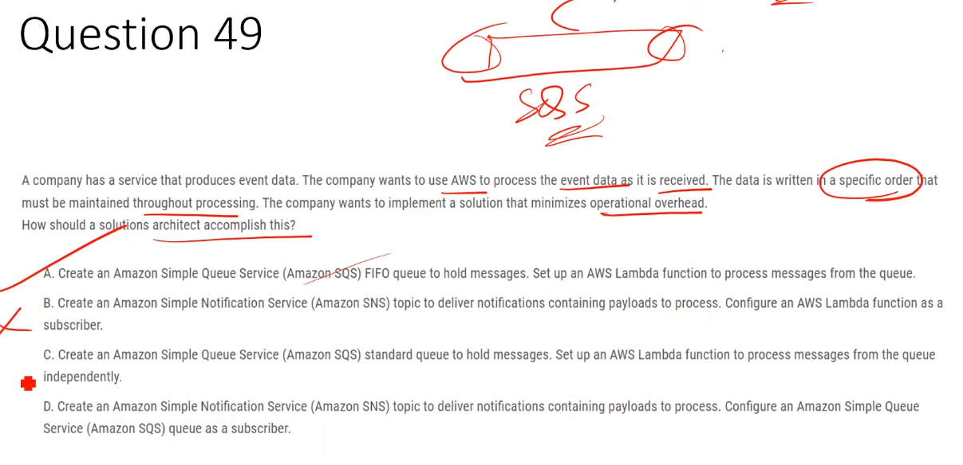

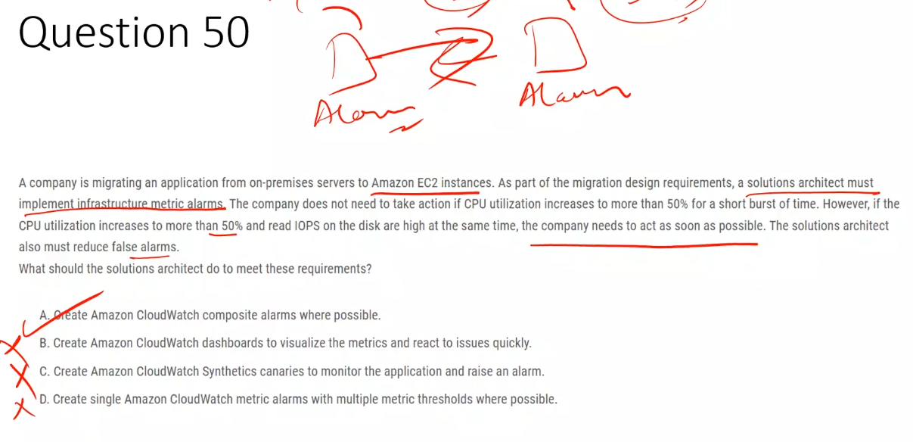

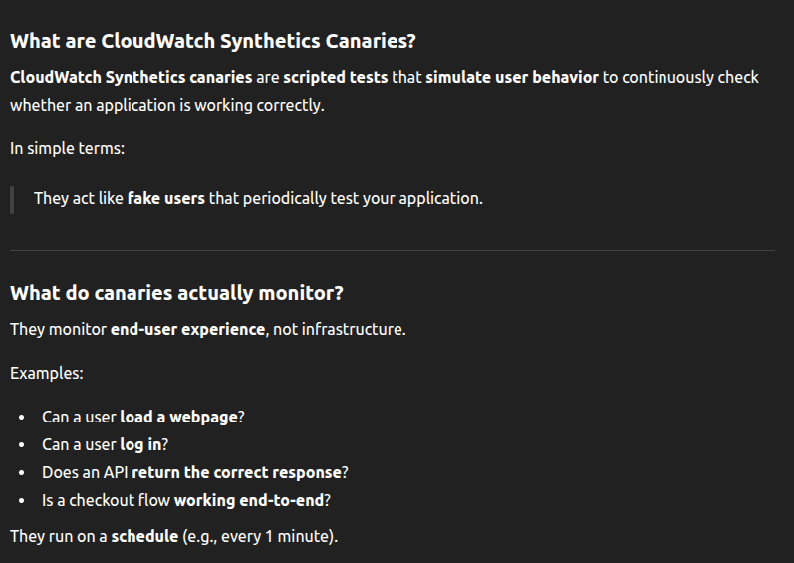

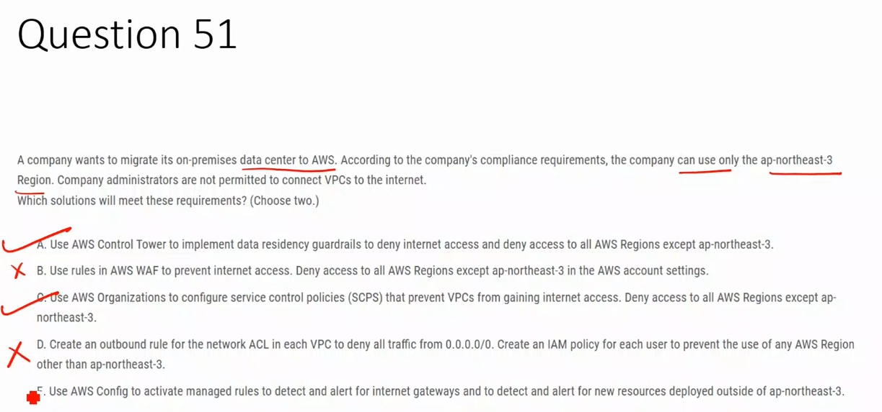

## **What does “guardrails” mean in AWS?**

**Guardrails** are **rules that enforce or monitor behavior across AWS accounts** to keep them compliant.

Think of guardrails as:

**Hard rules + alarms that stop or flag bad behavior**

They are **not suggestions**. They exist to **prevent mistakes** at scale.

## **What are Data Residency Guardrails specifically?**

**Data residency guardrails** ensure that:

* Resources are created **only in approved AWS Regions**
* Data does **not leave allowed Regions**
* Compliance requirements (legal/regulatory) are enforced

## **How Control Tower guardrails actually work (important)**

Control Tower guardrails are built using:

* **Service Control Policies (SCPs)** → prevention
* **AWS Config rules** → detection

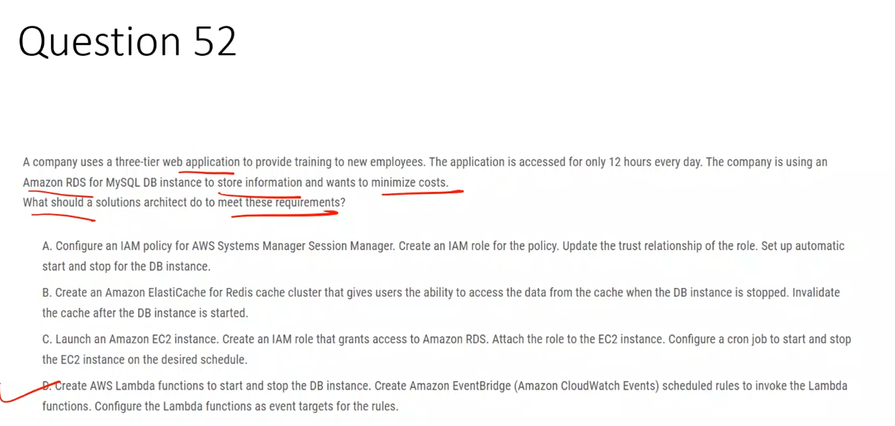

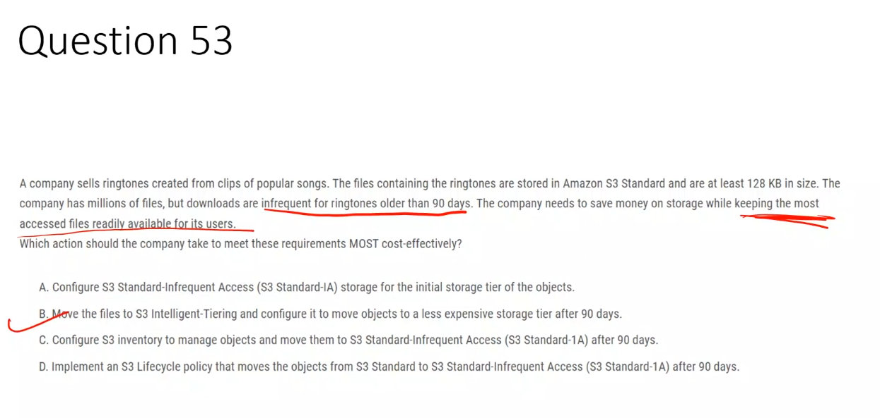

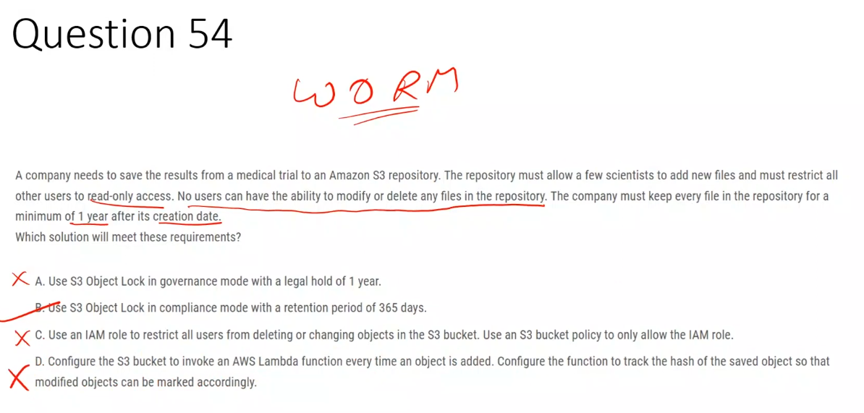

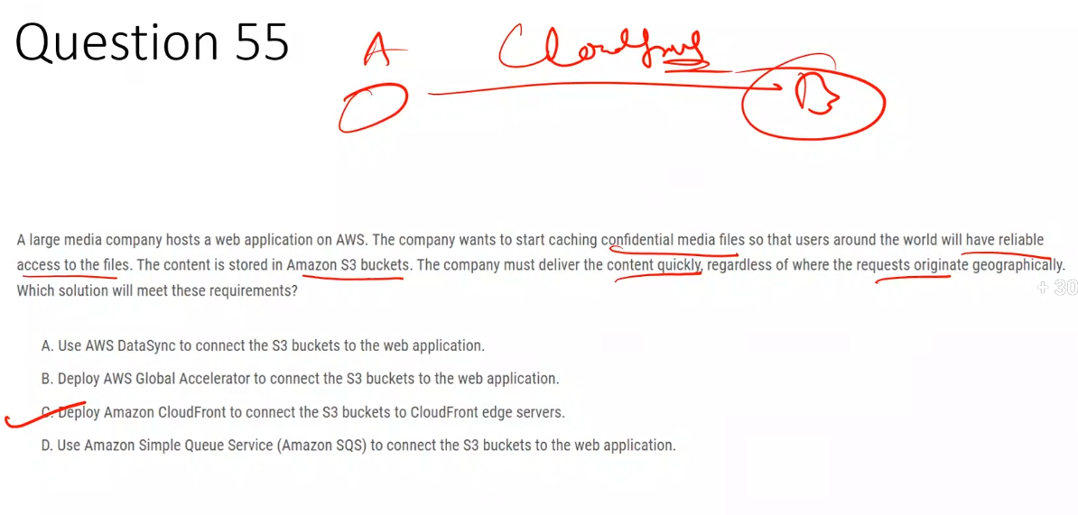

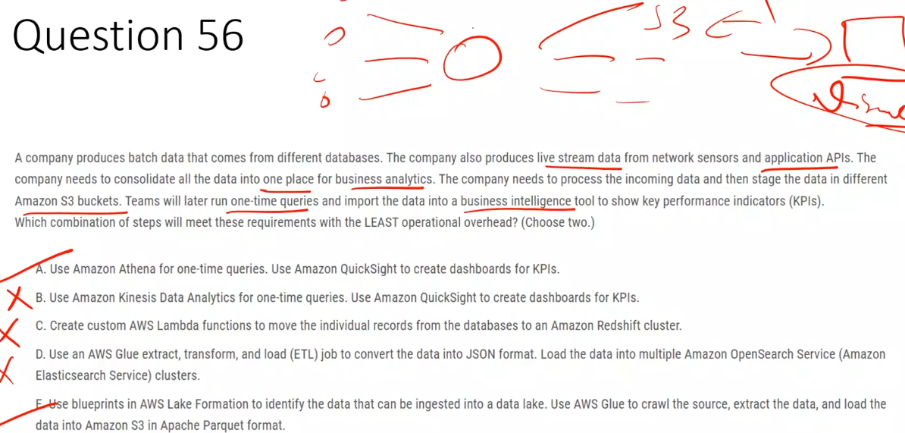

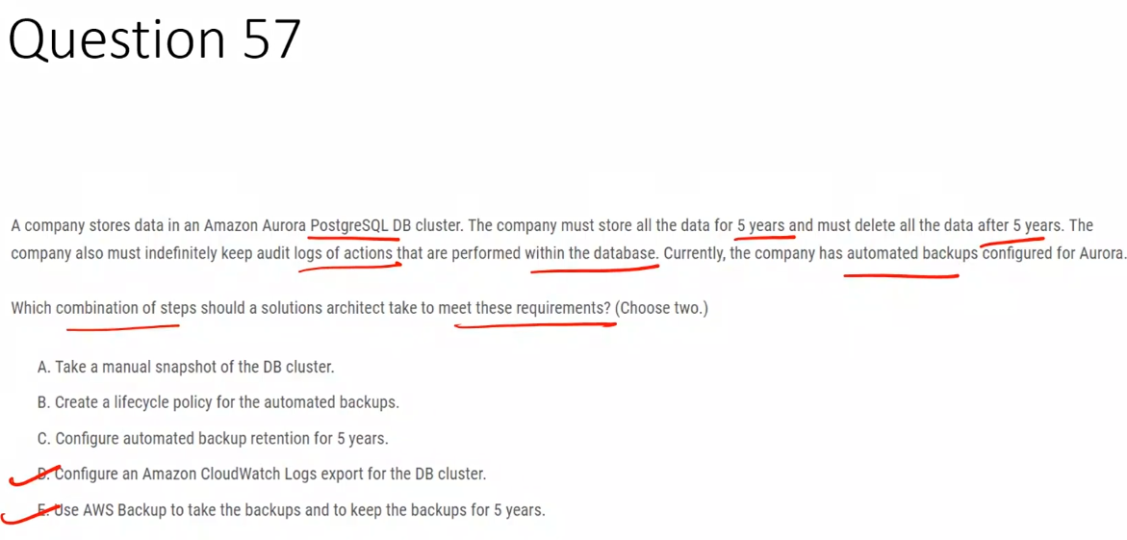

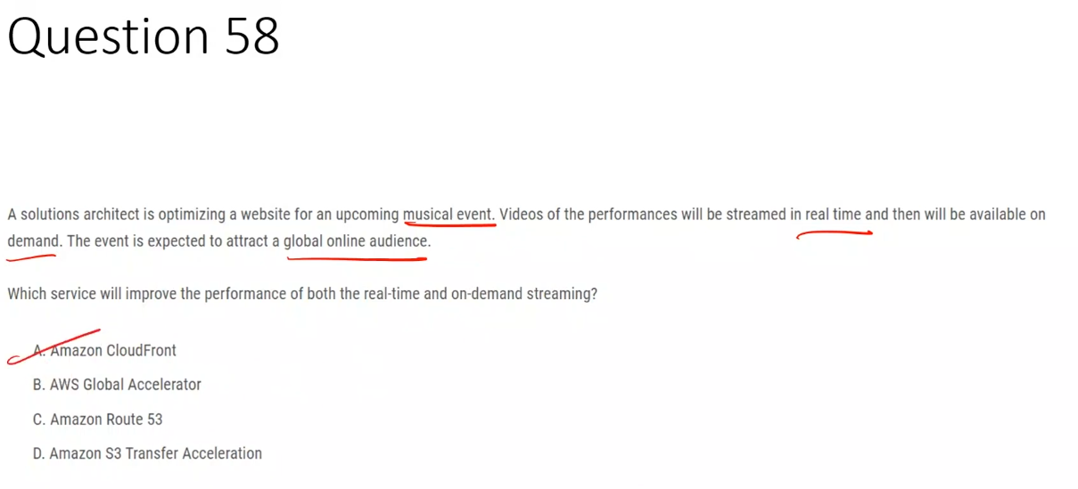**Exam memory rule (burn this in)**

* **Streaming / media / VOD → CloudFront**
* **APIs / TCP / UDP / gaming → Global Accelerator**
* **Caching required → CloudFront**
* **No caching → Global Accelerator**

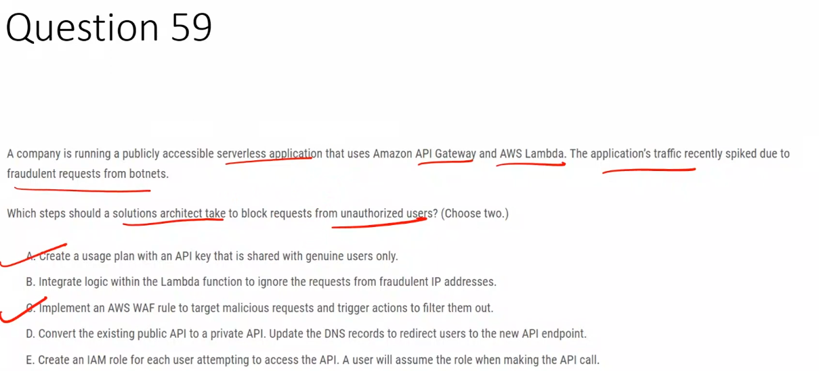

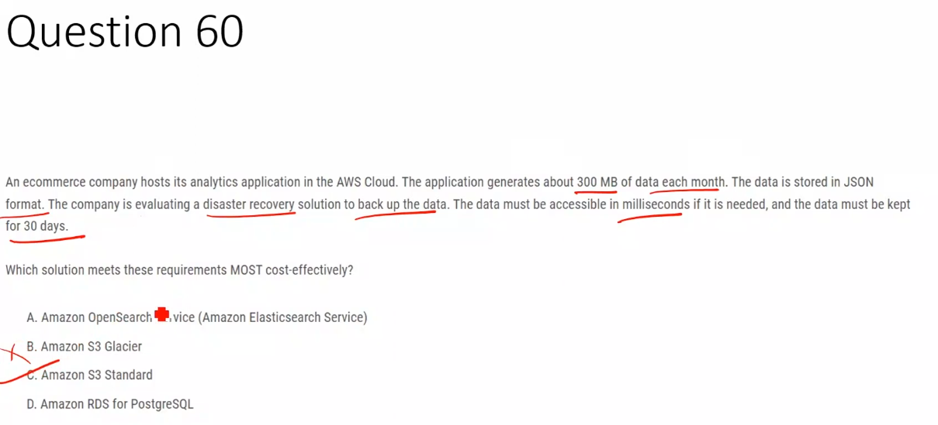

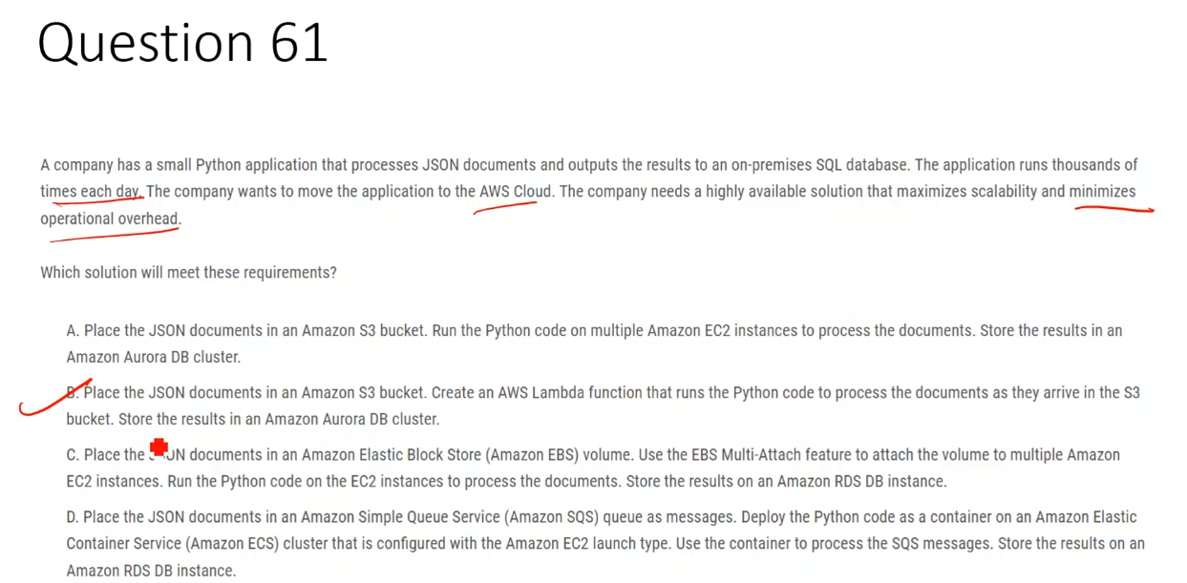

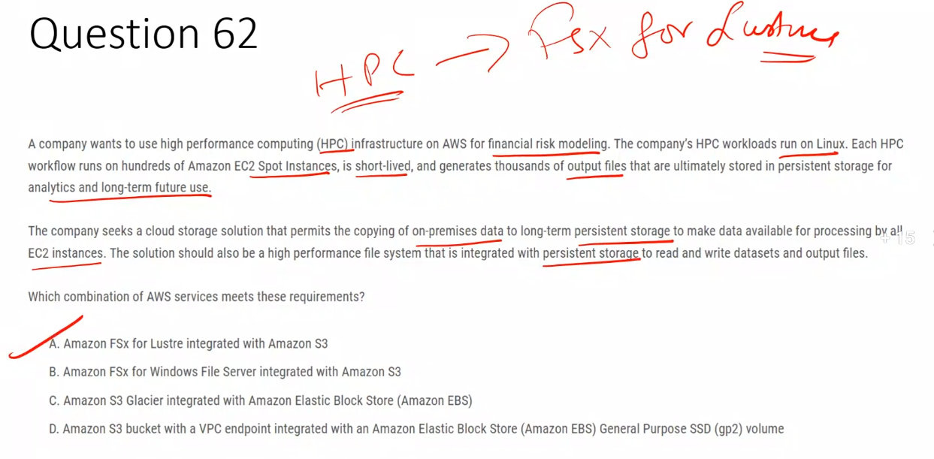

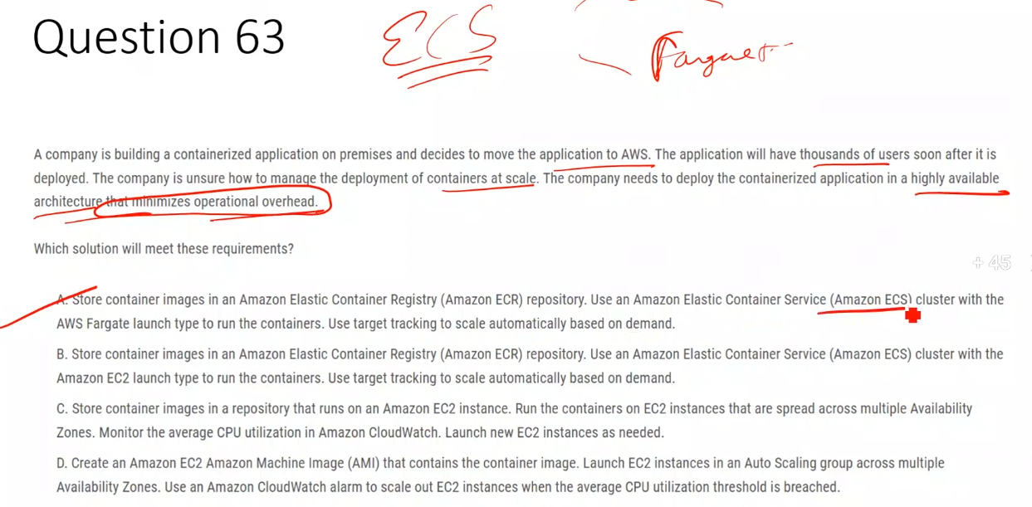

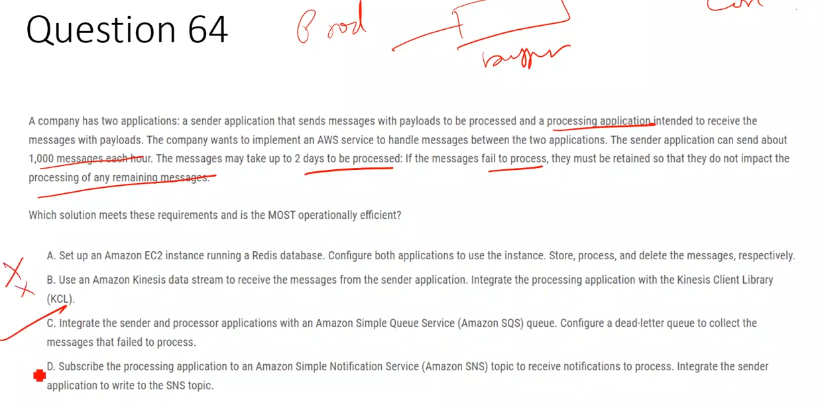

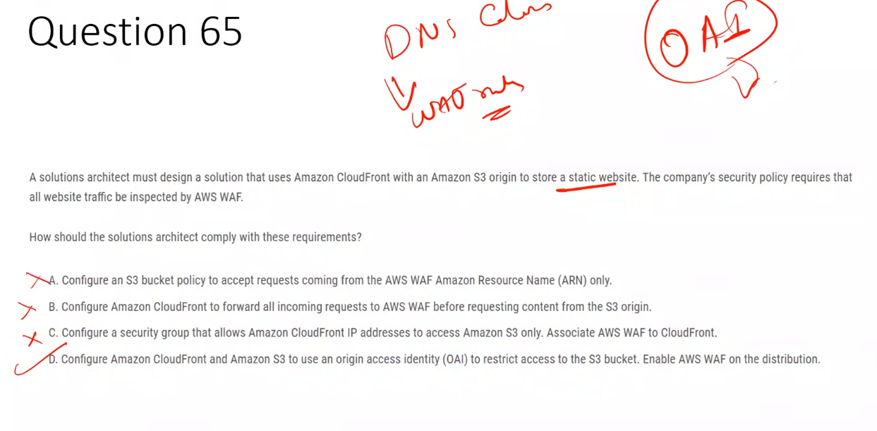

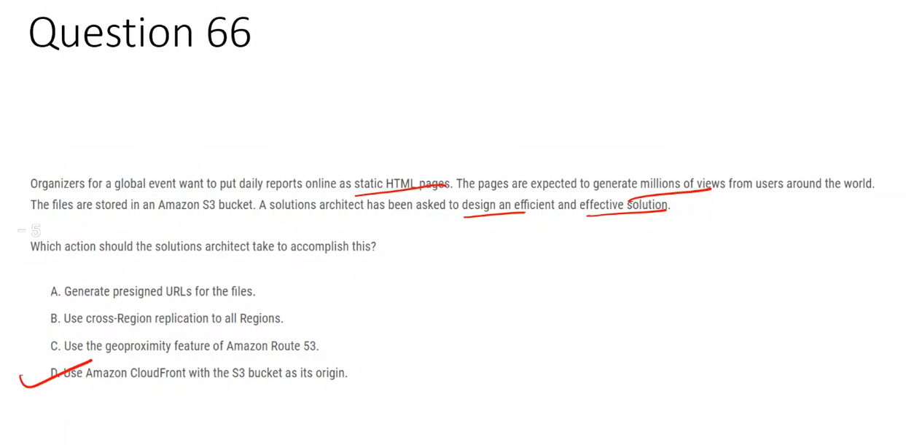

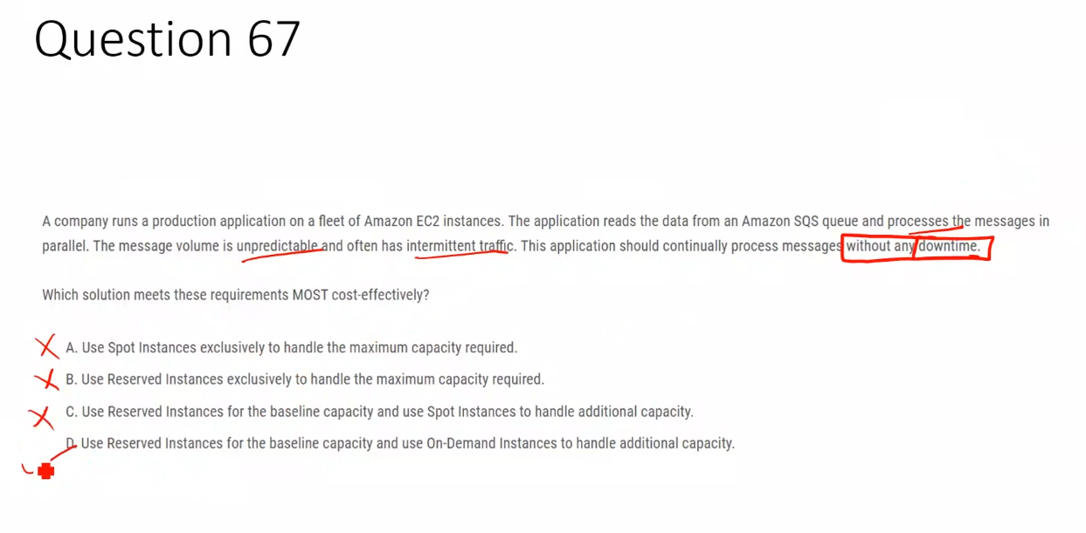

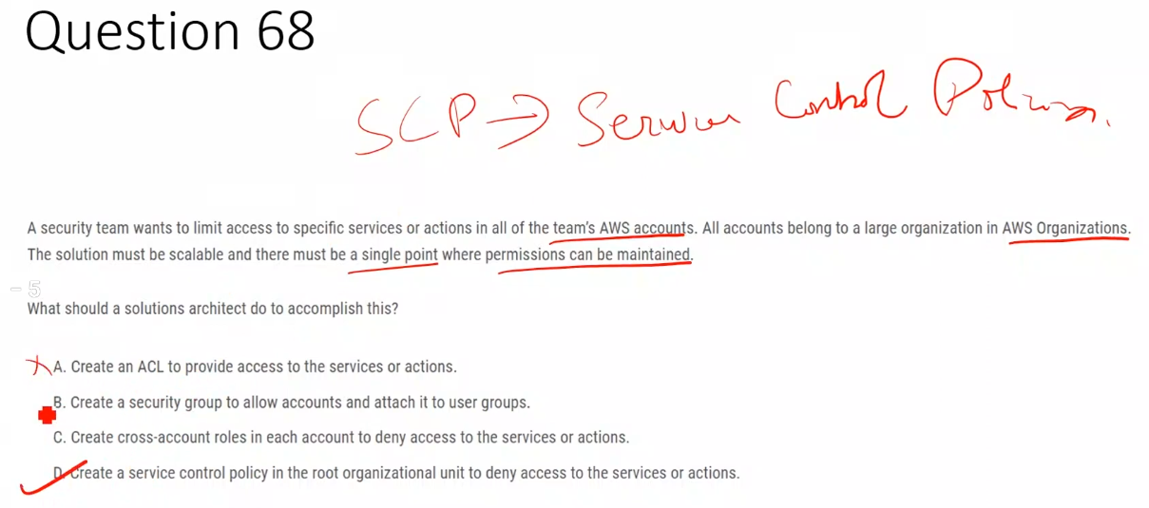

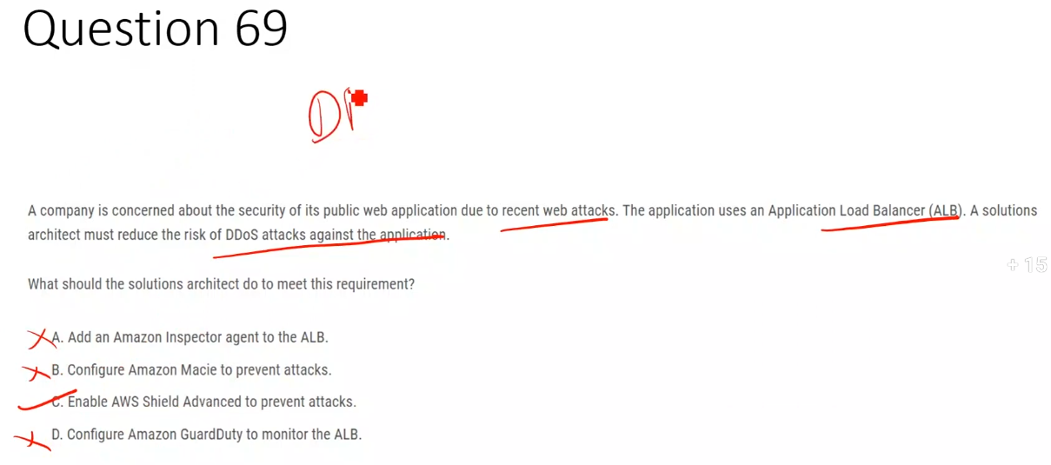

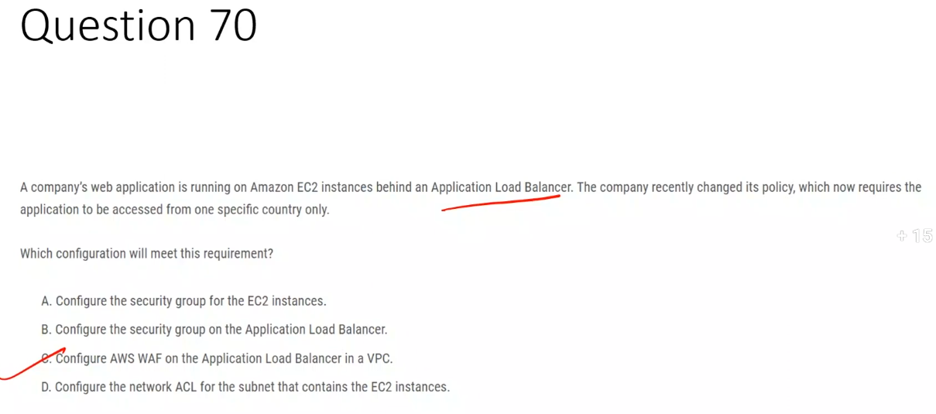

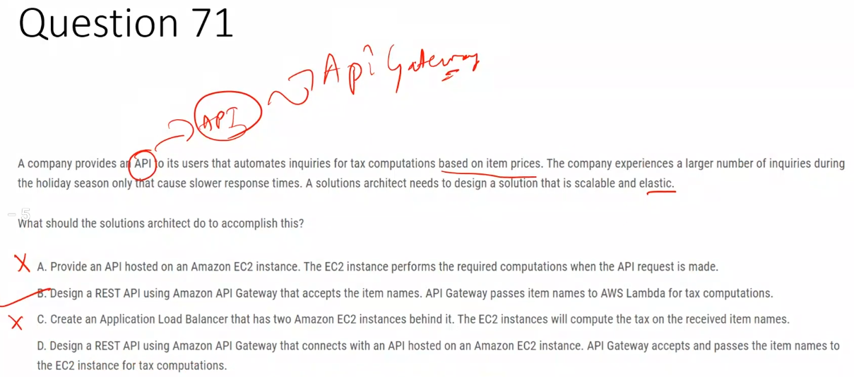

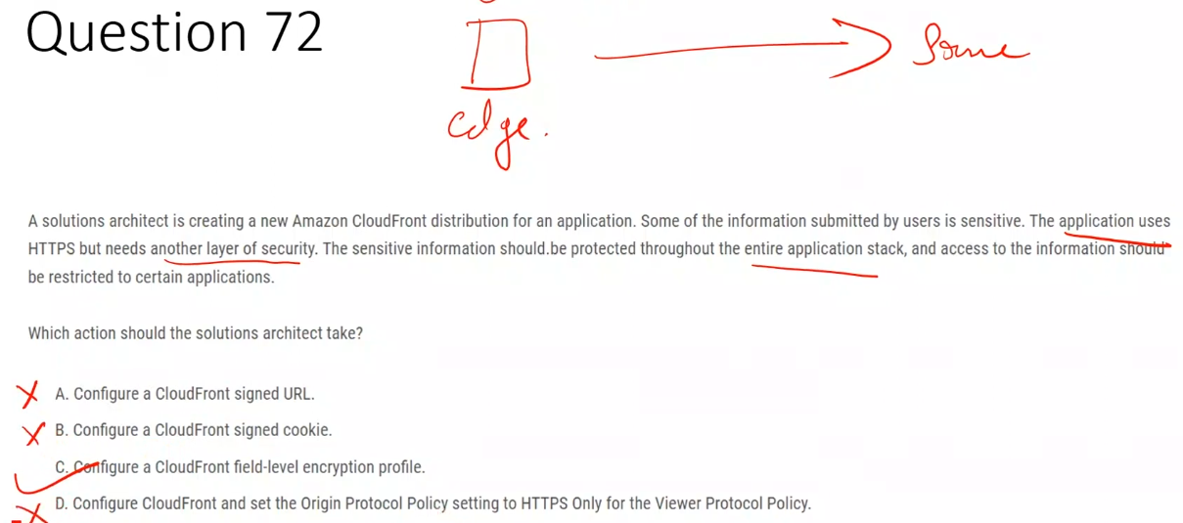

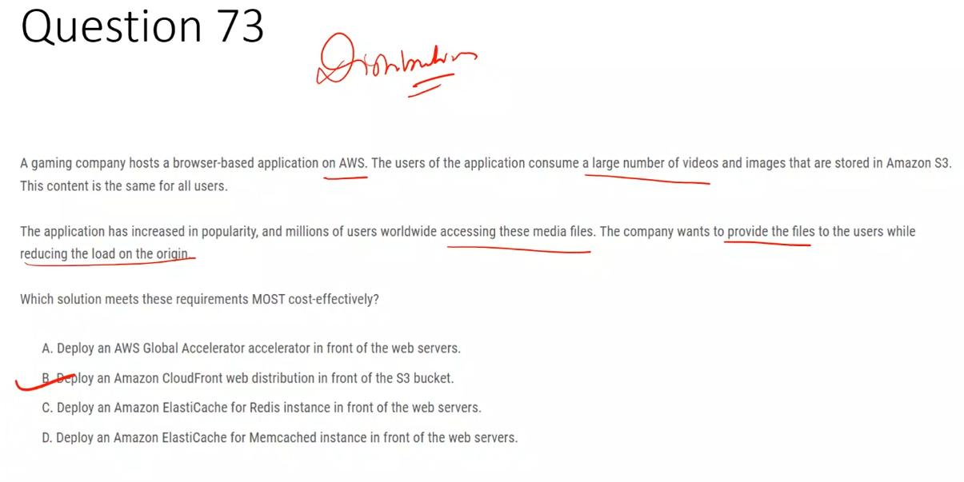

**A. AWS Global Accelerator**  
 ❌ Optimizes network paths but does not cache content or reduce origin load.

**B. Amazon CloudFront with S3** ✅  
 ✅ Caches static content at edge locations to serve global users efficiently and reduce origin load.

**C. Amazon ElastiCache for Redis**  
 ❌ Designed for application data caching, not for serving static media files to end users.

**D. Amazon ElastiCache for Memcached**  
 ❌ In-memory cache unsuitable for large static files and global content delivery.

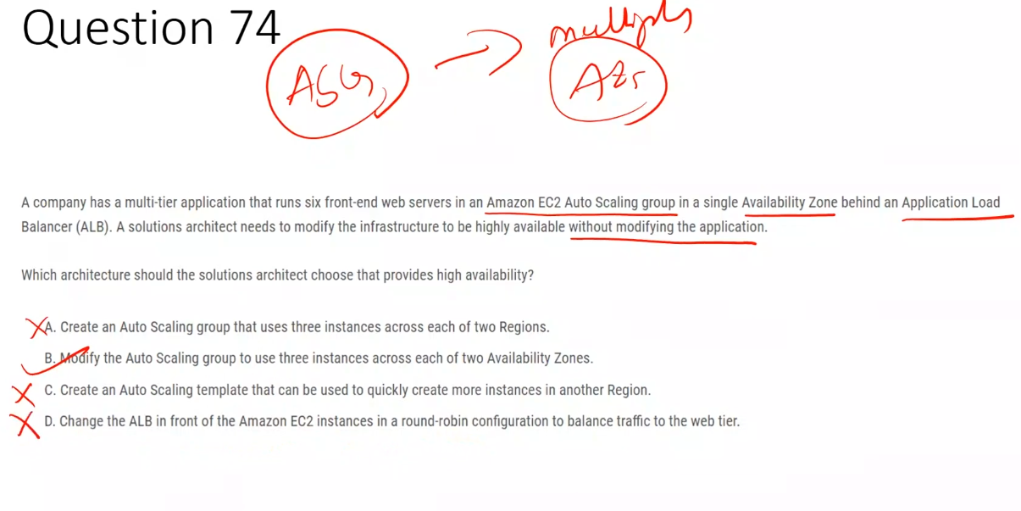

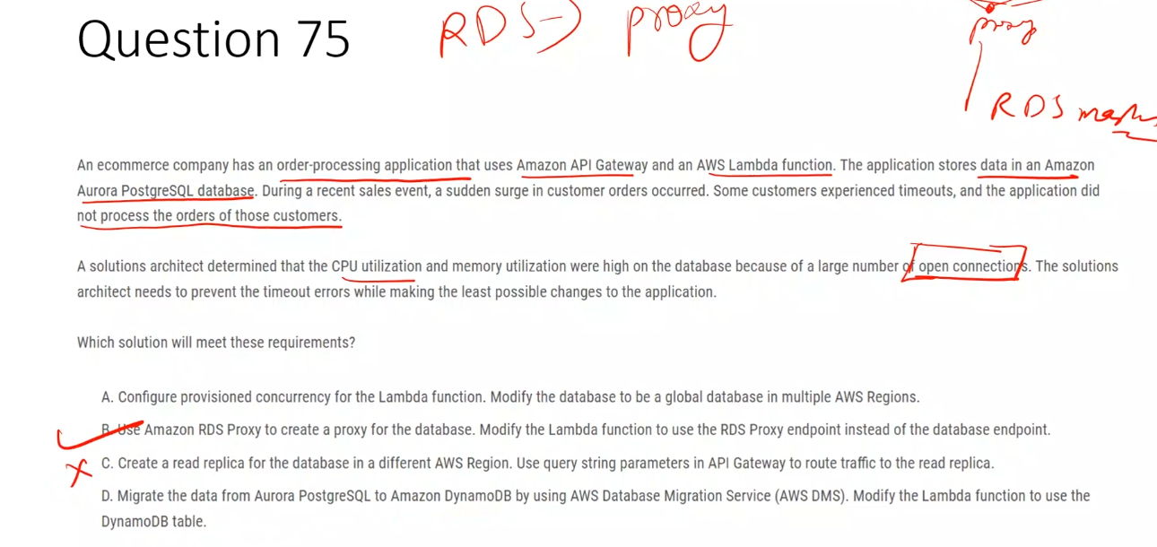

Yes, it is possible to use RDS Proxy for Aurora PostgreSQL databases.

RDS Proxy is fully supported for Aurora PostgreSQL and provides several benefits:

* Improved scalability: Pools and shares database connections, allowing applications to handle more connections efficiently
* Enhanced availability: Reduces failover times by up to 66% for Aurora databases
* Better security: Manages database credentials through AWS Secrets Manager and IAM authentication

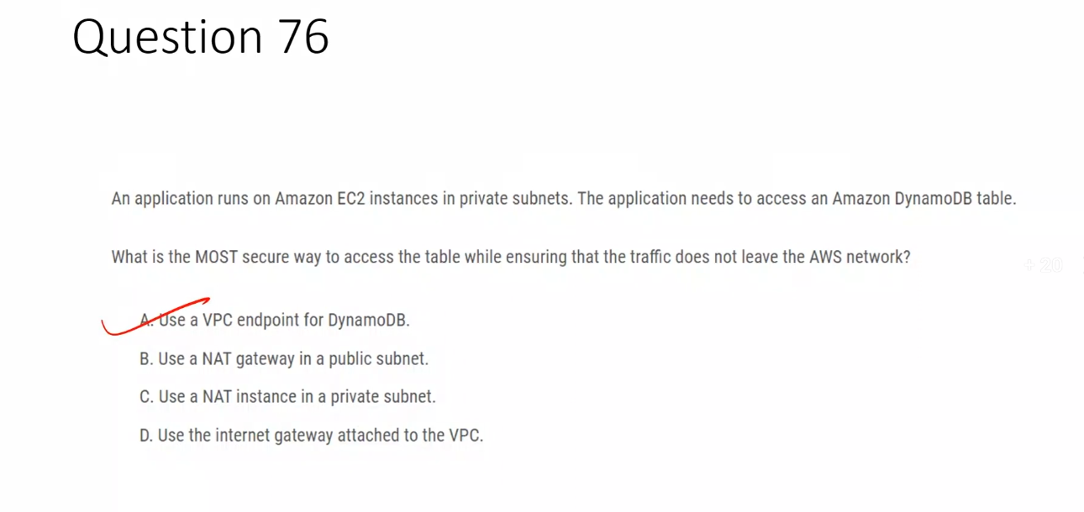

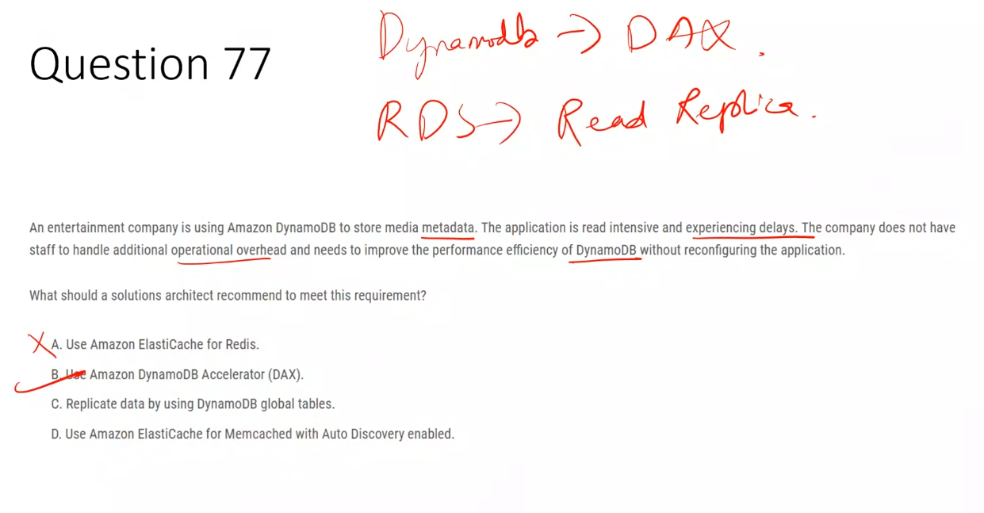

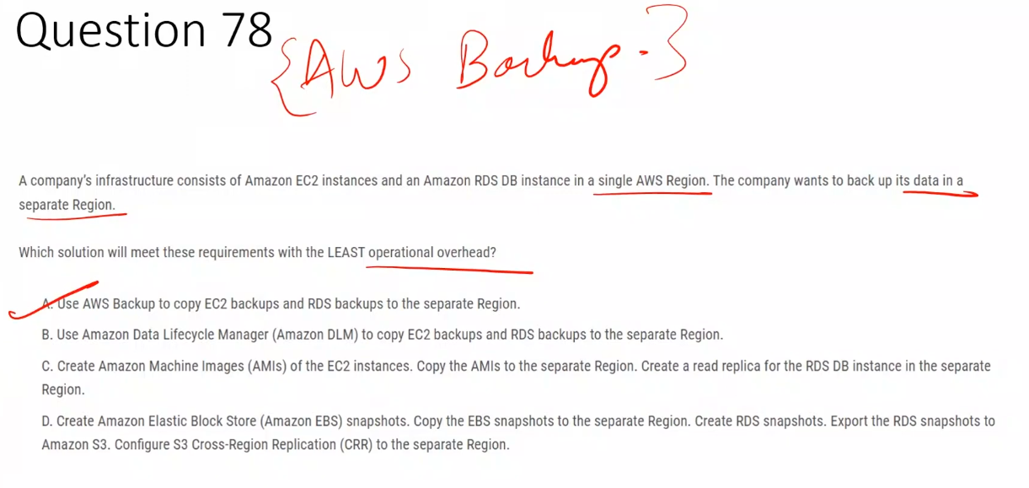

Amazon Data Lifecycle Manager (DLM) is used to automate the creation, retention, and deletion of EBS snapshots and EBS-backed AMIs.

Here are the key uses of Amazon DLM:

* Automated backup management: Eliminates the need for custom scripts to manage EBS snapshots by automating snapshot creation and deletion based on schedules you define
* Cost optimization: Helps reduce storage costs by automatically deleting old snapshots according to your retention policies
* Simplified operations: Reduces operational complexity through a simple, policy-based approach to managing backups
* Tag-based policies: Creates lifecycle policies based on resource tags assigned to EBS volumes or EC2 instances
* Compliance and data protection: Ensures regular backups are taken according to your organization's requirements
* Regional and account-specific: Policies apply to resources within a specific AWS account and Region

The best part is that Amazon DLM is free to use and available in all AWS Regions. You only pay for the storage costs of the snapshots themselves.

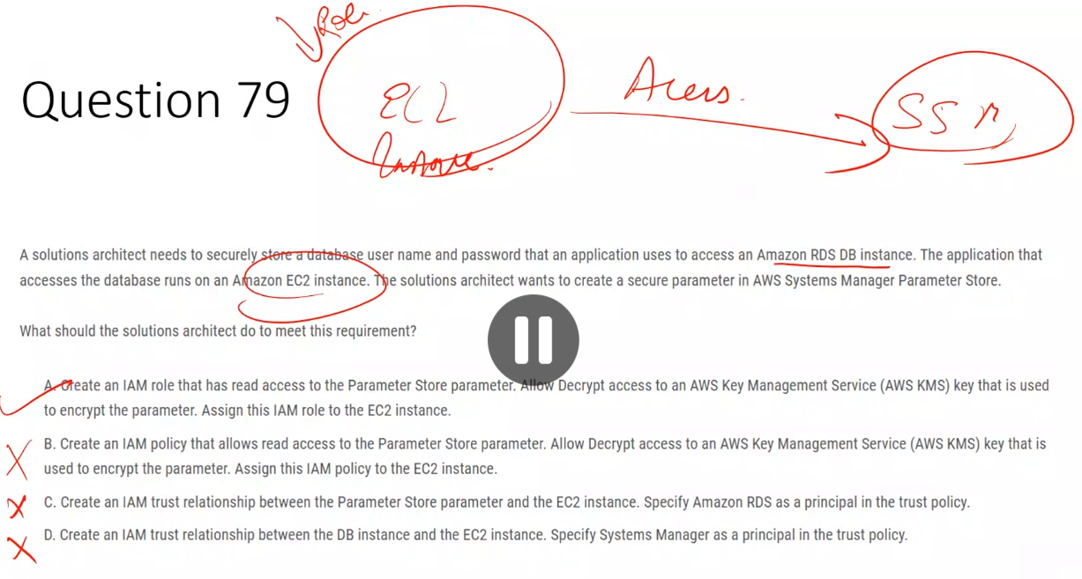

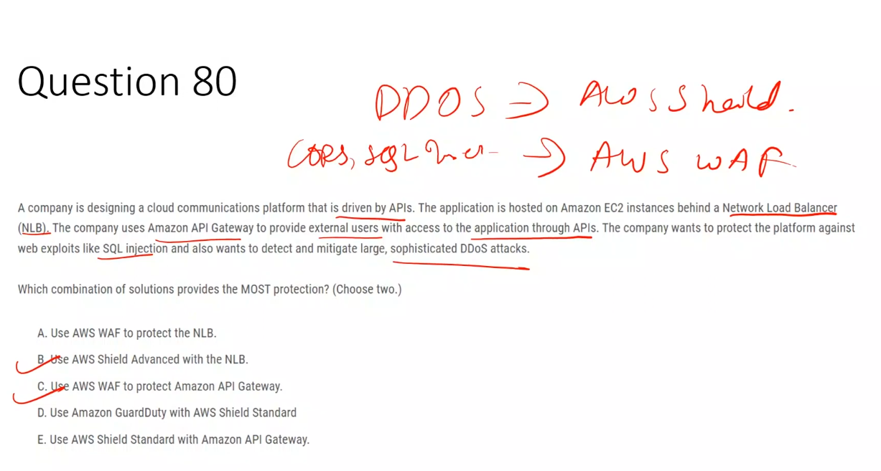

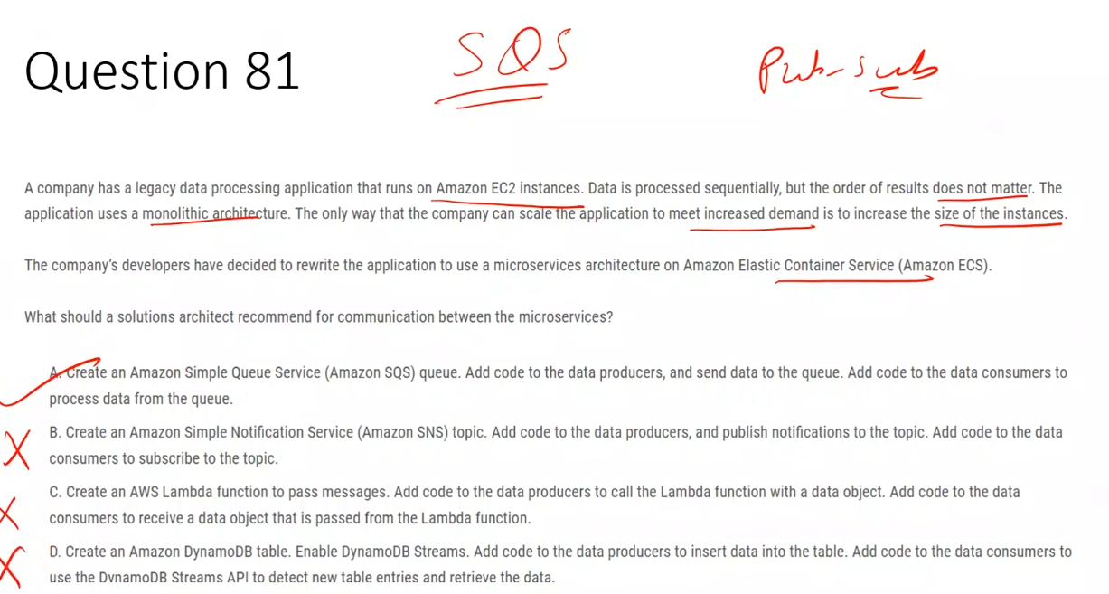

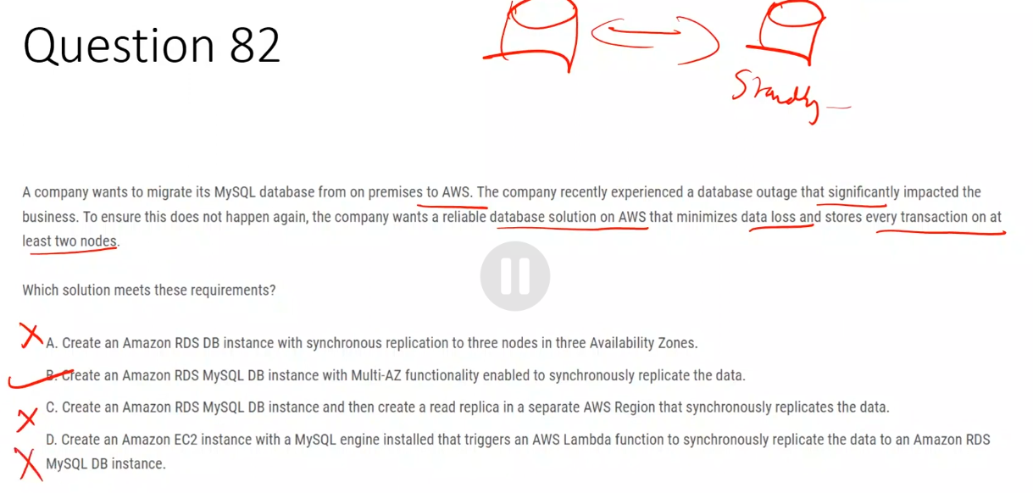

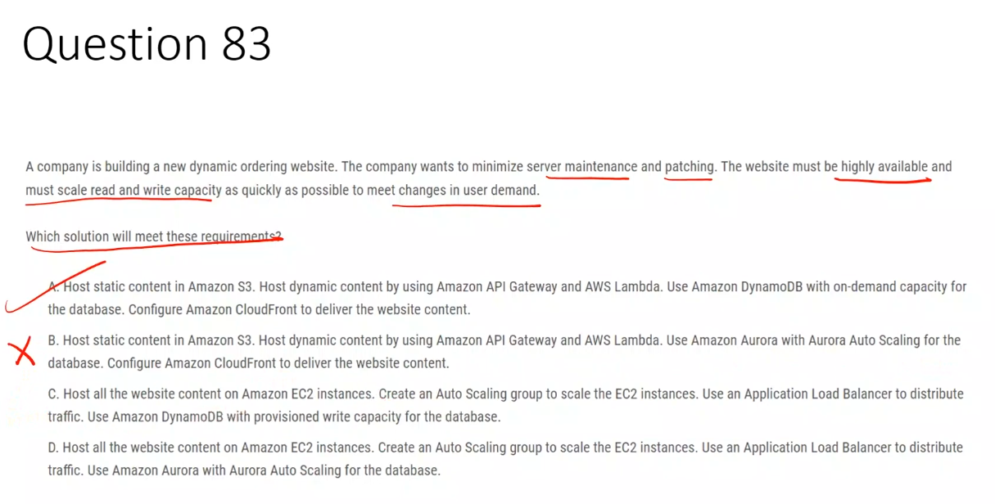

Aurora still requires database maintenance and does not scale read/write capacity as instantly as DynamoDB on-demand, violating the requirement for minimal maintenance and rapid scaling.

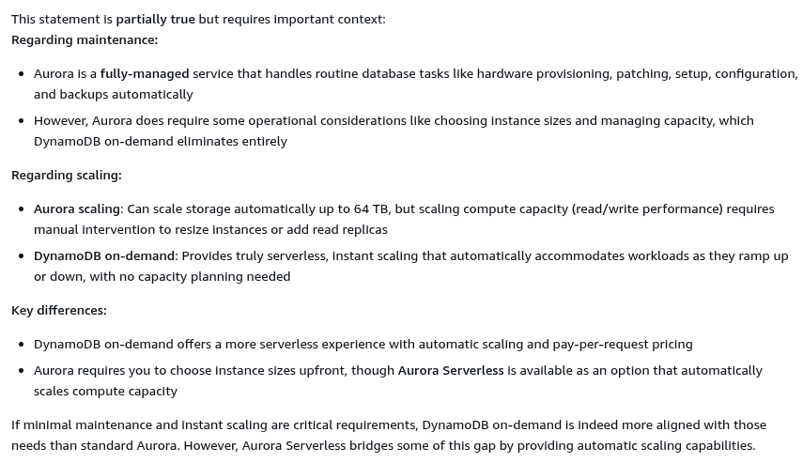

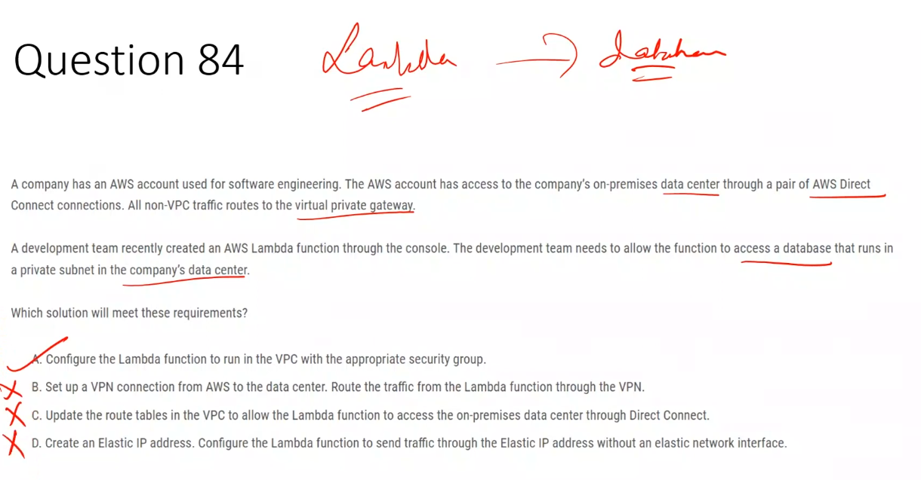

Route tables decide *where* traffic can go.  
 Security groups decide *whether* traffic is allowed.

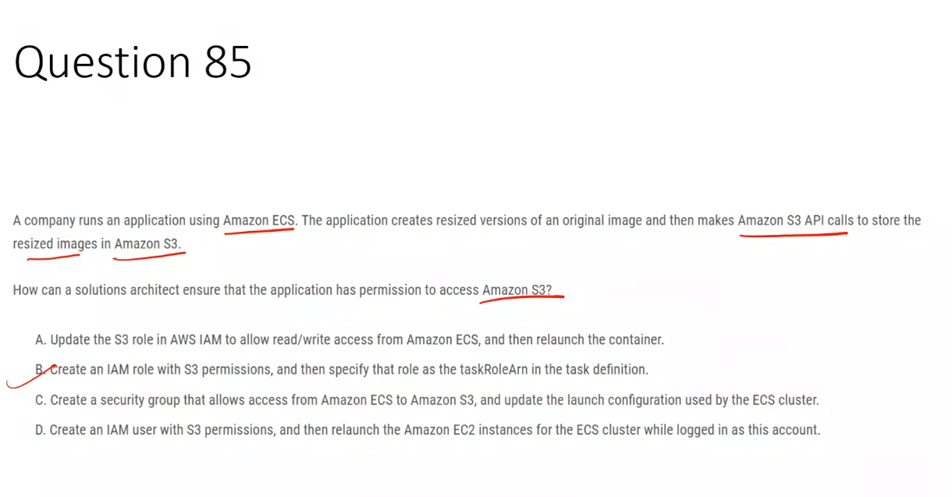

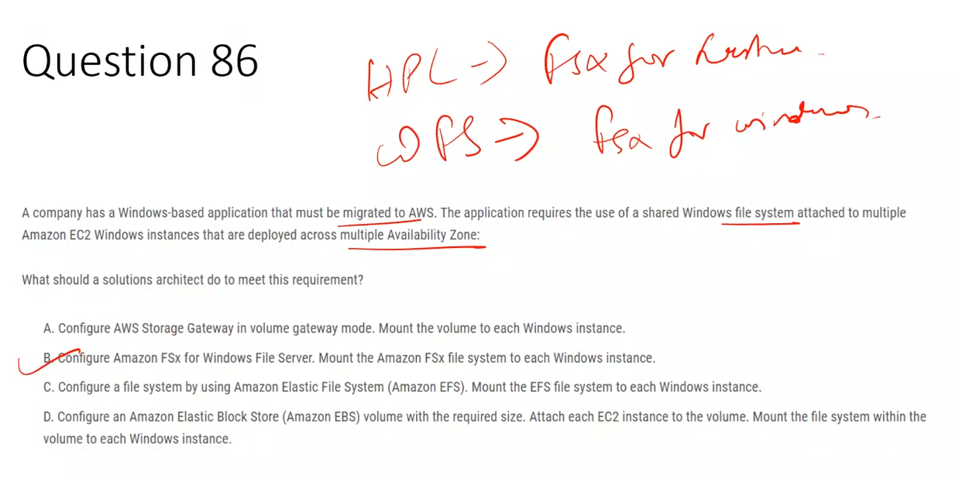

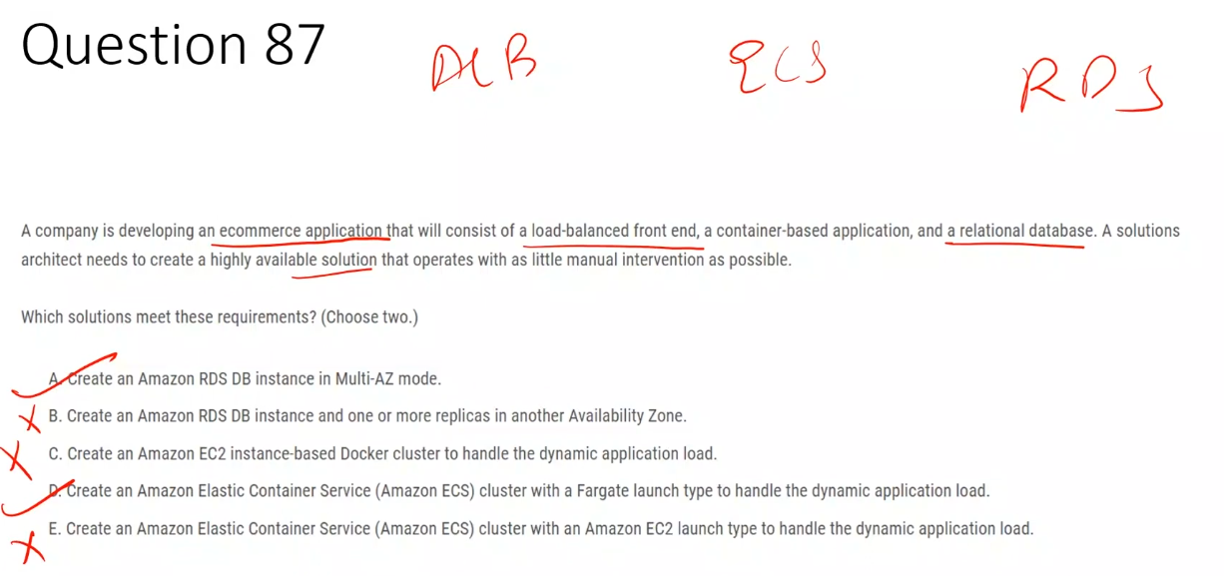

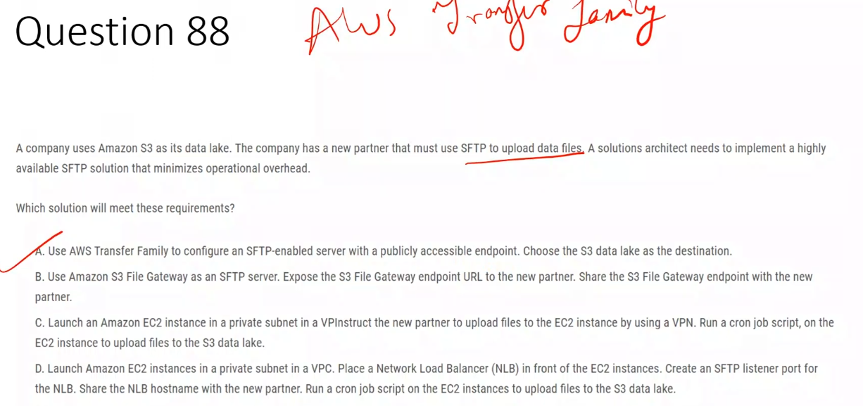

## **Why S3 File Gateway is NOT correct**

### **1️⃣ It is NOT an SFTP server**

* S3 File Gateway exposes:
  + **NFS**
  + **SMB**
* ❌ It does **NOT support SFTP**

So the partner **cannot connect using SFTP at all**.

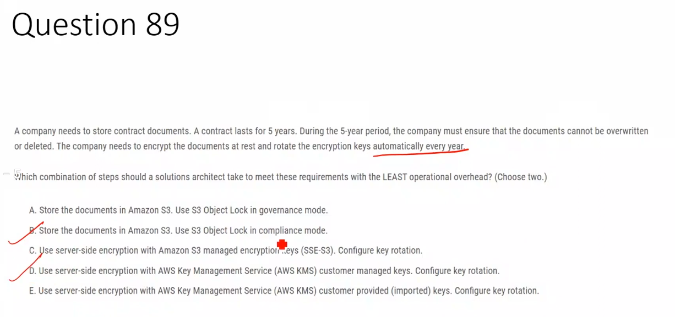

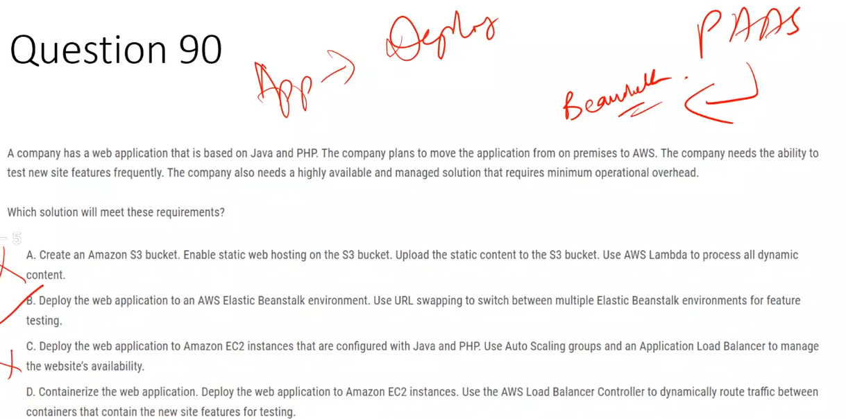

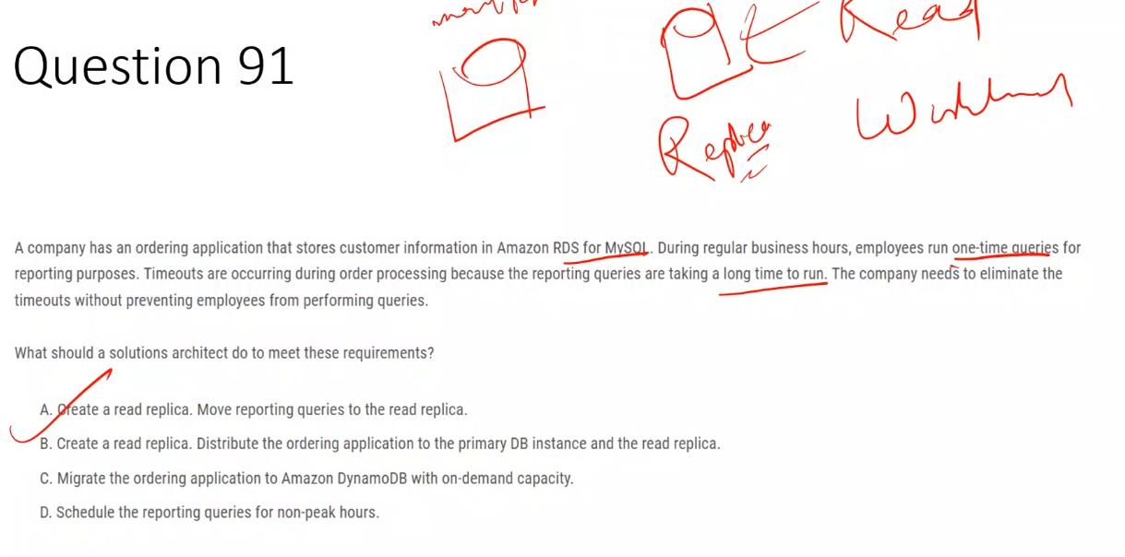

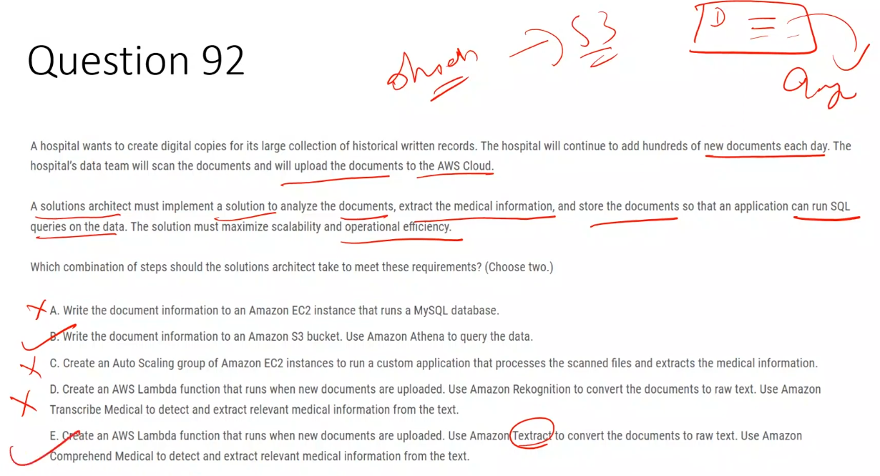

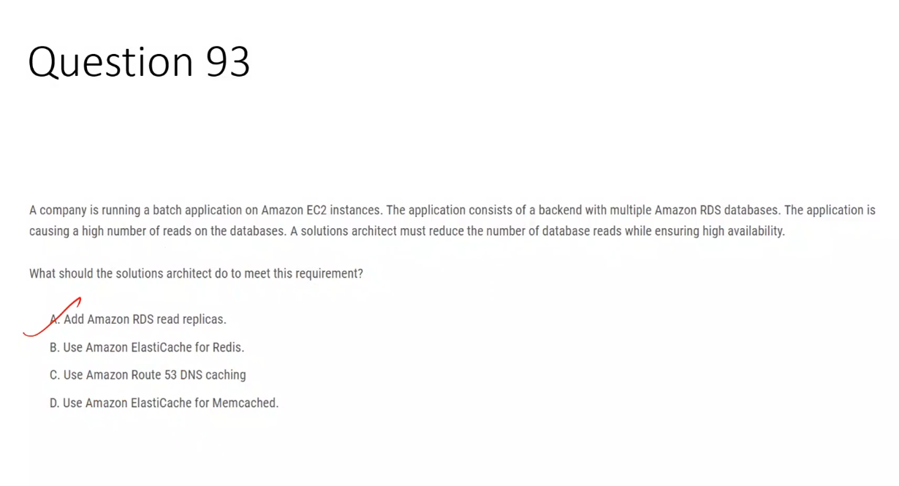

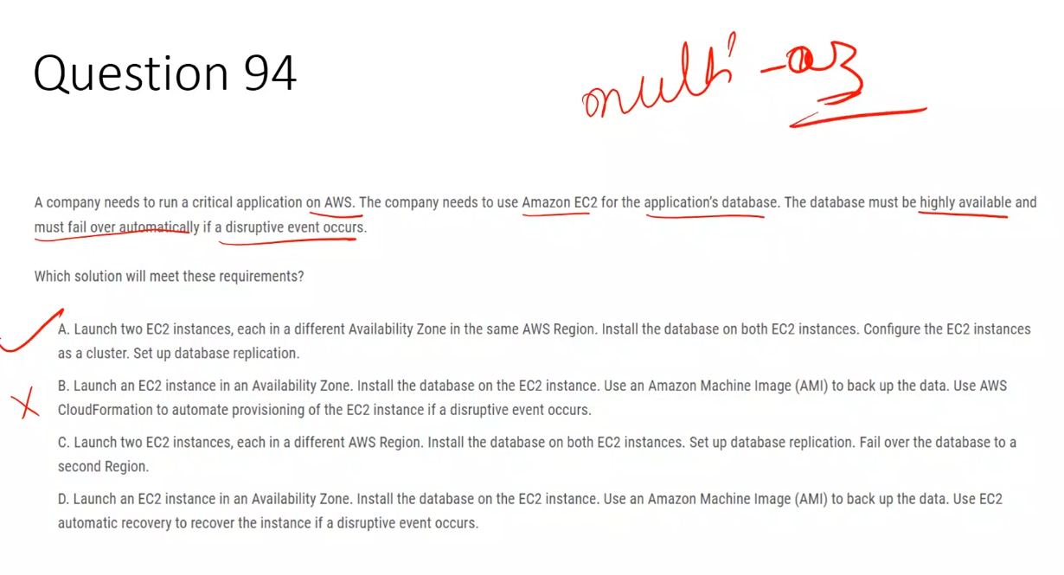

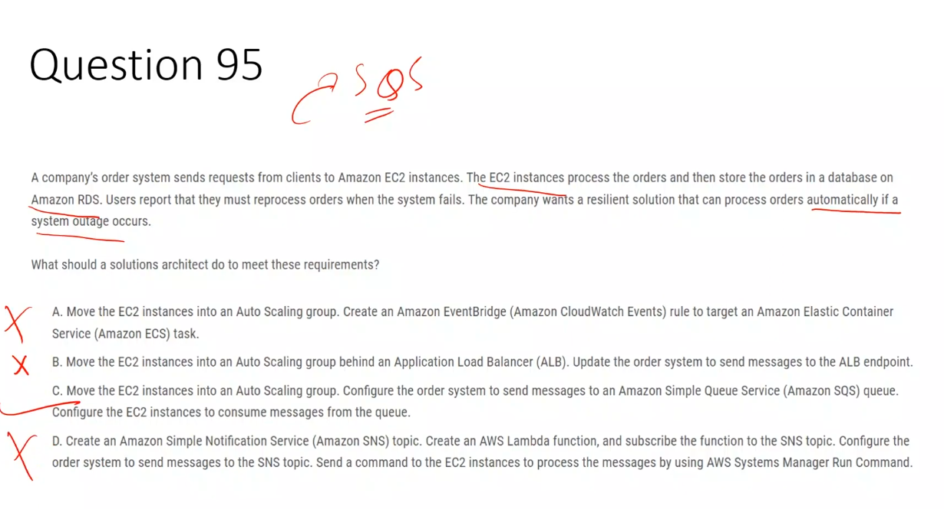

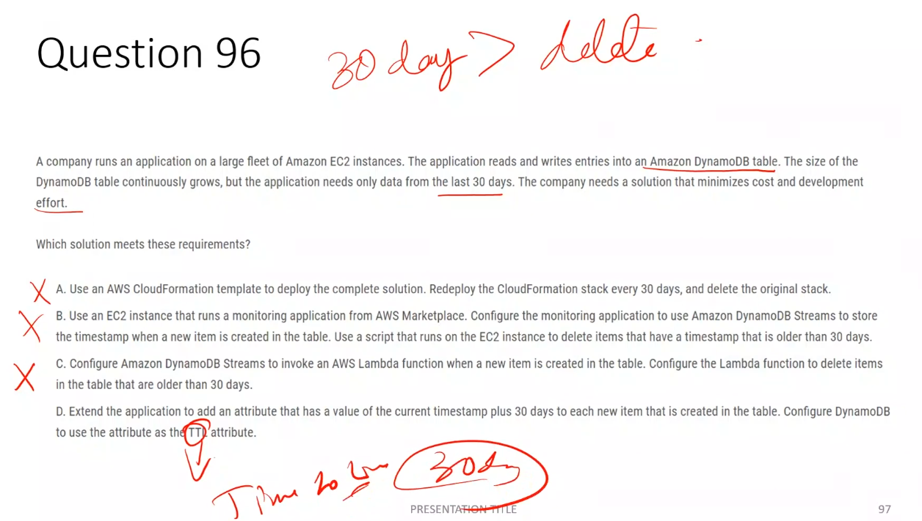

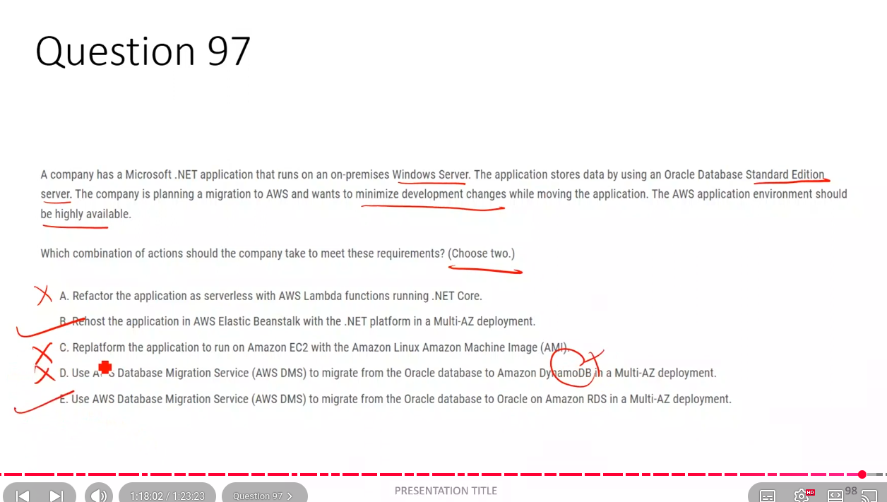

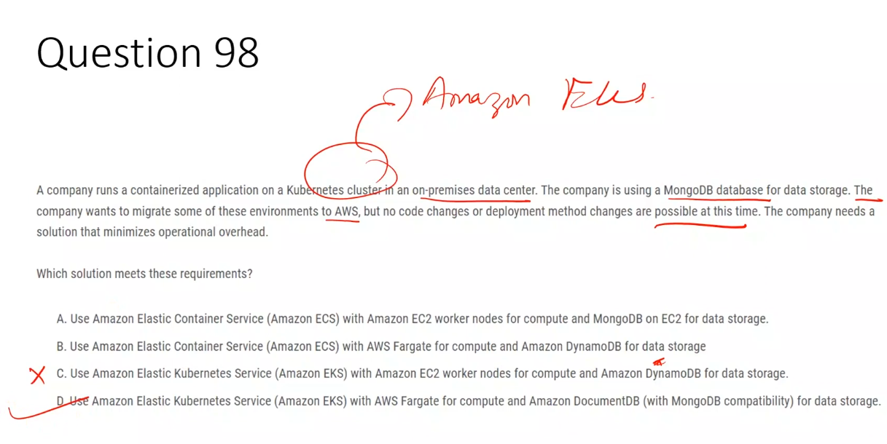

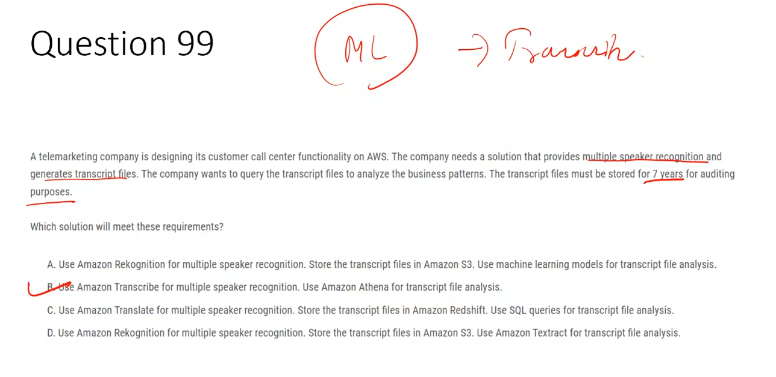

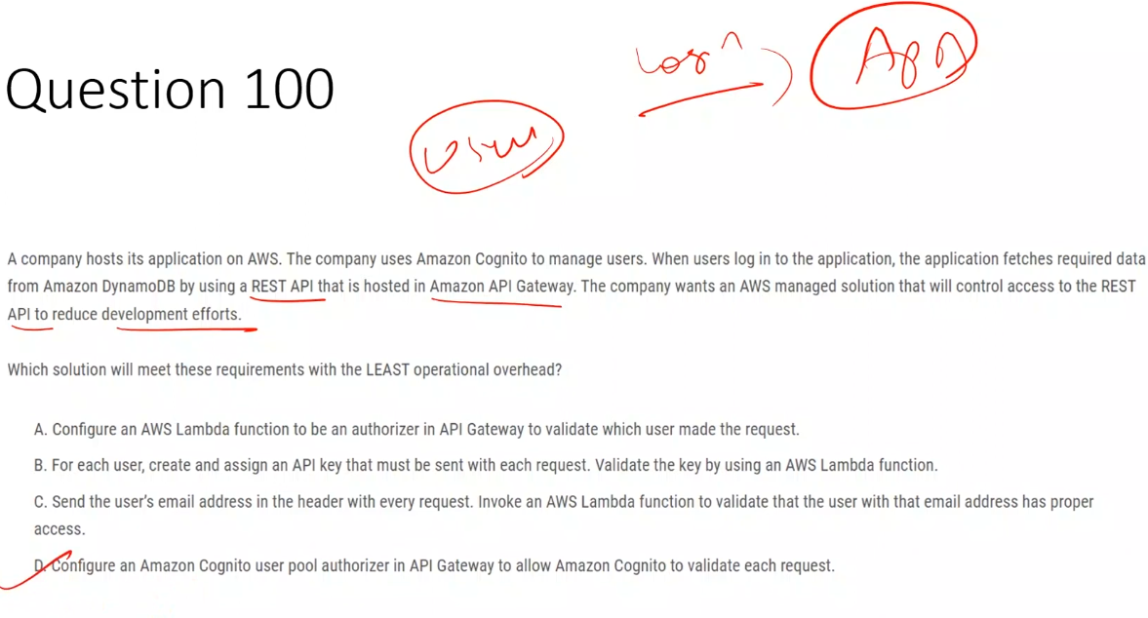

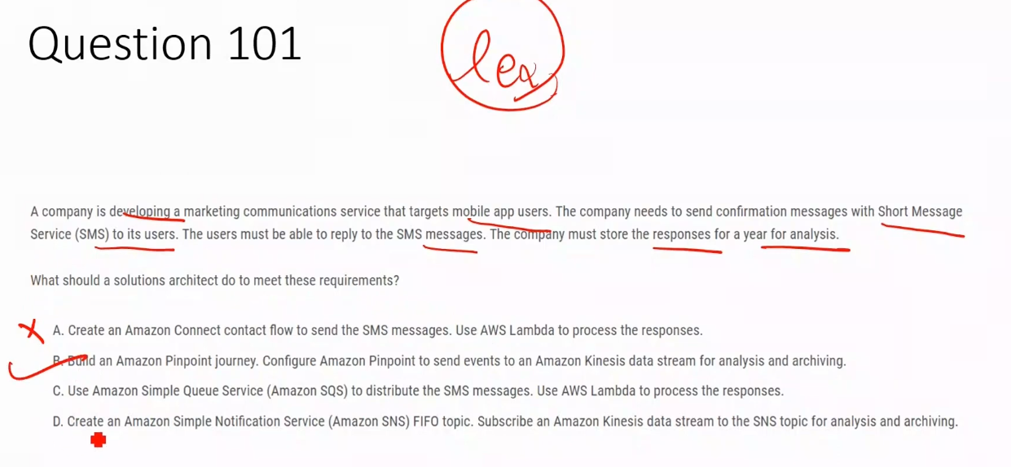

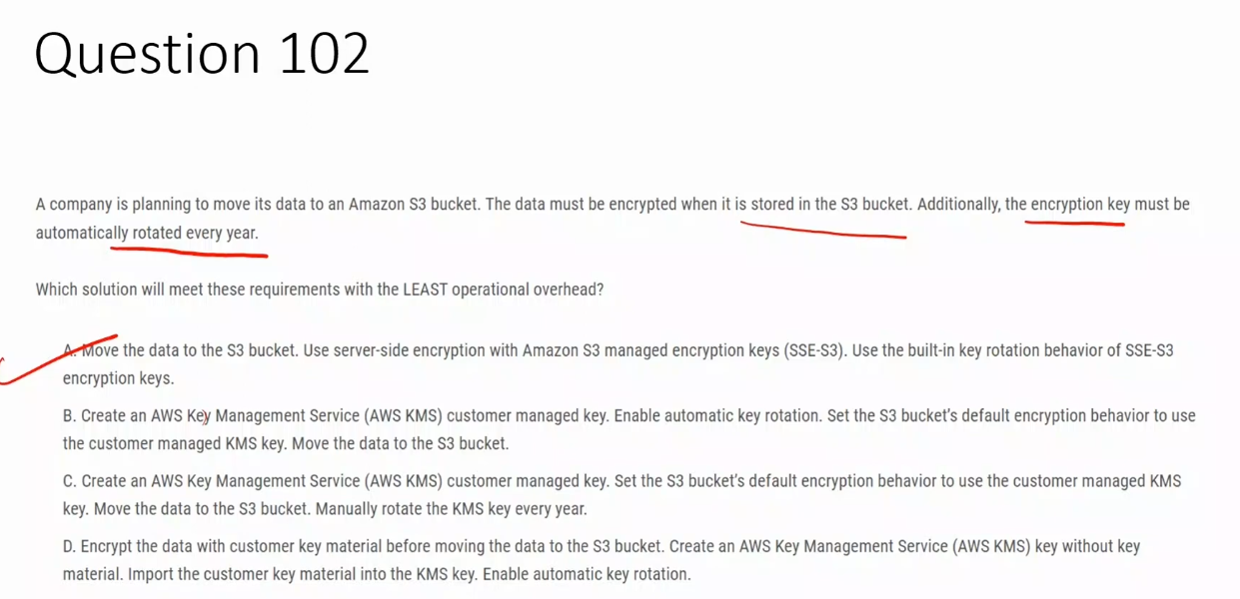

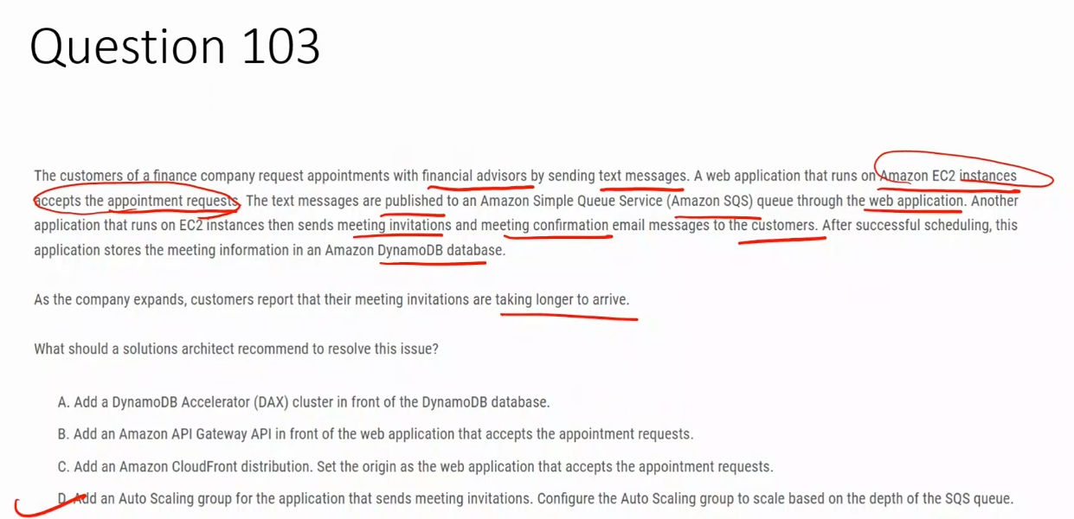

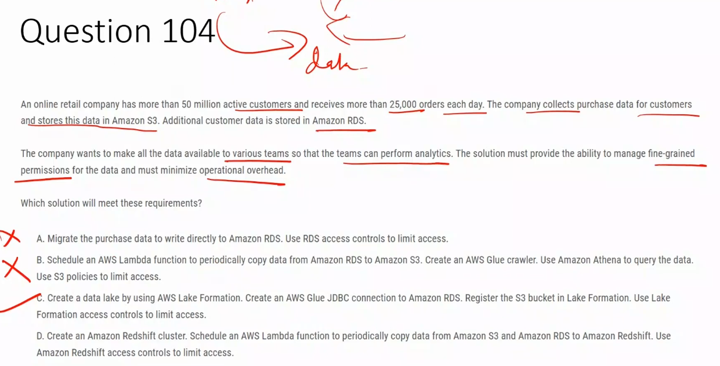AWS Glue JDBC connections are used to connect AWS Glue ETL jobs to various relational databases for extracting, transforming, and loading data.

Key uses of AWS Glue JDBC connections:

* Connect to multiple database types: Supports Amazon Redshift, Amazon Aurora, Microsoft SQL Server, MySQL, Oracle, PostgreSQL, MariaDB, and Snowflake
* Hybrid environments: Enables access to on-premises databases through VPN or AWS Direct Connect, allowing you to analyze and process data from on-premises data stores
* ETL operations: Extract data from JDBC-accessible databases, transform it using AWS Glue, and load results back to S3, VPC data stores, or on-premises databases
* Reusable configurations: Store connection details (credentials, URI strings, VPC information) in the AWS Glue Data Catalog, eliminating the need to specify connection details for every job
* Secure connectivity: Uses elastic network interfaces (ENIs) in your VPC to establish secure connections to databases

How it works: When you create a JDBC connection in AWS Glue, you specify the database type, connection URL, credentials, and network configuration. This connection can then be referenced in your ETL jobs to read from or write to the database without repeatedly entering connection details.

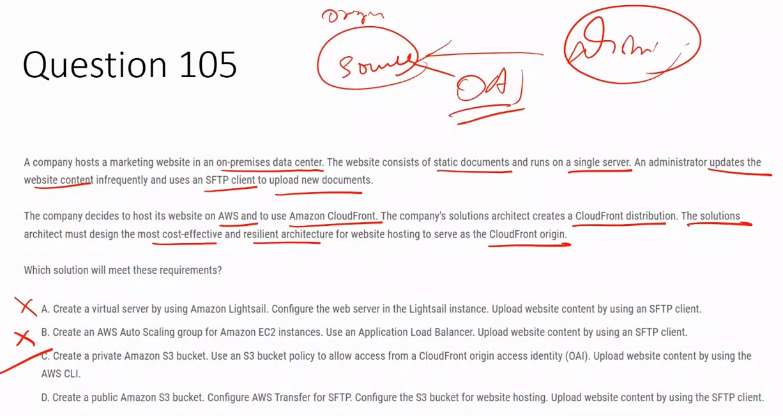

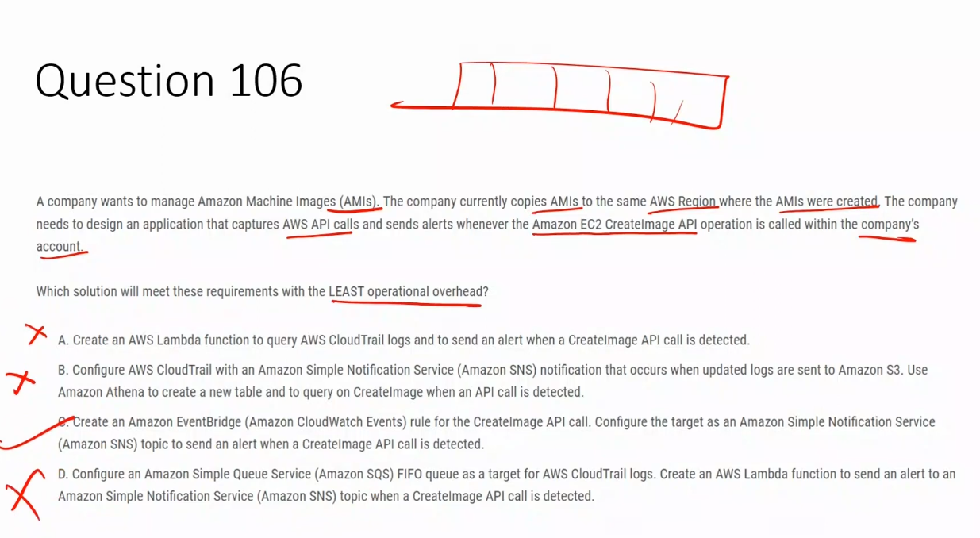

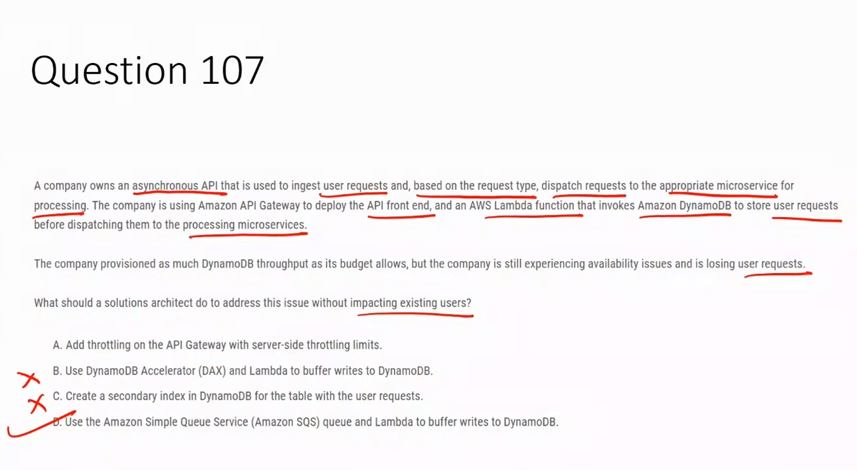

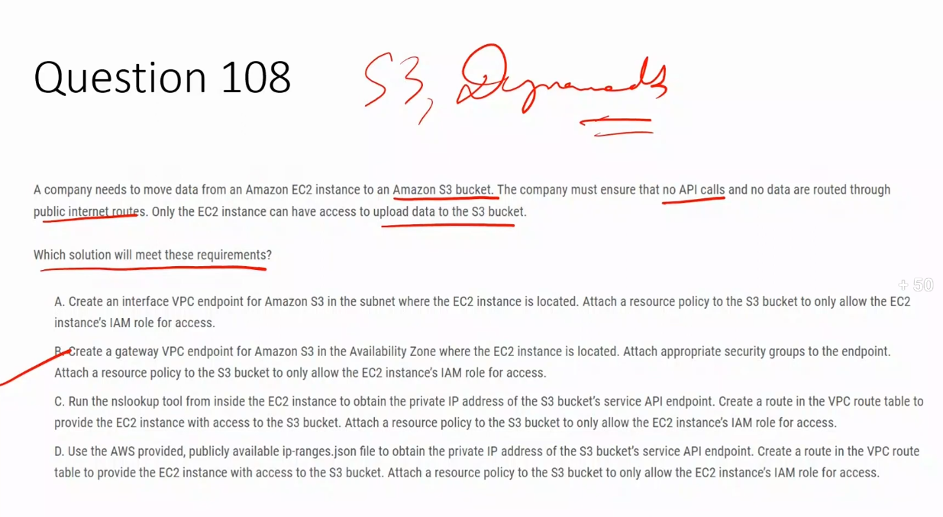

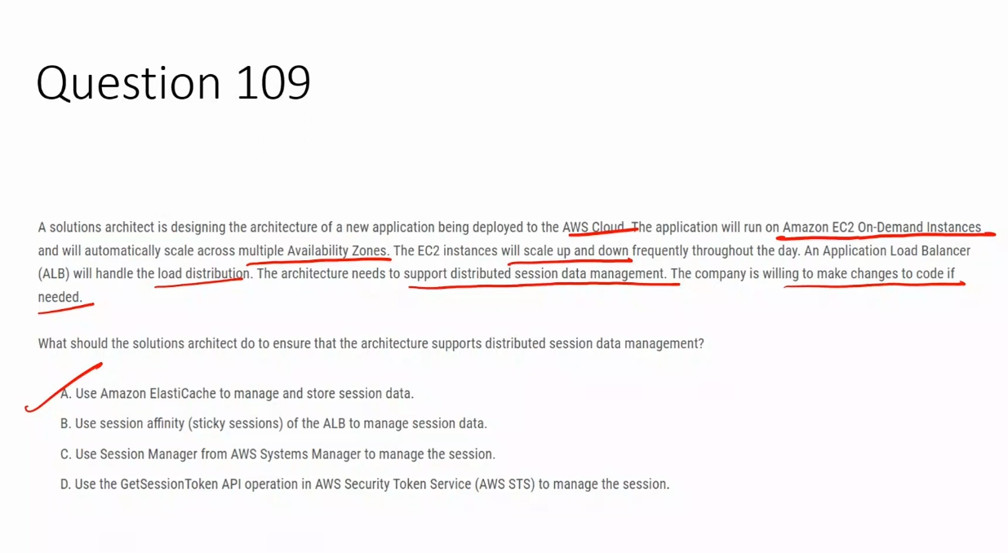

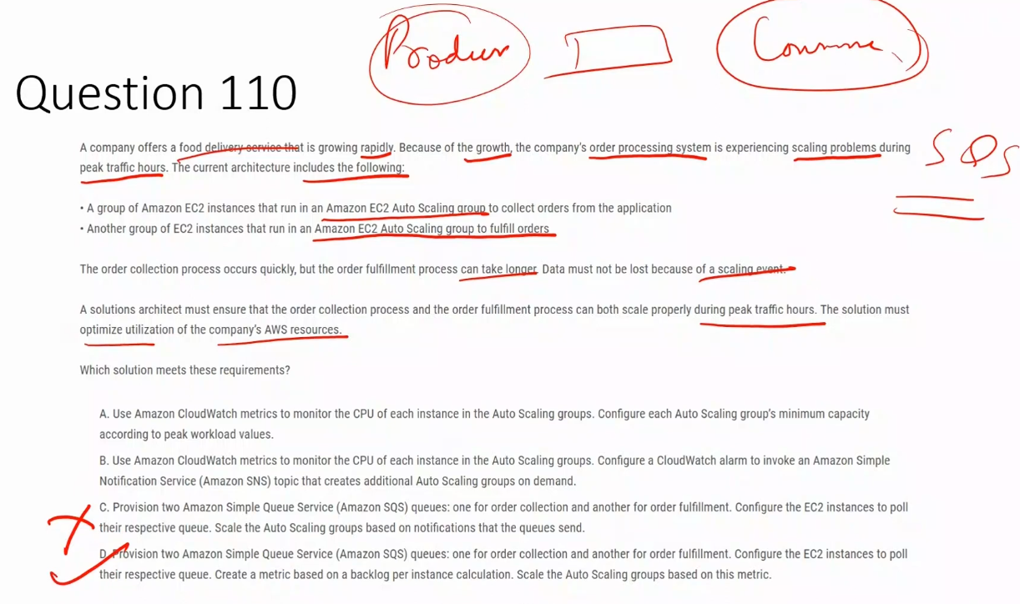

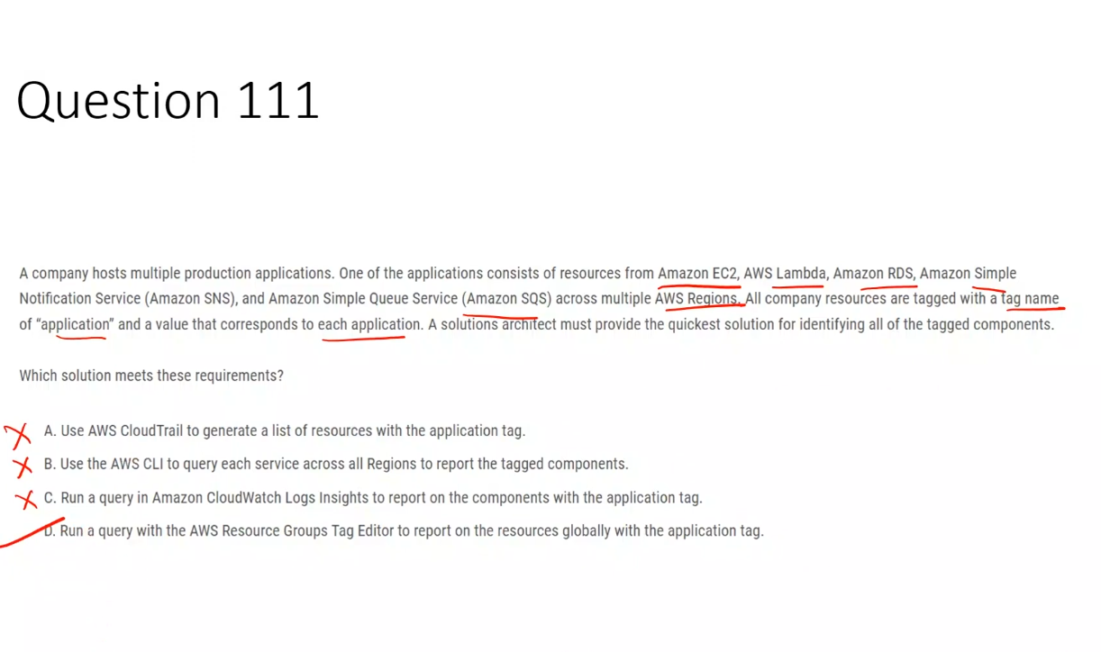

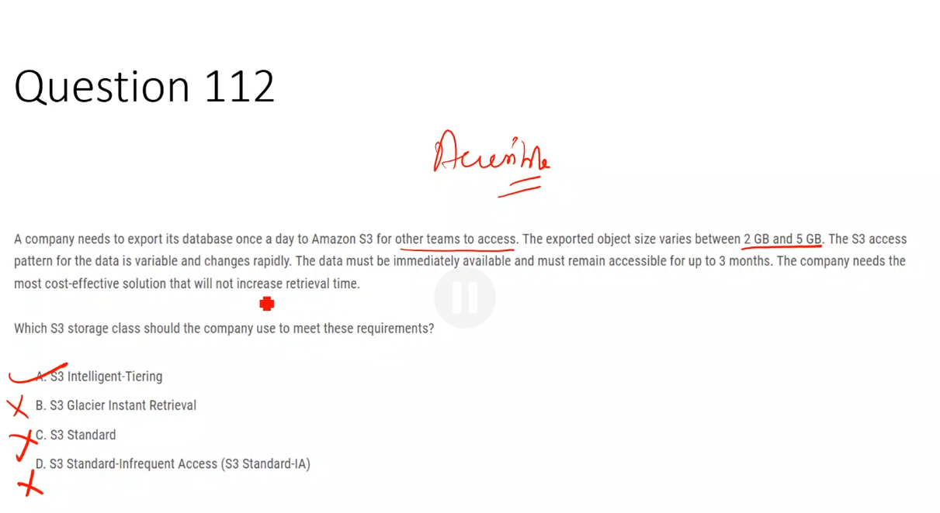

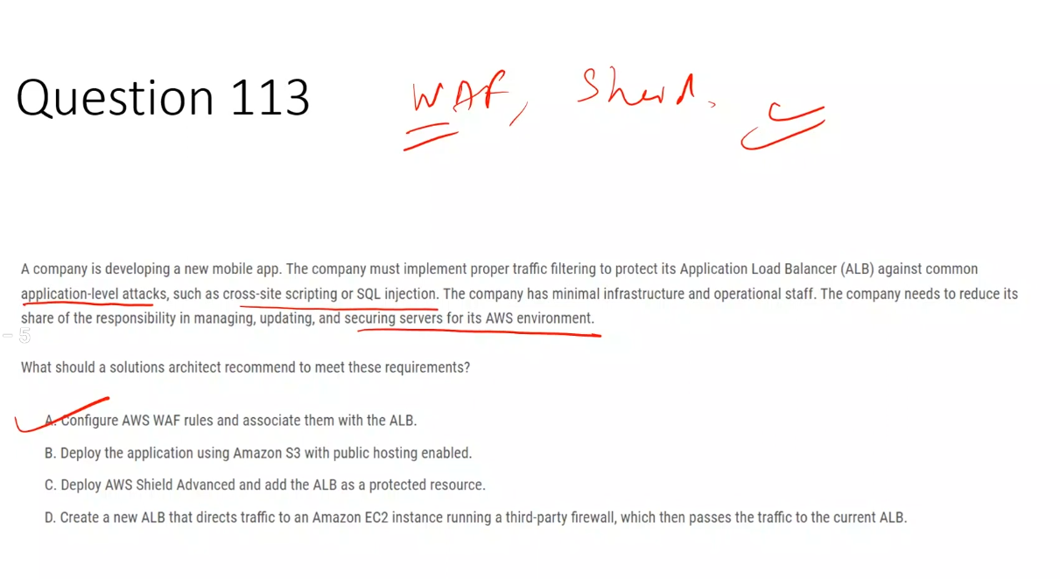

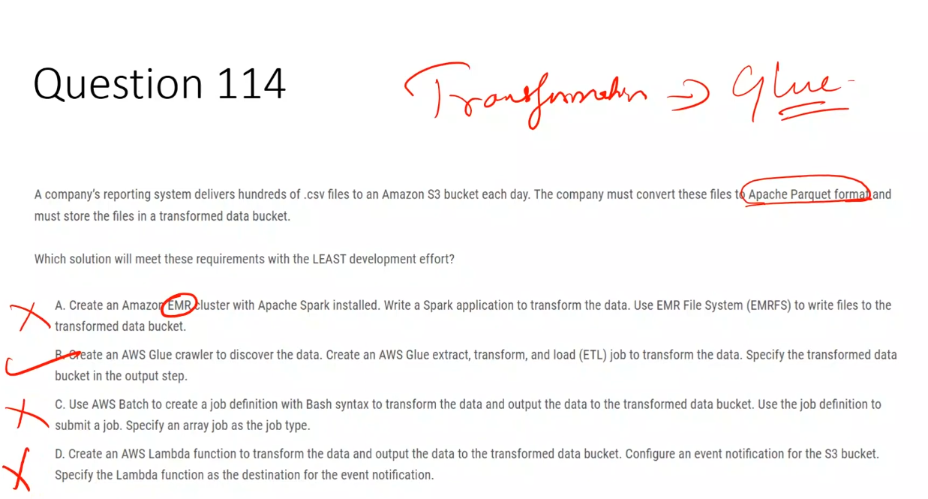

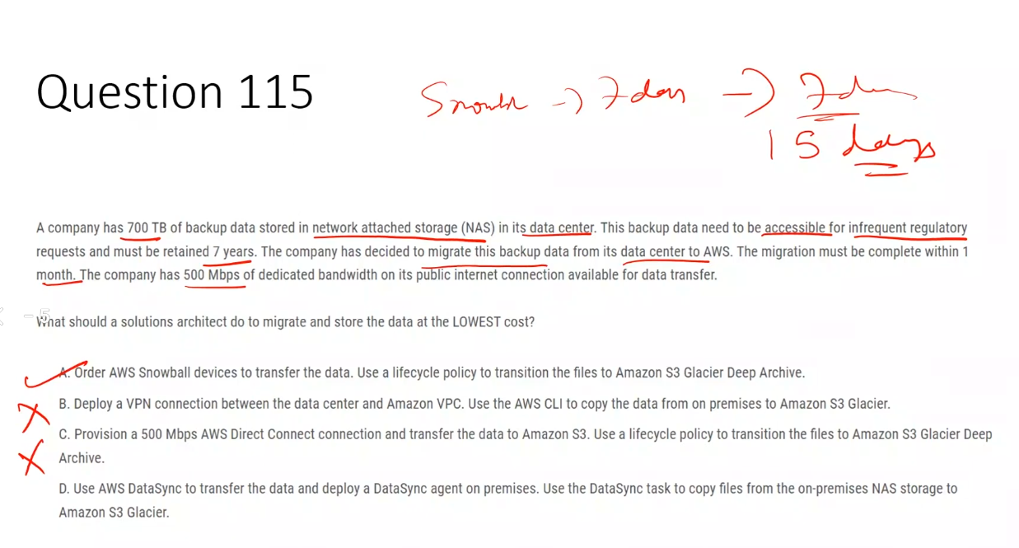

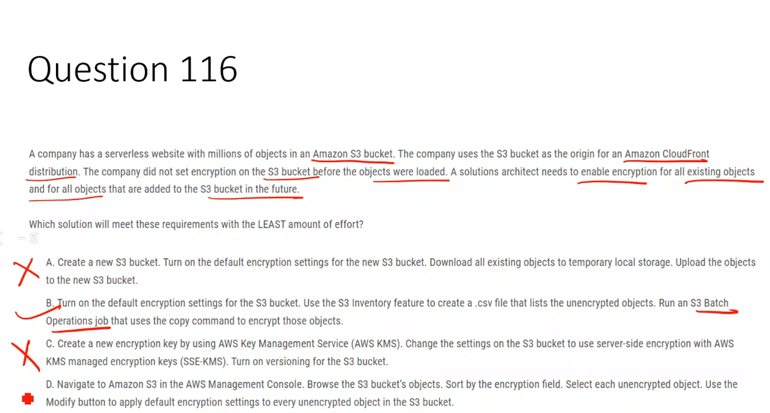

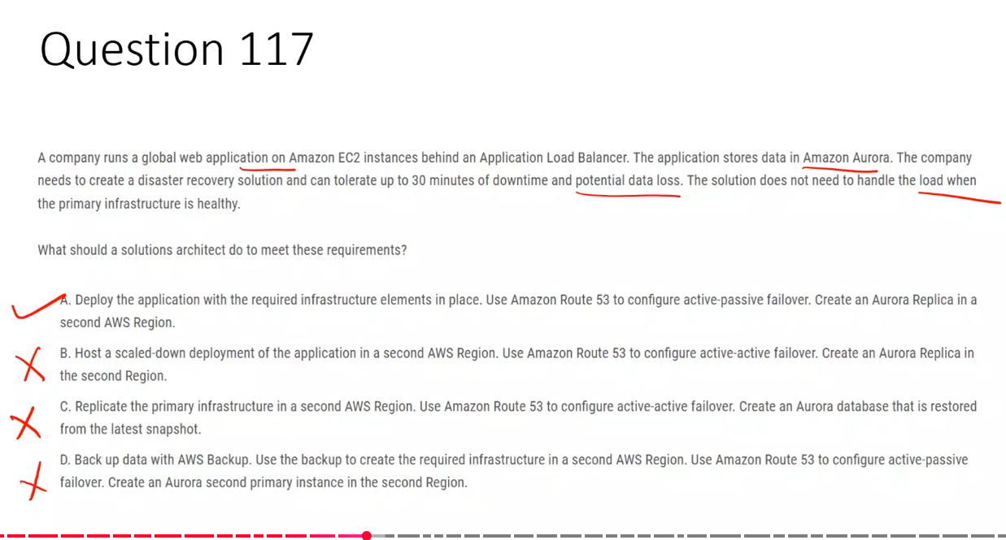

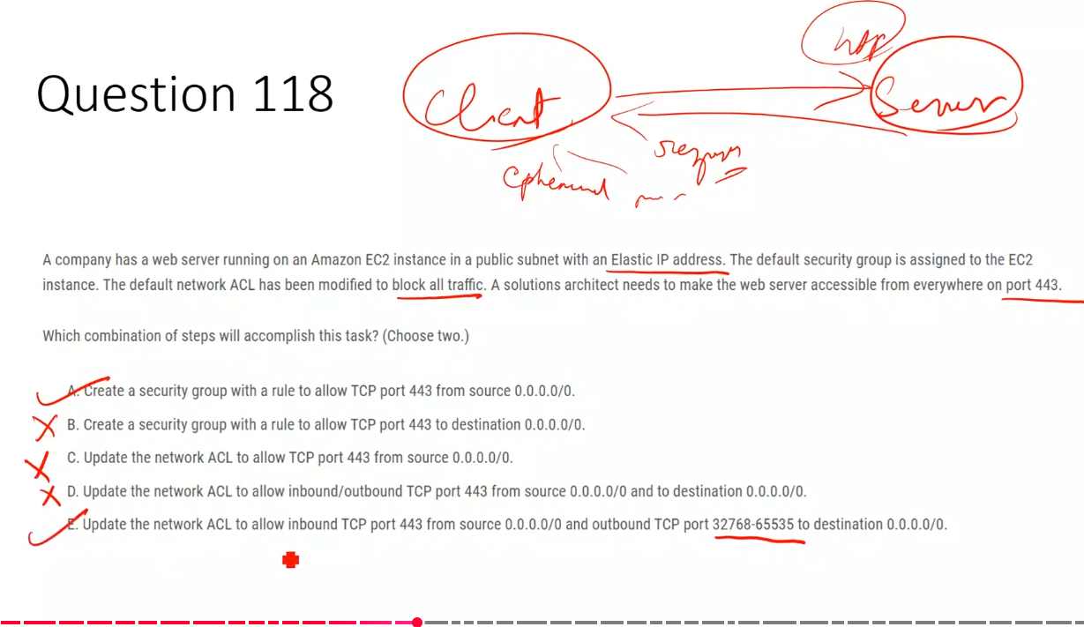

**32768–65535 is the ephemeral (temporary) port range used by clients for TCP responses.**

### **What happens in an HTTPS connection**

When a client connects to your server:

1. The **server listens** on a **well-known port**
   1. HTTPS → **443**
2. The **client does NOT use port 443**
   1. Client picks a **random high-numbered port**
   2. This is called an **ephemeral port**

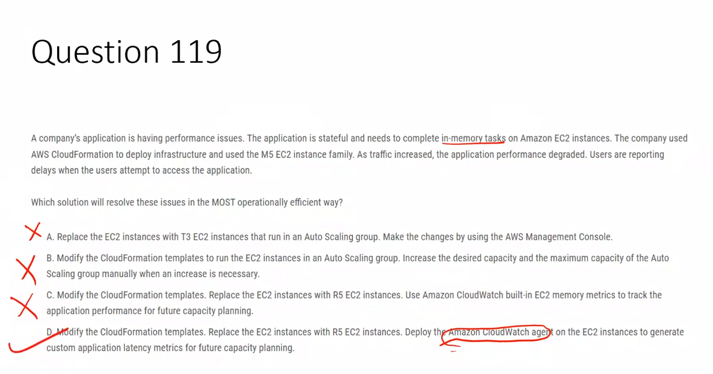

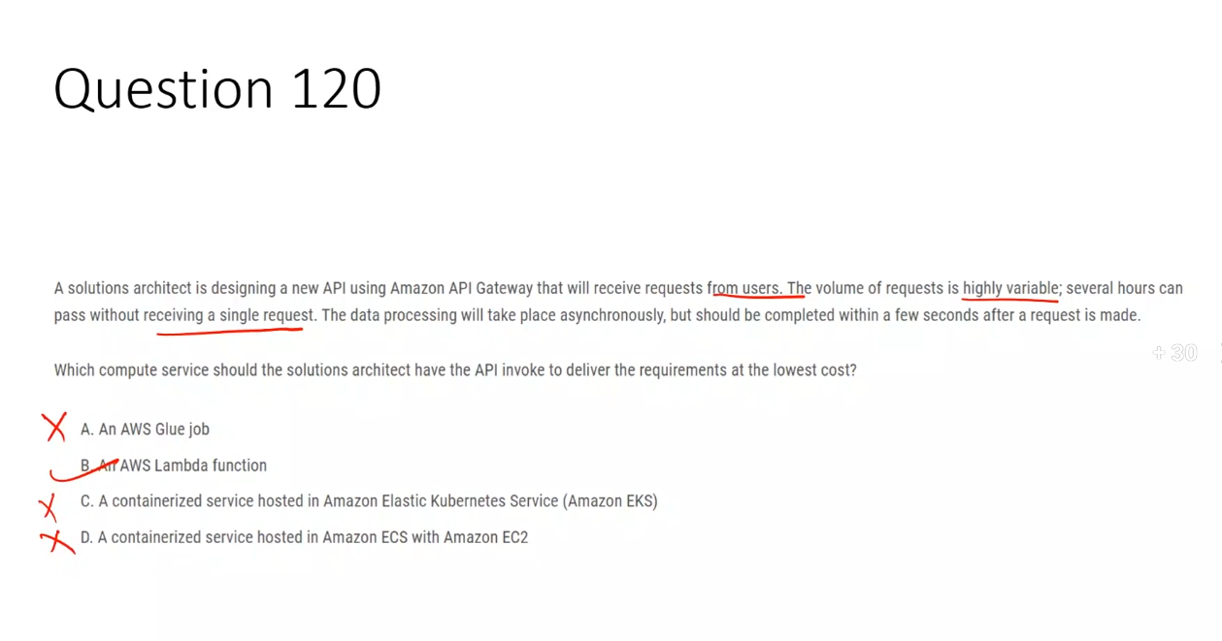

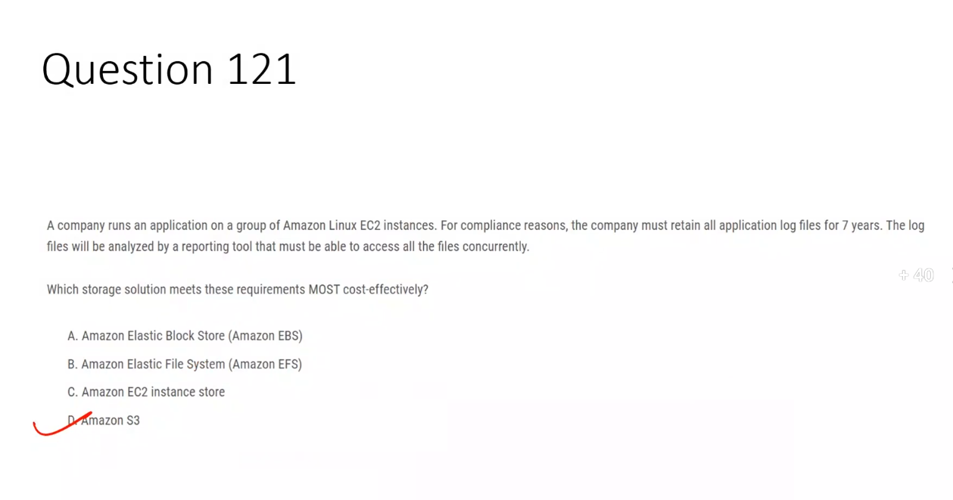

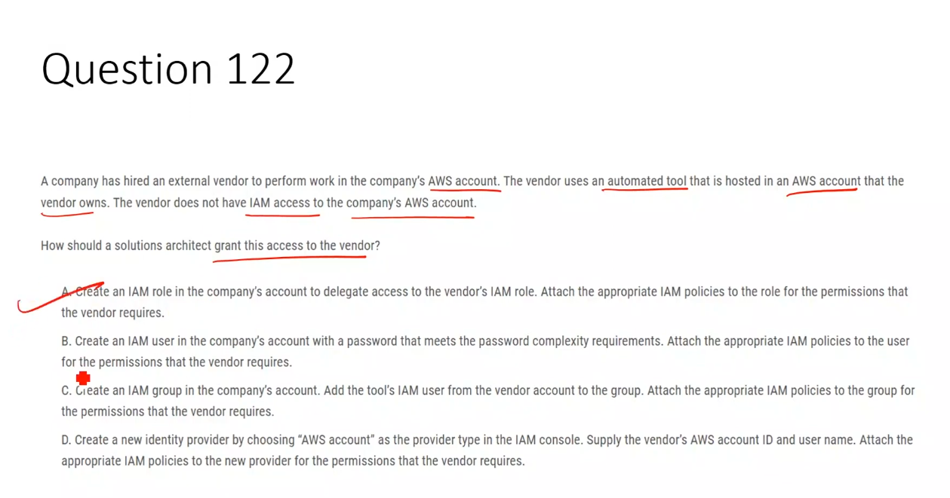

### **✅ Correct Answer: Option A (Single-paragraph explanation)**

Option A is correct because the vendor’s tool runs in the vendor’s own AWS account and needs **secure, temporary access** to the company’s AWS account without creating IAM users or sharing credentials. By creating an **IAM role in the company’s account** with the required permissions and configuring a **trust policy** that allows the vendor’s AWS account to assume the role, the vendor can use **STS AssumeRole** (via console “Switch Role” or programmatically) to access only the permitted resources. This approach follows AWS best practices for **cross-account access**, provides least privilege, is auditable, and avoids long-term credentials—making it the **correct and secure solution**.

### **❌ Why the other options are incorrect**

**Option B:**  
 ❌ Creates an IAM user in the company’s account, which violates best practices and increases security risk by requiring password or long-term credentials for an external vendor.

**Option C:**  
 ❌ You cannot add an IAM user from another AWS account into an IAM group; IAM groups are account-local only and do not support cross-account users.

**Option D:**  
 ❌ IAM identity providers are used for federation (SAML/OIDC), not for standard AWS account-to-account access; this overcomplicates the solution and does not match the requirement.

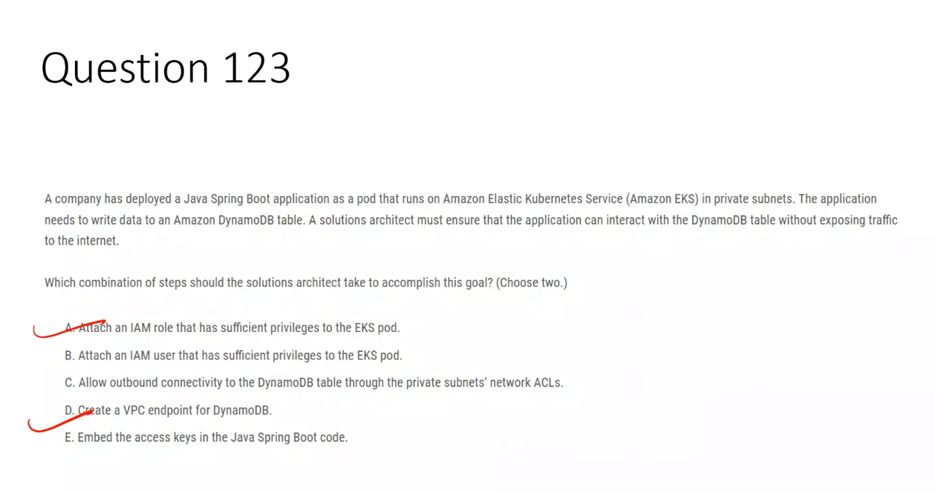

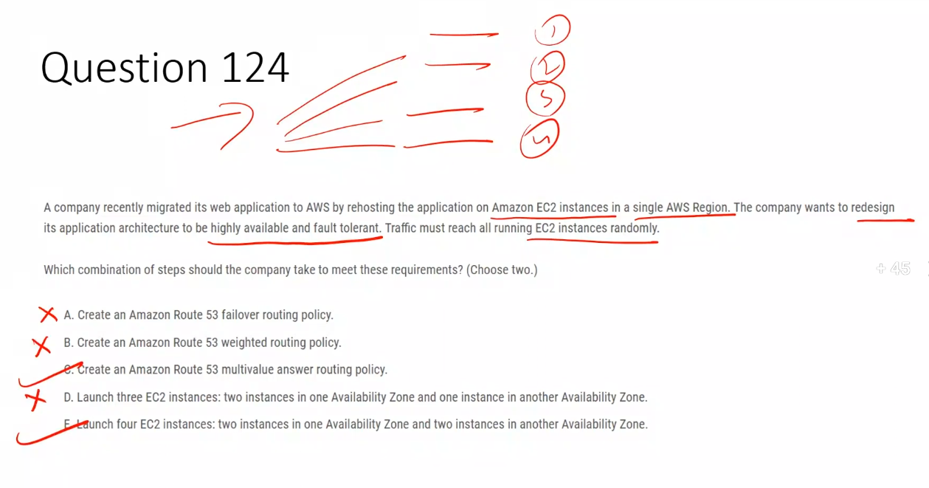

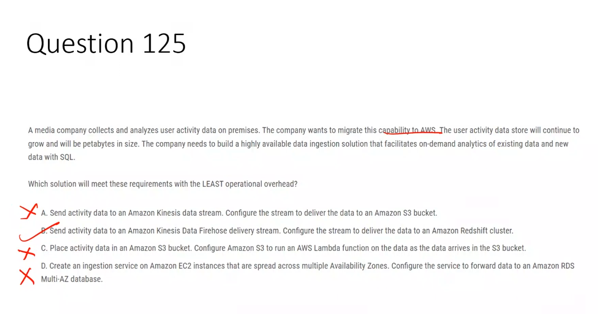**✅ Correct Option**

**B. Send activity data to an Amazon Kinesis Data Firehose delivery stream. Configure the stream to deliver the data to an Amazon Redshift cluster.**  
 ✅ **Correct** because Kinesis Data Firehose is fully managed and highly available, requires no capacity planning, and can directly load streaming data into Amazon Redshift, which supports **SQL-based, on-demand analytics at petabyte scale** with minimal operational overhead.

## **❌ Incorrect Options**

**A. Send activity data to an Amazon Kinesis data stream. Configure the stream to deliver the data to an Amazon S3 bucket.**  
 ❌ Kinesis Data Streams require shard capacity planning and consumer management, and S3 alone does not provide native SQL analytics without additional services like Athena.

**C. Place activity data in an Amazon S3 bucket. Configure Amazon S3 to run an AWS Lambda function on the data as it arrives.**  
 ❌ Lambda is event-driven processing, not suitable for large-scale, petabyte-level analytics or ad-hoc SQL queries on historical and streaming data.

**D. Create an ingestion service on Amazon EC2 instances across multiple AZs and forward data to an Amazon RDS Multi-AZ database.**  
 ❌ Requires high operational overhead (EC2 management) and Amazon RDS is not designed for petabyte-scale analytics workloads.

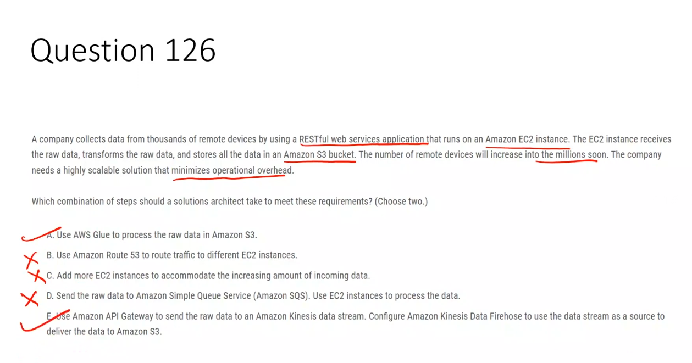

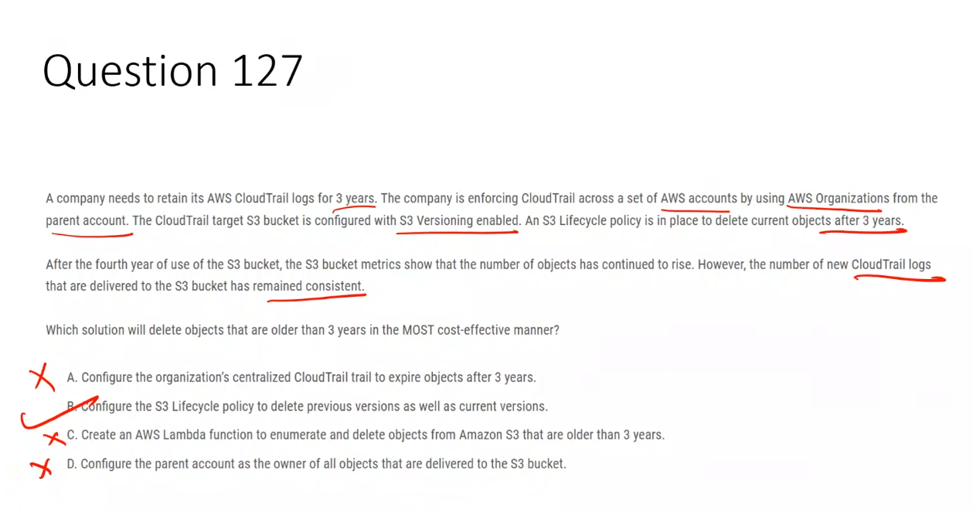

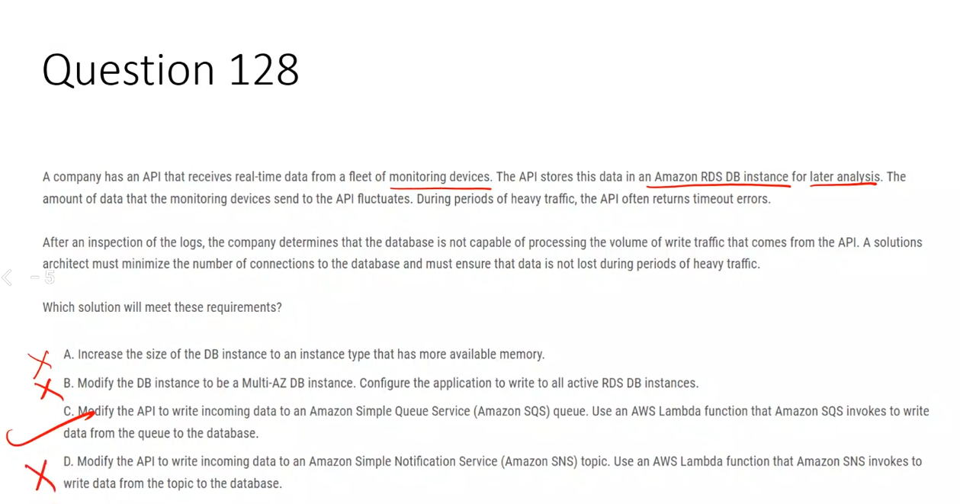

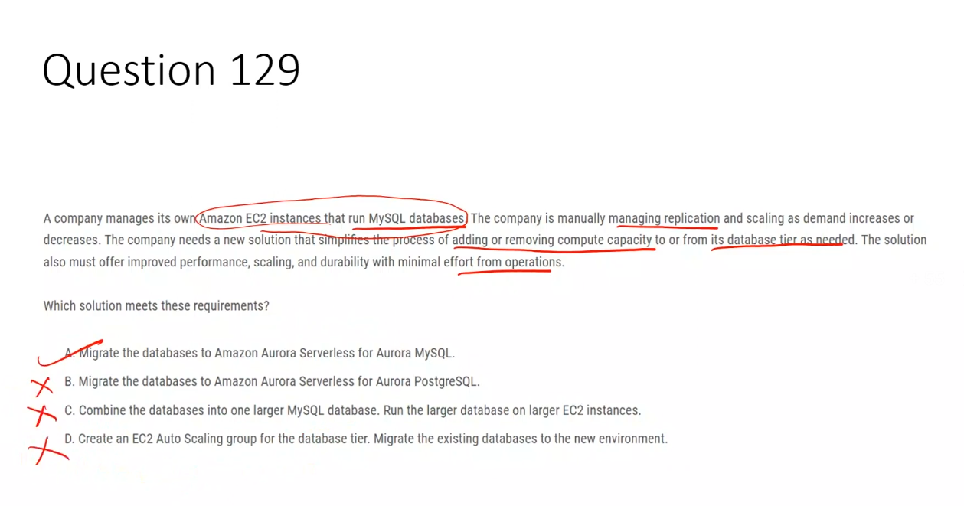

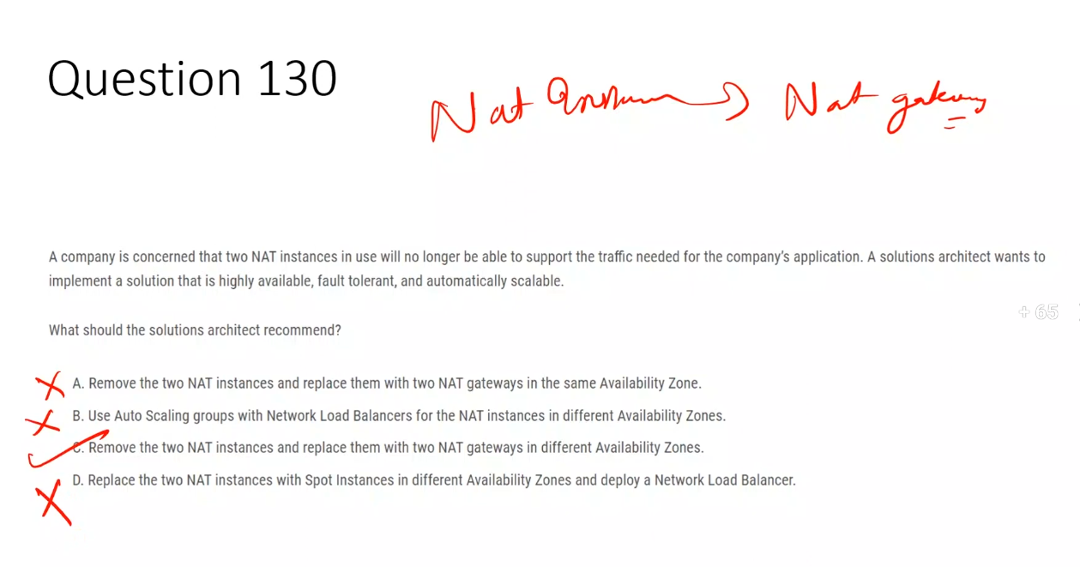

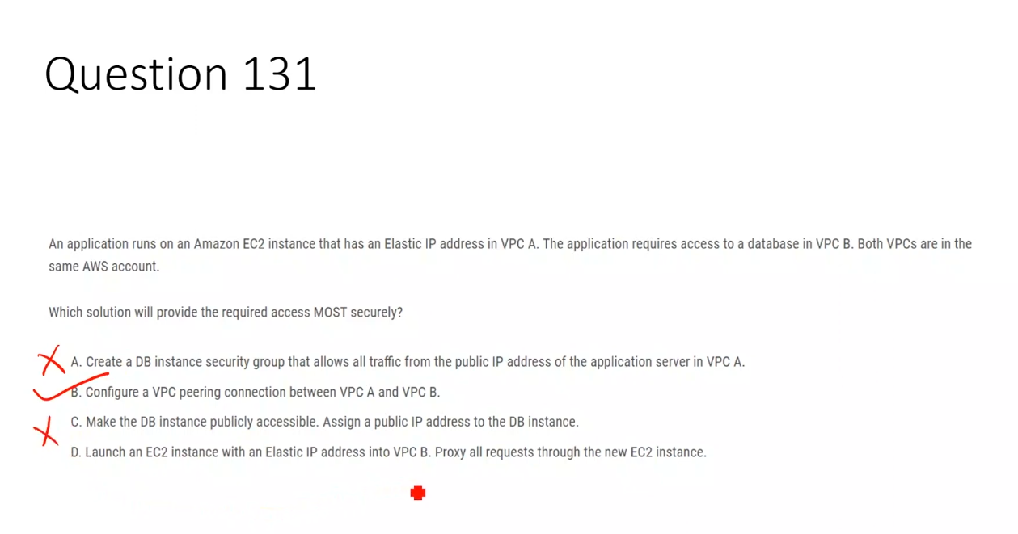

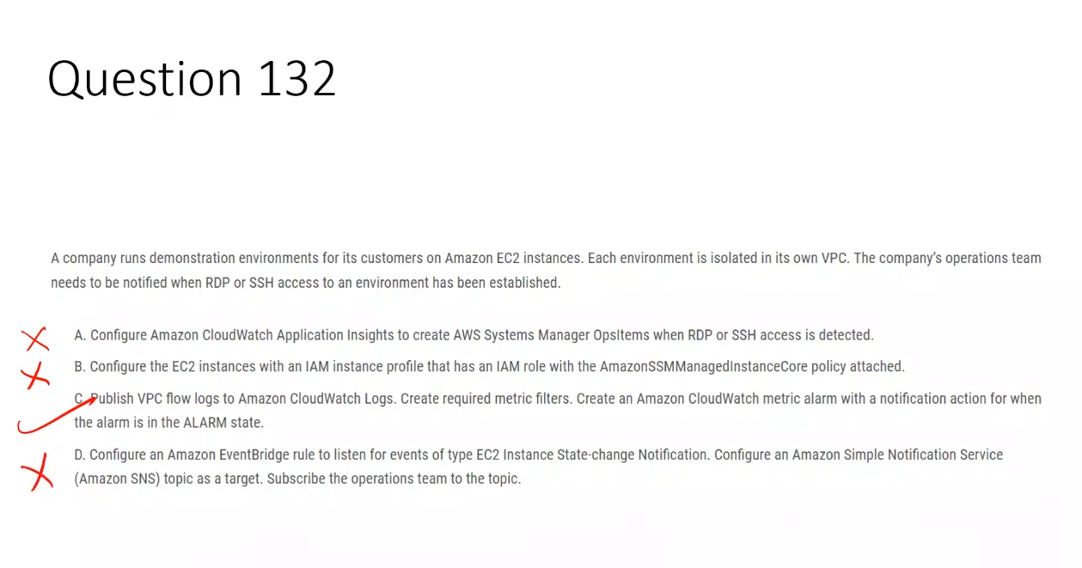

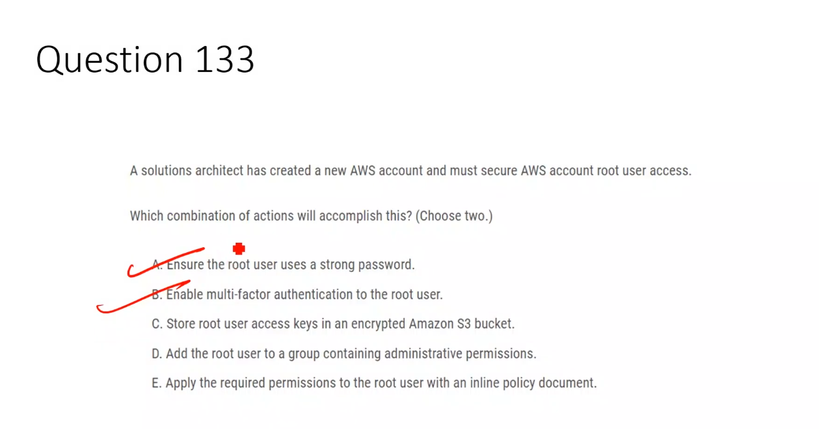

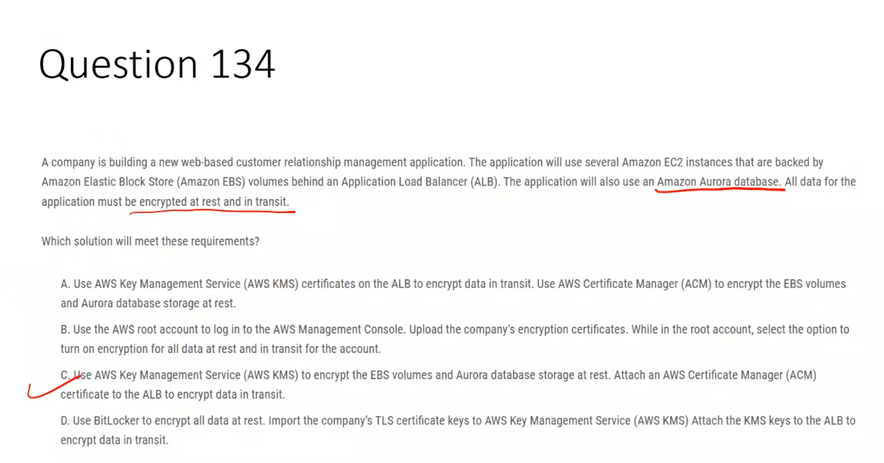

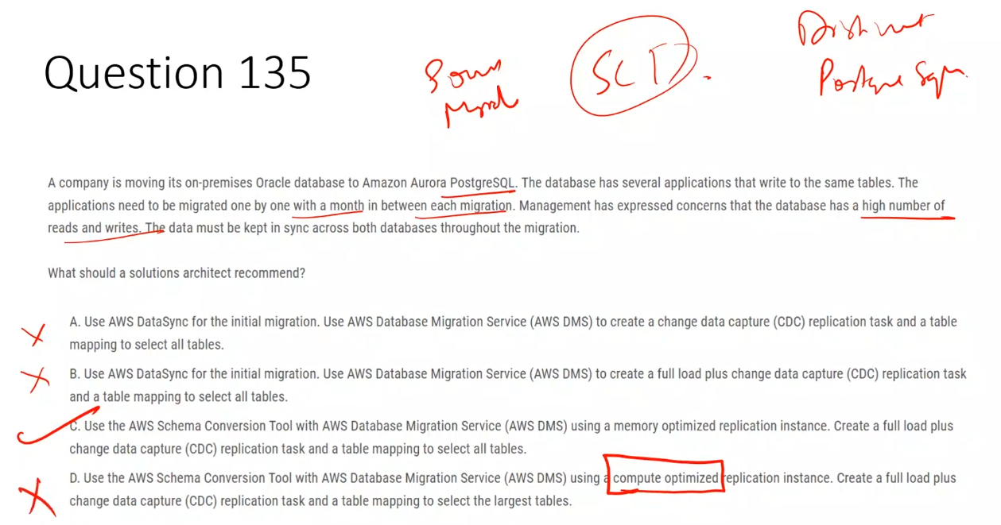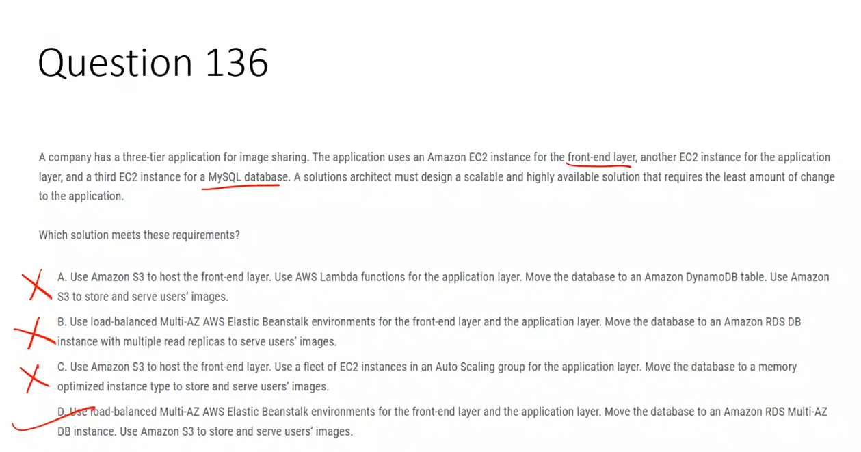

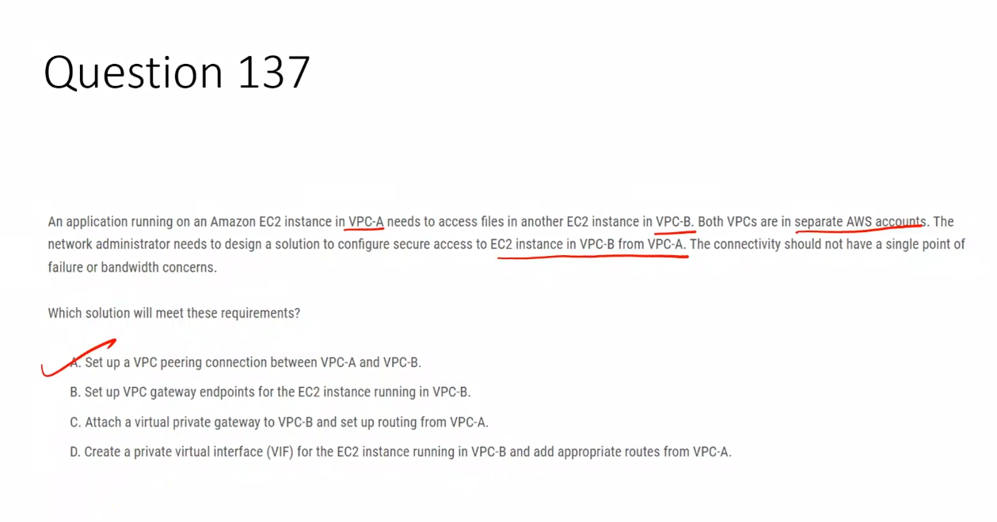

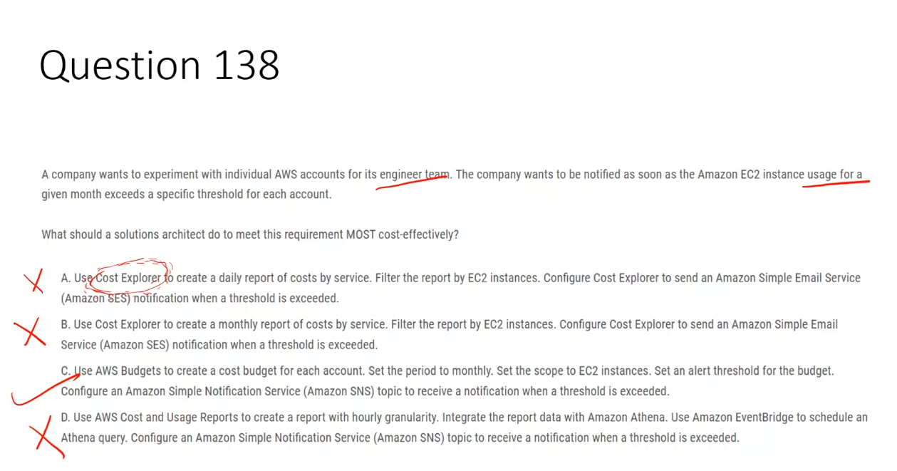

AWS Budgets:

* Tracks **actual usage translated into cost**
* EC2 usage → EC2 spend
* That’s what finance and alerts care about

### **Correct Option – C**

**Use AWS Budgets to create a monthly cost budget for each account scoped to EC2 and configure an SNS alert.**  
 AWS Budgets can monitor monthly EC2 usage based on incurred costs per account and send near real-time notifications when a defined threshold is exceeded, with the least operational overhead and cost.

### **Incorrect Options**

**Option A – Cost Explorer daily report**  
 Cost Explorer is only for cost analysis and visualization and does not support real-time threshold-based alerts or SNS notifications.

**Option B – Cost Explorer monthly report**  
 Cost Explorer reports are generated for analysis purposes and cannot trigger alerts when usage or cost thresholds are exceeded.

**Option D – Cost and Usage Reports with Athena**  
 This approach requires additional services such as S3, Athena, and EventBridge, making it complex and expensive, which violates the requirement for the most cost-effective solution.

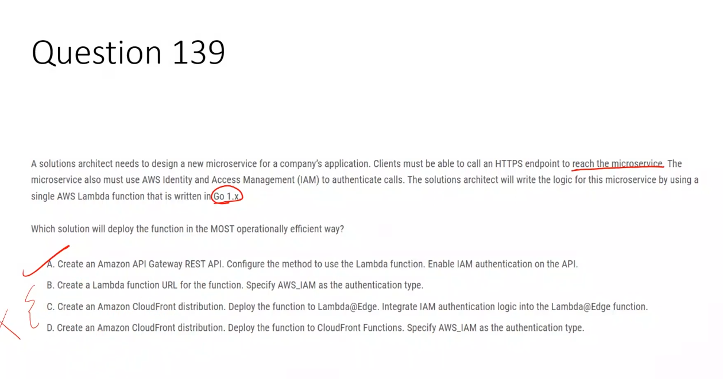

## **✅ Correct Option – A**

**Create an Amazon API Gateway REST API, integrate it with the Lambda function, and enable IAM authentication.**  
 API Gateway REST API natively supports **HTTPS endpoints**, **AWS_IAM authentication**, request validation, throttling, and tight Lambda integration. It is a fully managed service and is the **standard, most operationally efficient way** to expose a Lambda-based microservice securely using IAM.

## **❌ Why the other options are incorrect**

### **Option B – Lambda Function URL with AWS_IAM**

❌ Lambda Function URLs **do not support AWS_IAM authentication**. They support NONE or AWS_IAM *only for invocation via SigV4 in limited scenarios*, but **do not provide full IAM-based API authorization features** like API Gateway. Also, Function URLs lack advanced API features (throttling, request control), making them less suitable for a secure microservice endpoint.

### **Option C – CloudFront + Lambda@Edge**

❌ Lambda@Edge is designed for **edge request/response manipulation**, not for building backend microservices with IAM authentication. Implementing IAM auth logic manually inside Lambda@Edge increases complexity and operational overhead and is **not the intended use case**.

### **Option D – CloudFront Functions**

❌ CloudFront Functions **do not support IAM authentication**, external network calls, or backend integration. They are limited to lightweight request manipulation at the edge and **cannot run Go-based Lambda logic or enforce AWS_IAM authentication**.

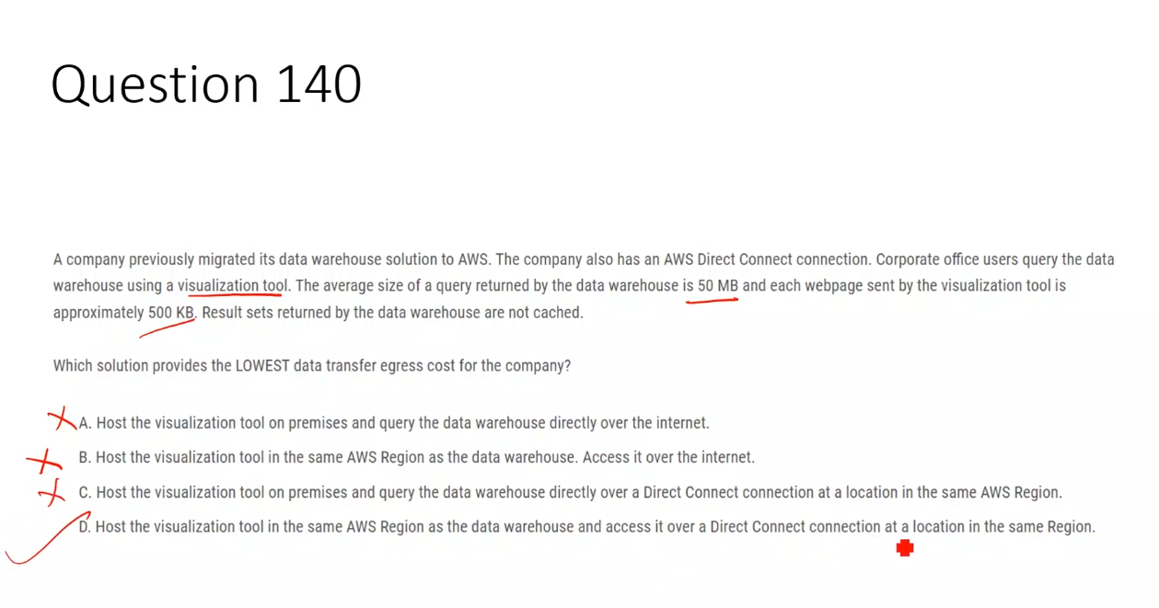

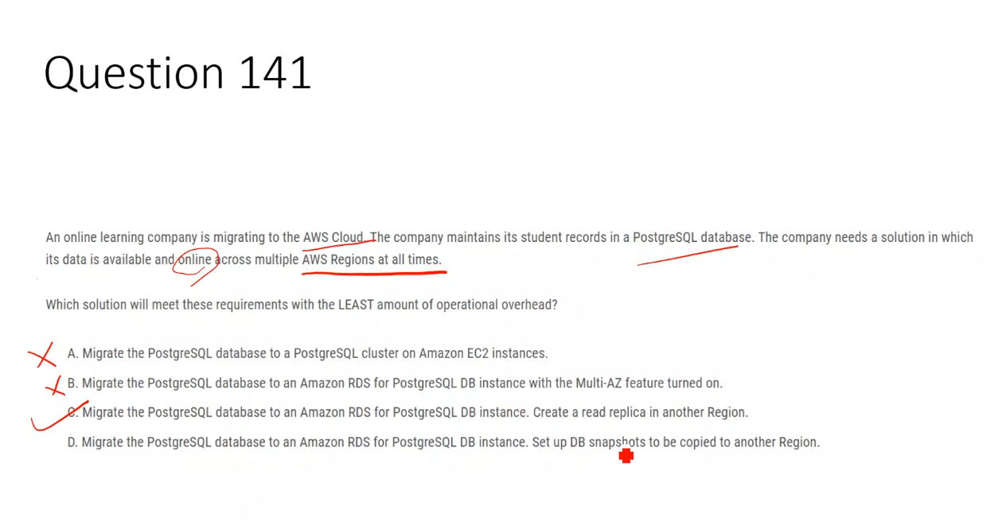

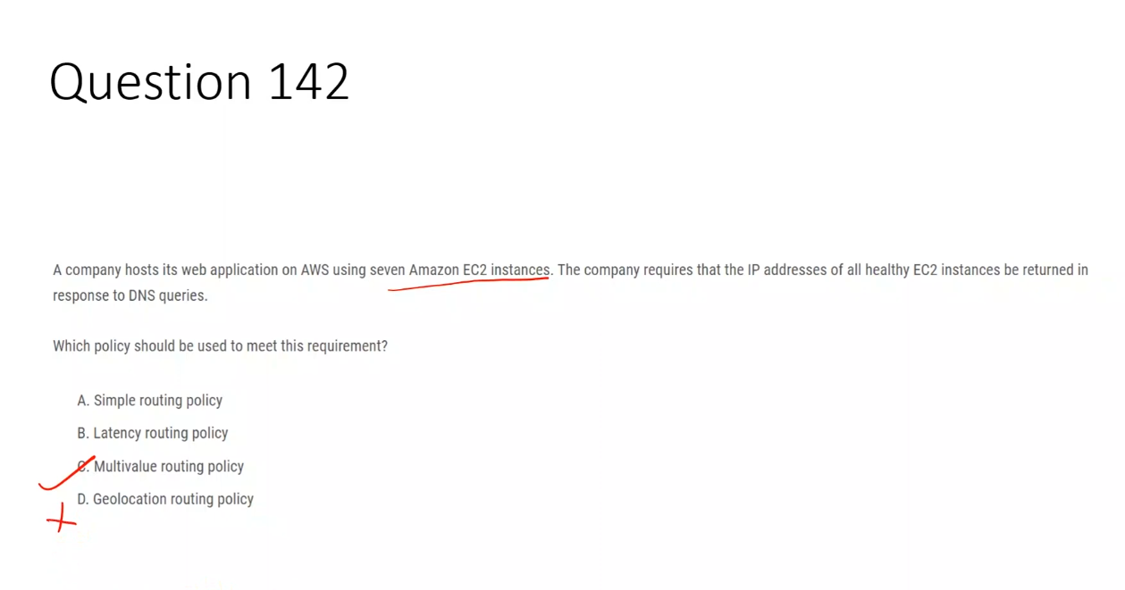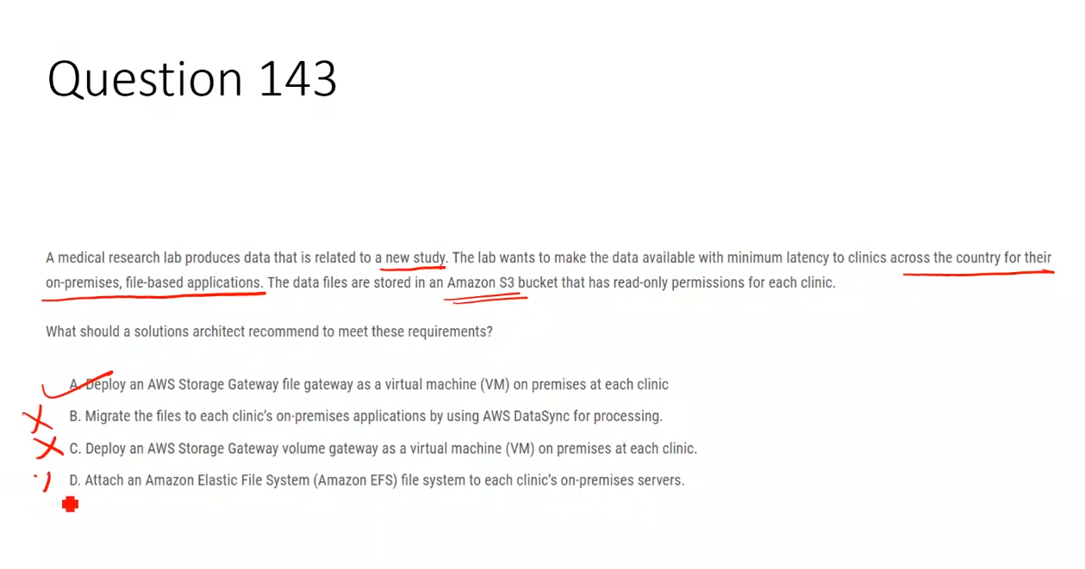

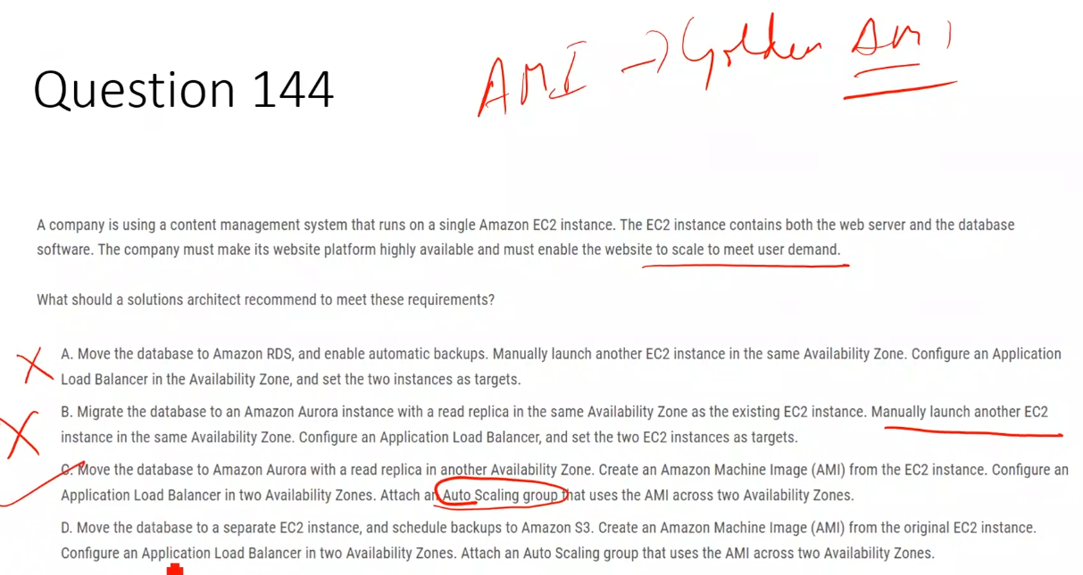

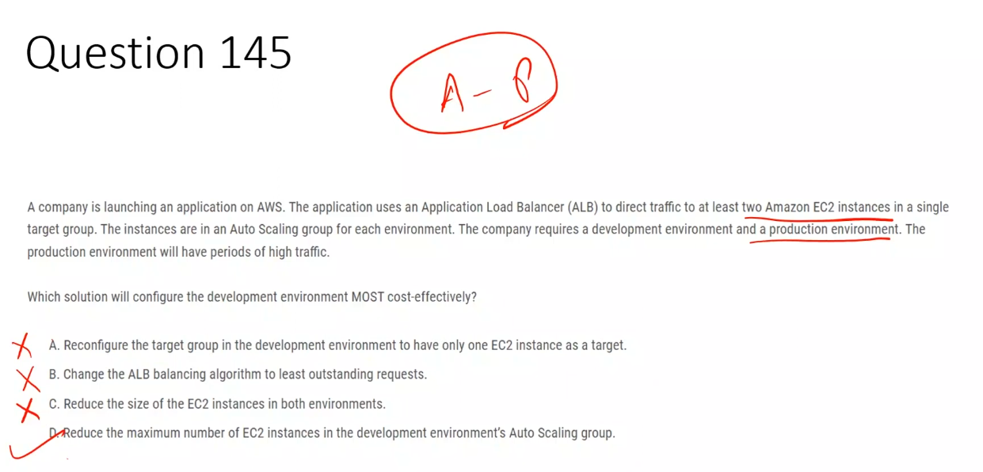

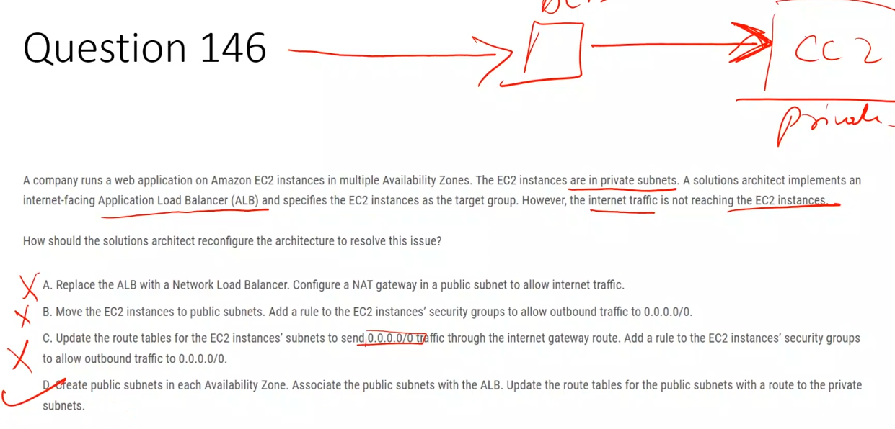

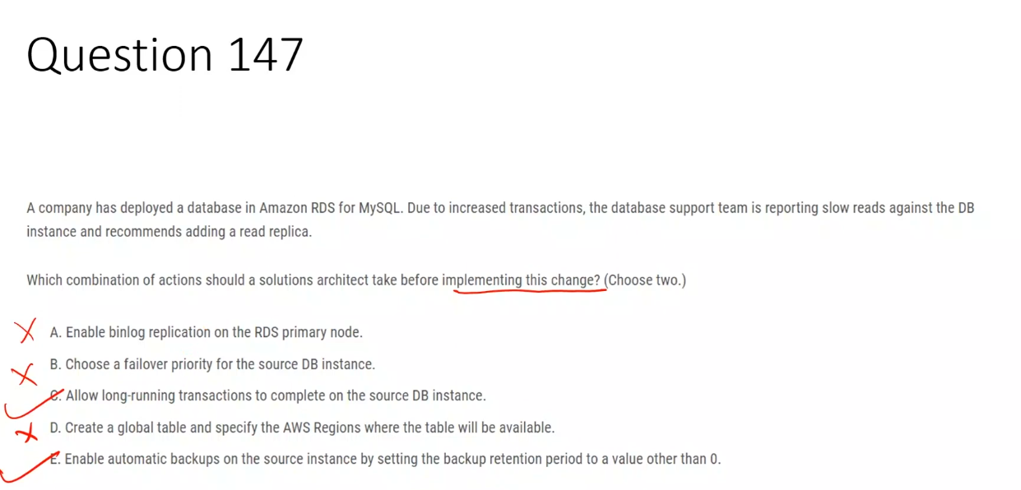

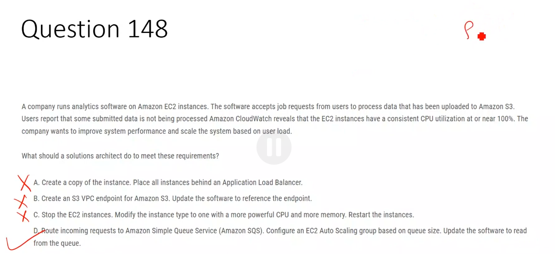

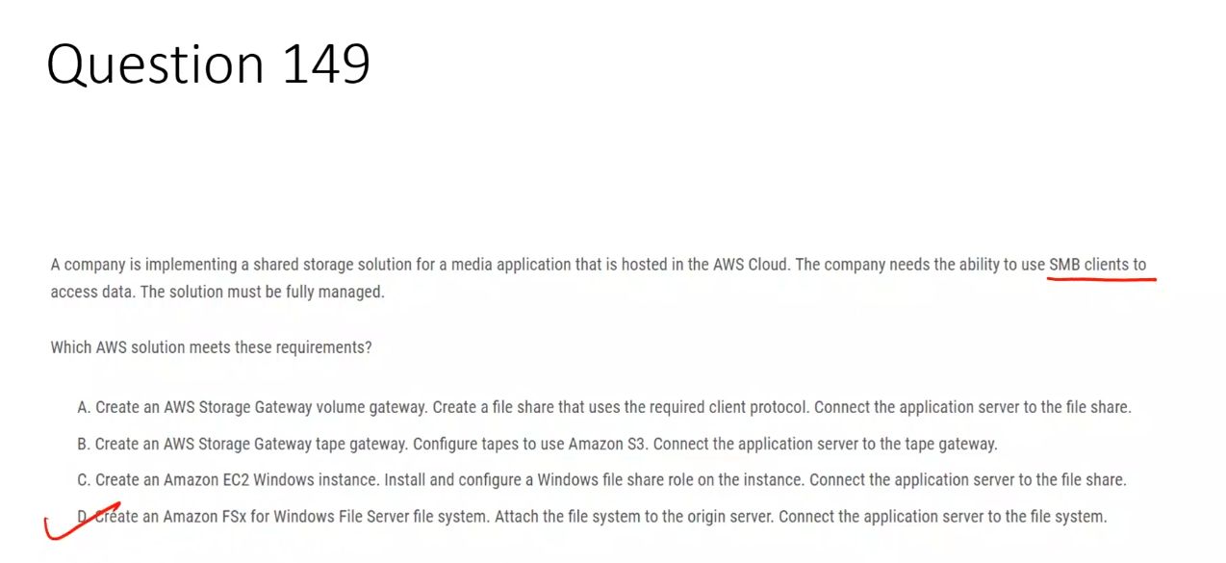

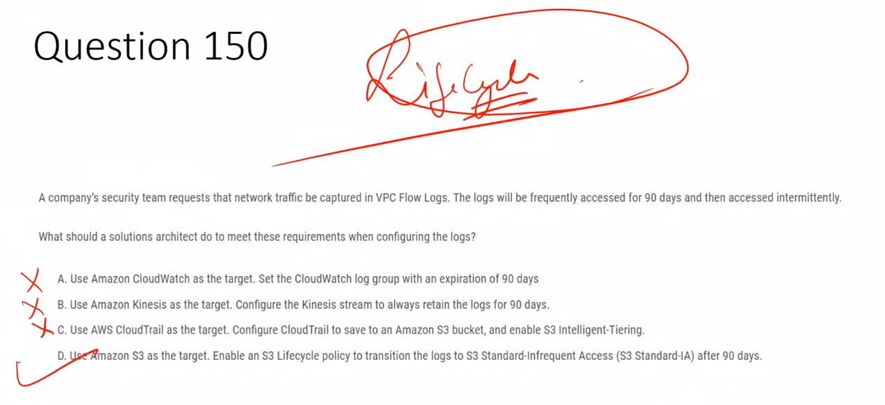

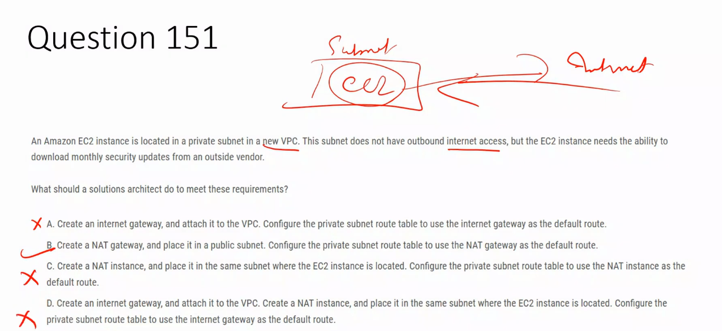

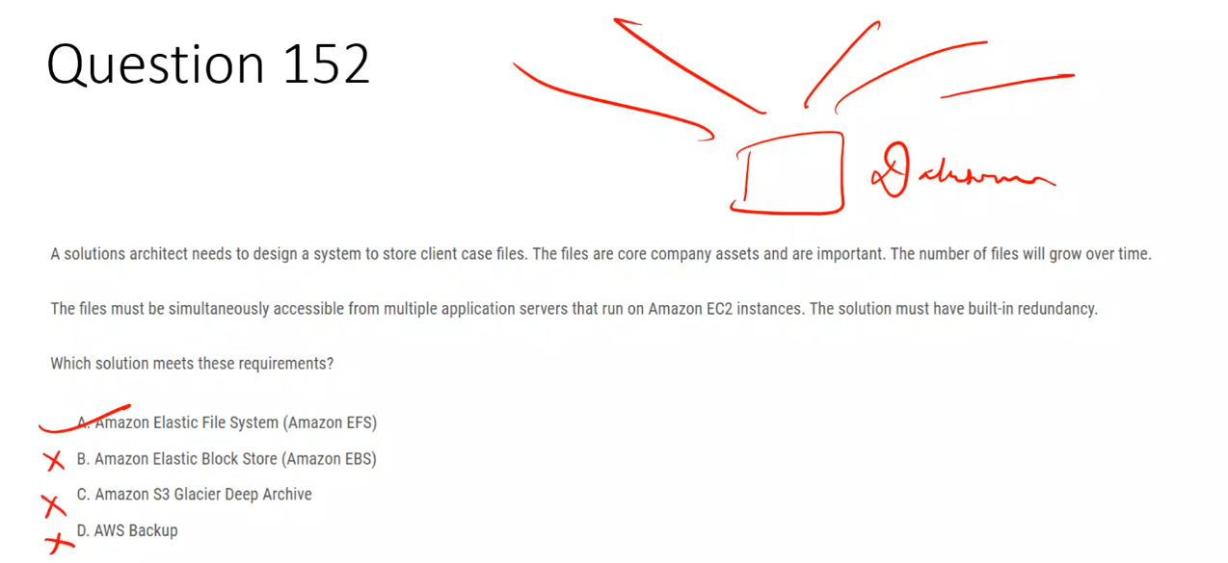

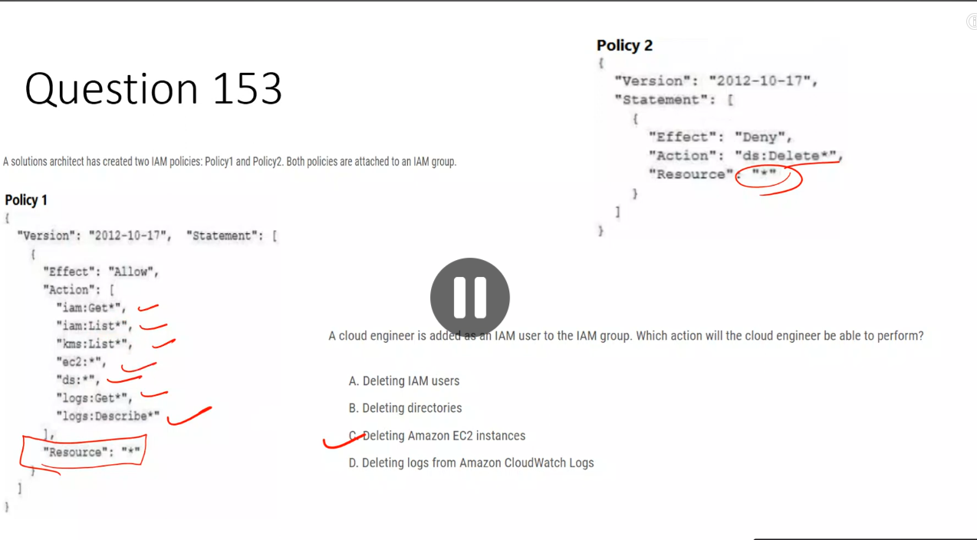

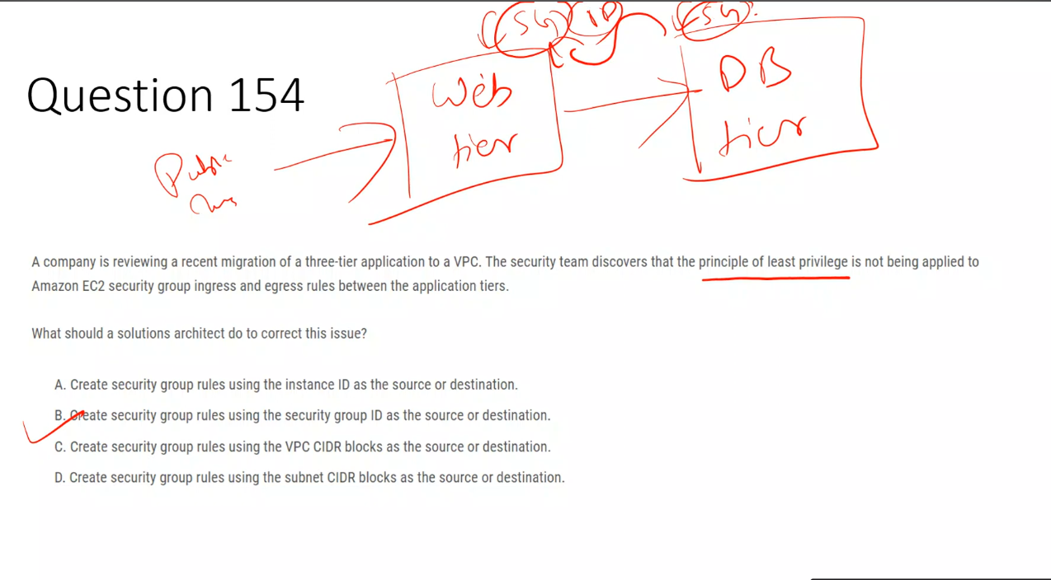

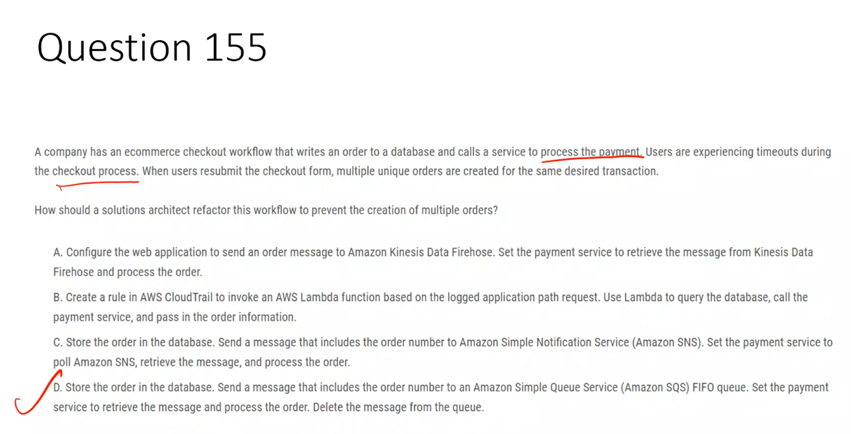

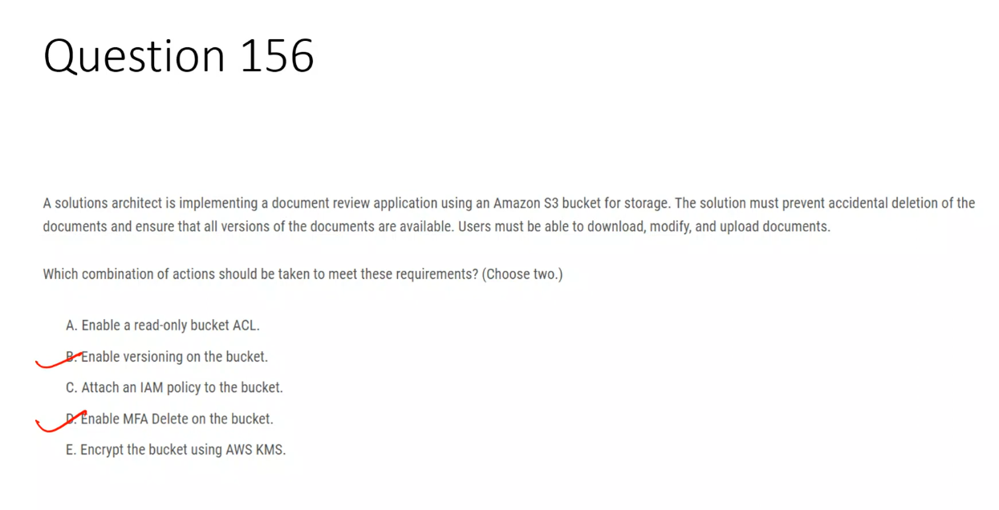

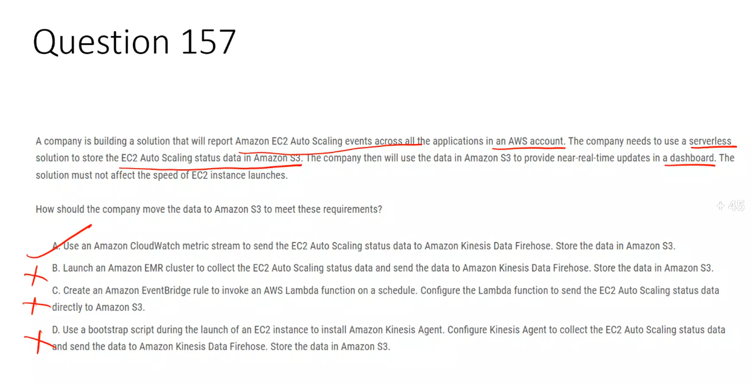

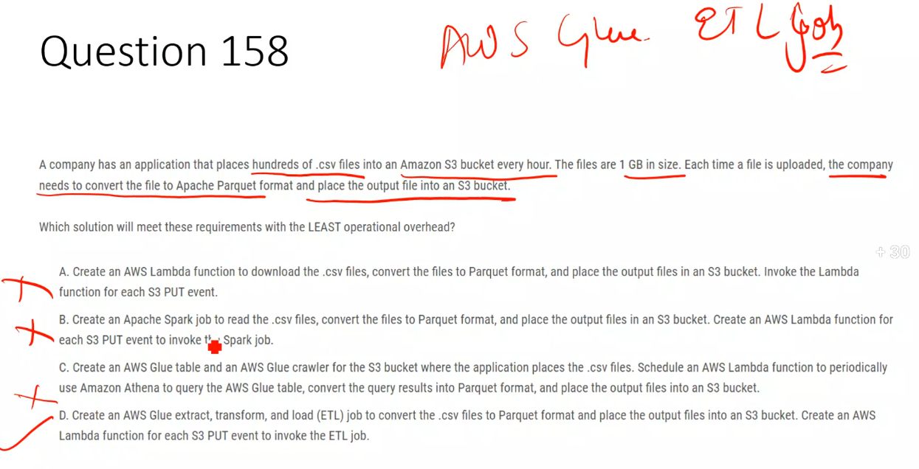

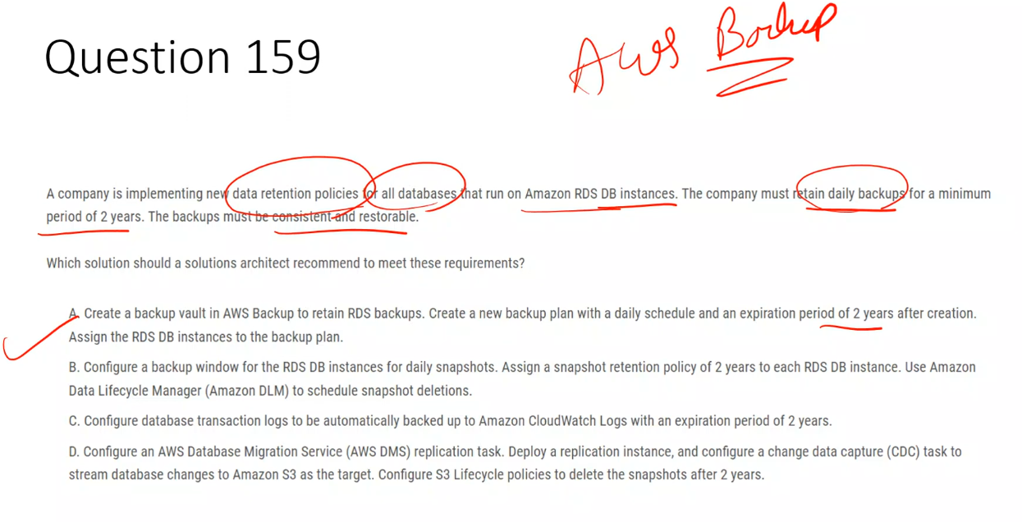

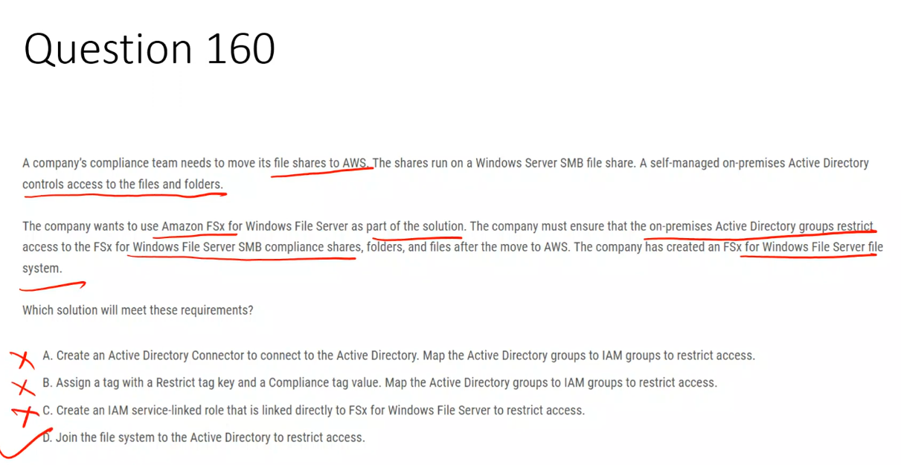

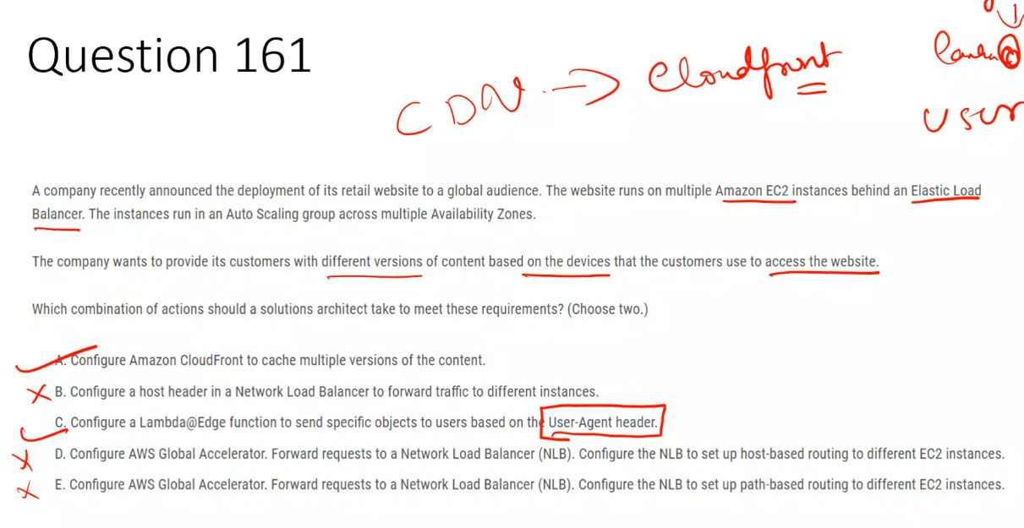

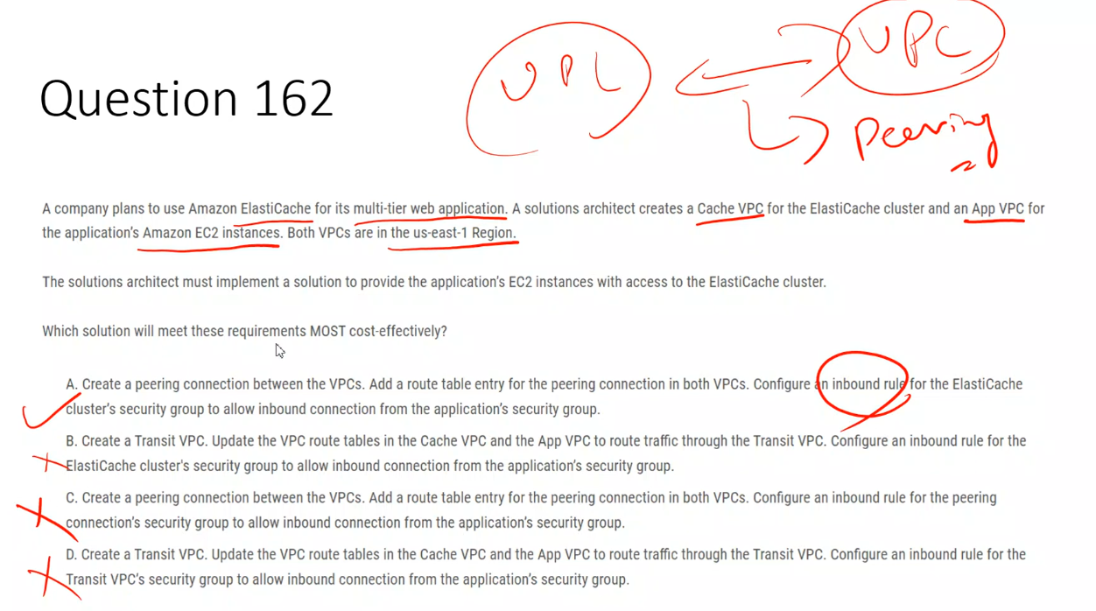

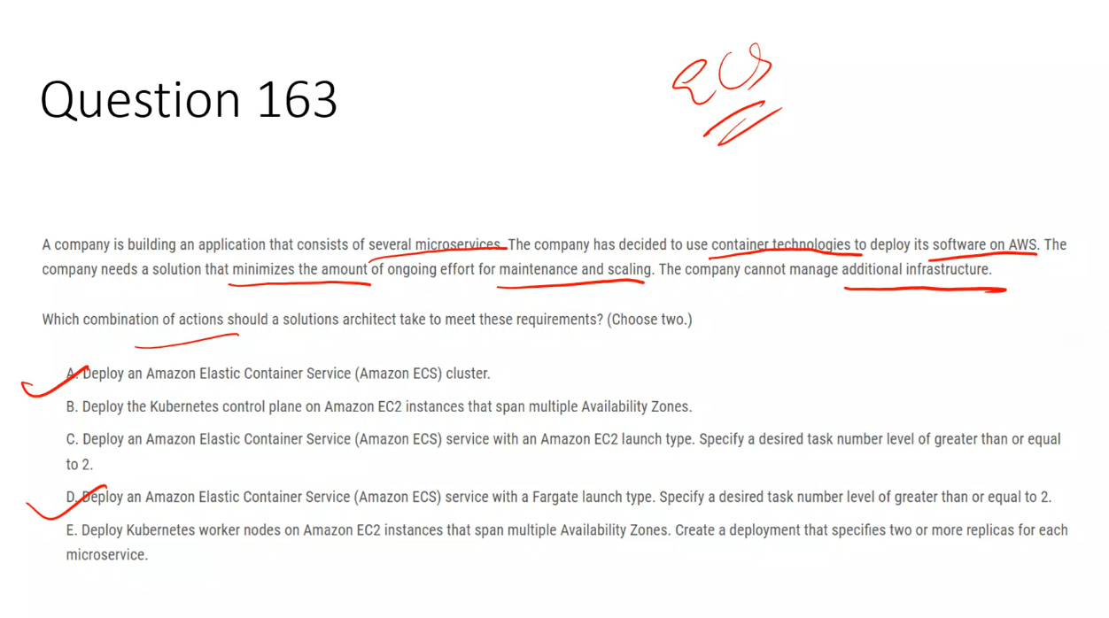

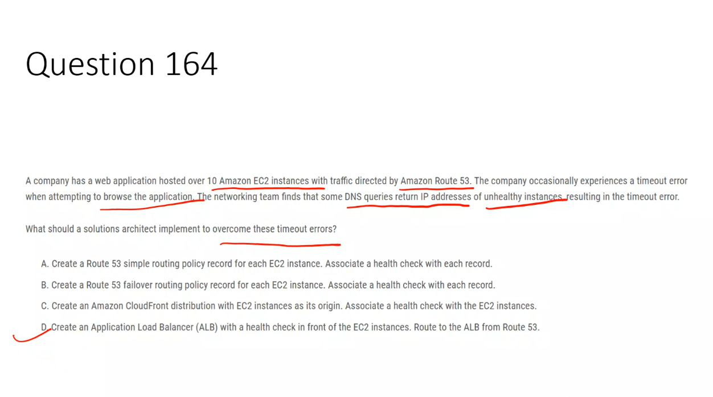

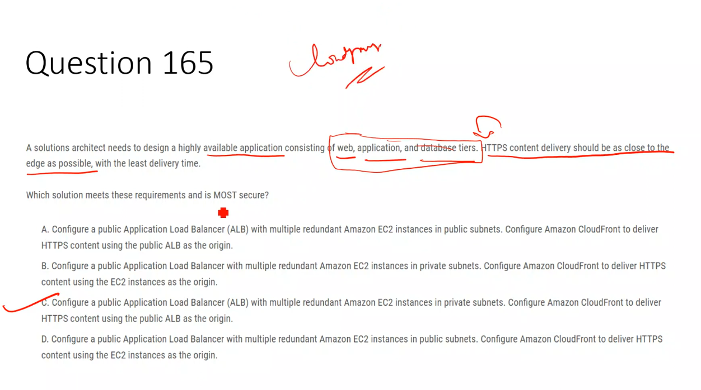

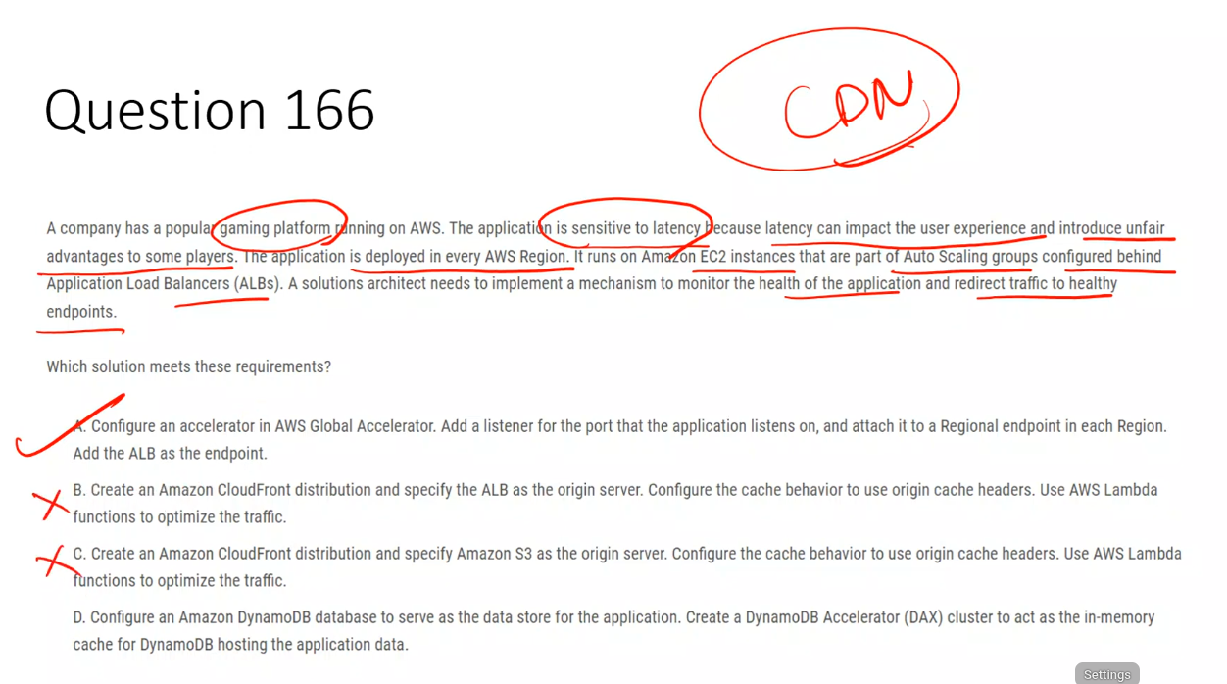

### **✅ Correct Answer: Option A (Single-paragraph explanation)**

Option A is correct because **AWS Global Accelerator** is specifically designed for **latency-sensitive, real-time applications** like online gaming and can **continuously monitor endpoint health and route traffic only to healthy endpoints**. The application is deployed in **multiple AWS Regions**, runs behind **Application Load Balancers**, and needs **fast, consistent global performance without caching**. Global Accelerator uses the **AWS global edge network** to route user traffic to the **nearest healthy Regional ALB**, automatically performs **health checks**, and instantly **redirects traffic away from unhealthy Regions**, ensuring low latency, high availability, and fair gameplay without introducing caching delays. This makes it the most suitable and operationally efficient solution.

### **❌ Why the other options are incorrect**

**Option B:** ❌ Amazon CloudFront is optimized for **content delivery and caching**, not for real-time, stateful gaming traffic. Caching and edge logic do not solve the need for **dynamic health-based traffic steering across Regions**.

**Option C:** ❌ Using CloudFront with Amazon S3 as the origin is completely unsuitable because the application runs on **EC2 instances behind ALBs**, not on static S3 content.

**Option D:** ❌ DynamoDB Accelerator (DAX) only improves **database read latency** and does **nothing for global traffic routing, health checks, or redirecting users to healthy application endpoints**.

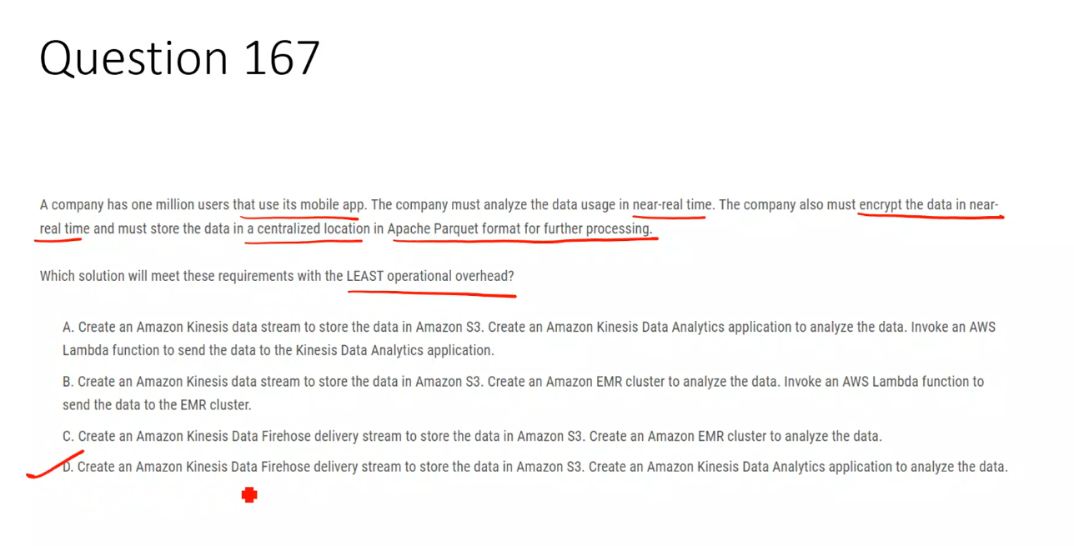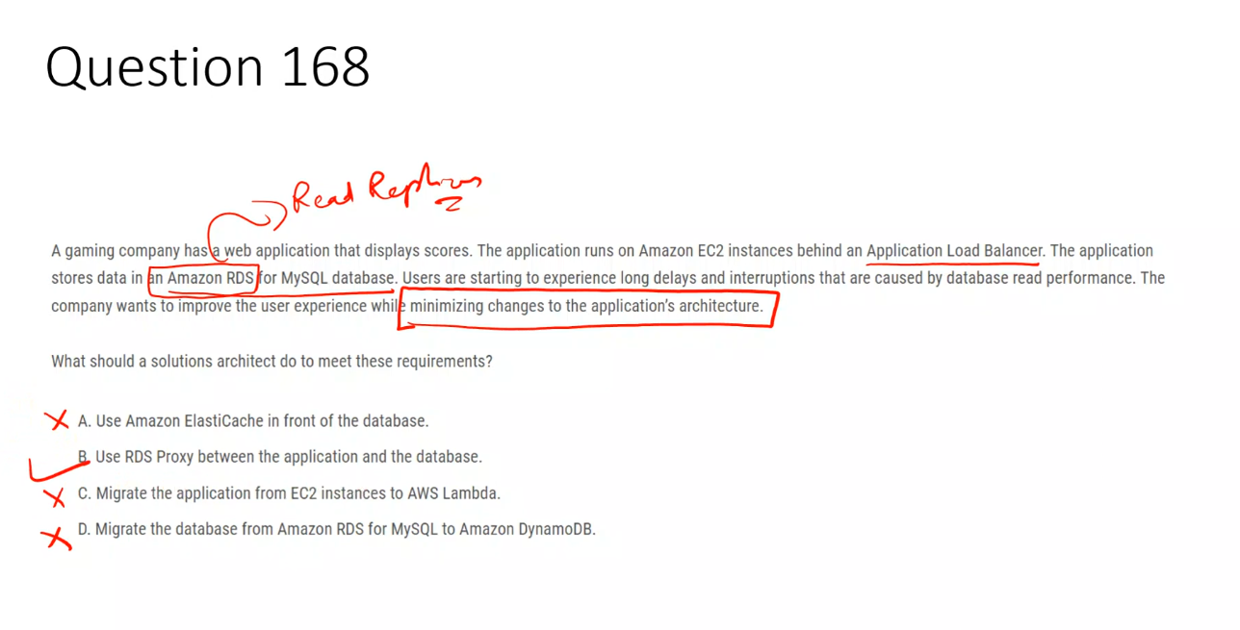

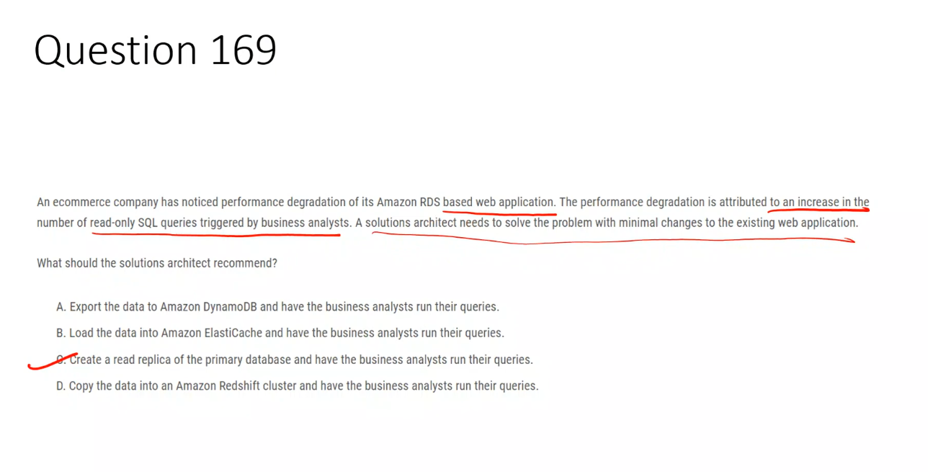

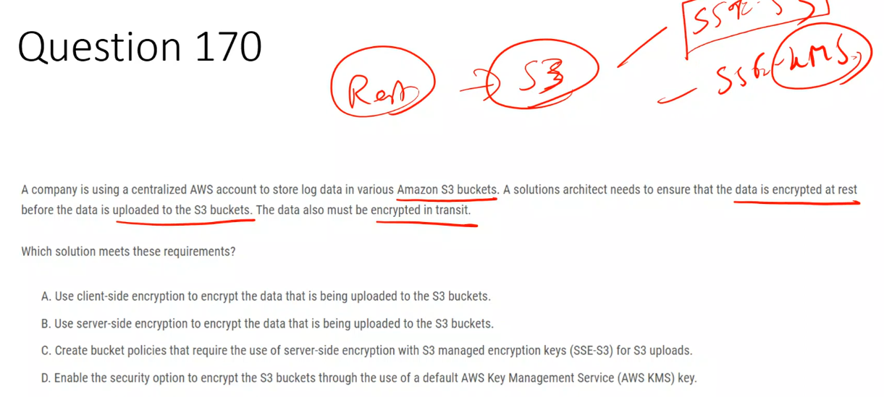

### **✅ Correct Answer: A**

**A. Client-side encryption**  
 Encrypts the data **before it leaves the client**, ensuring encryption at rest **before upload** and encryption in transit using HTTPS.

### **❌ Incorrect Options**

**B. Server-side encryption**  
 Encrypts data **after S3 receives it**, so the data is **not encrypted before upload**.

**C. Bucket policy enforcing SSE-S3**  
 Only enforces **server-side encryption**, which still happens **after upload**, not before.

**D. Default KMS encryption on bucket**  
 Applies encryption **within S3 after upload**, failing the **before upload** requirement.

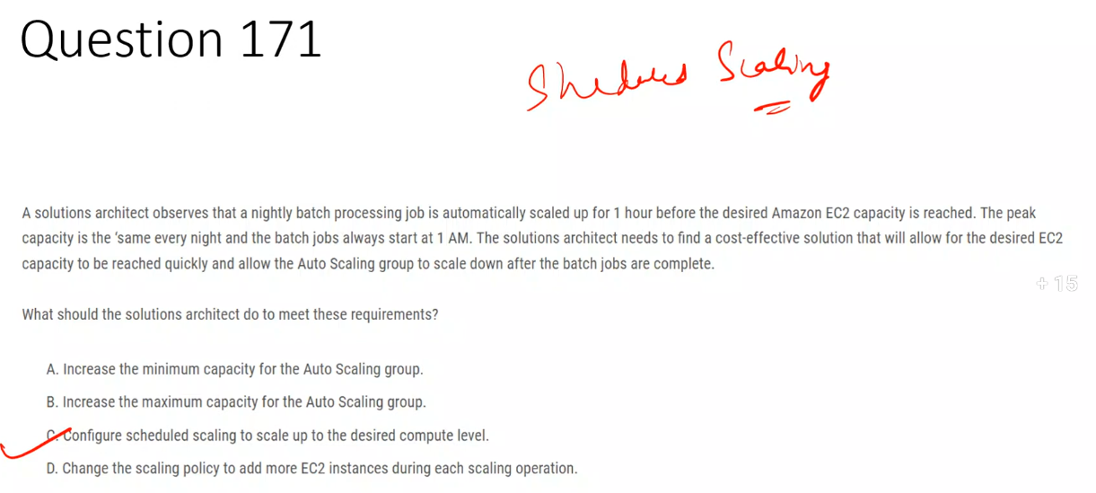

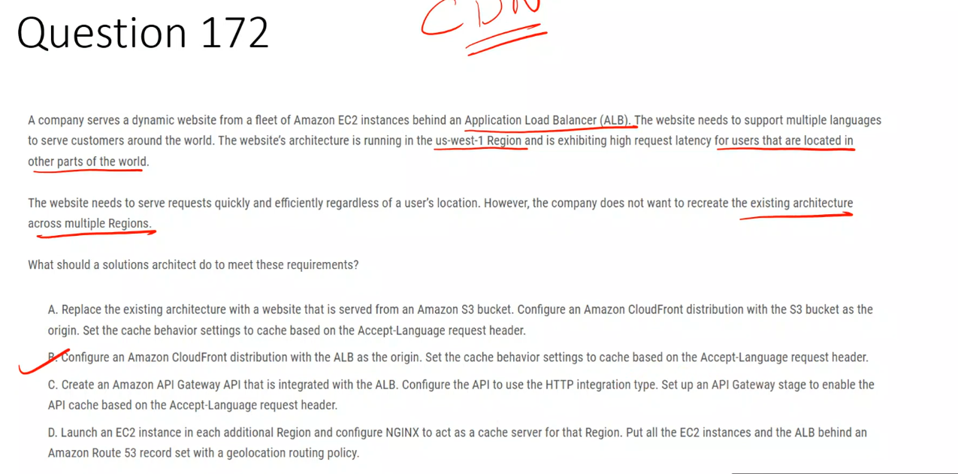

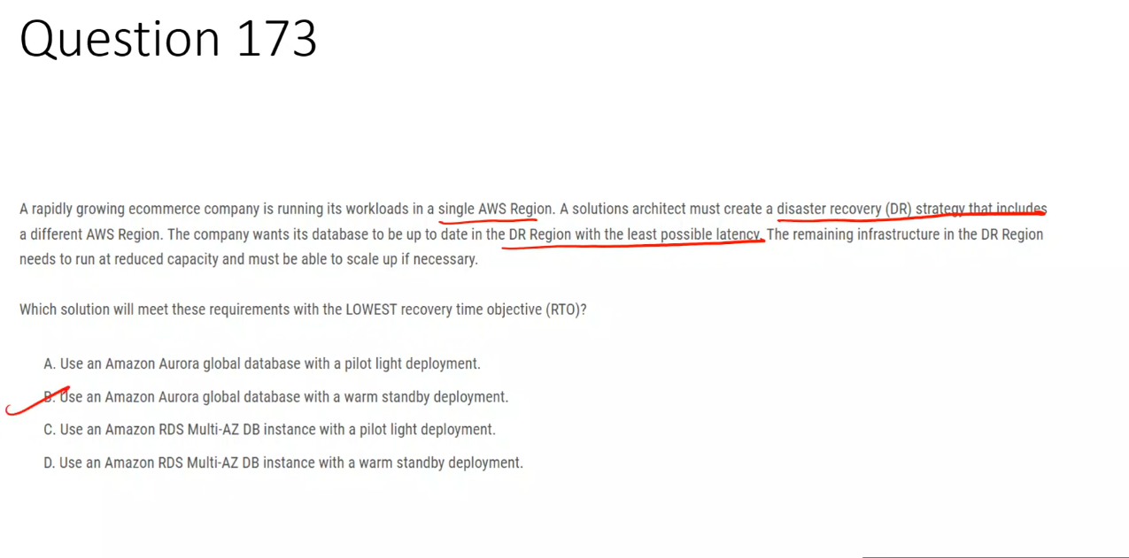

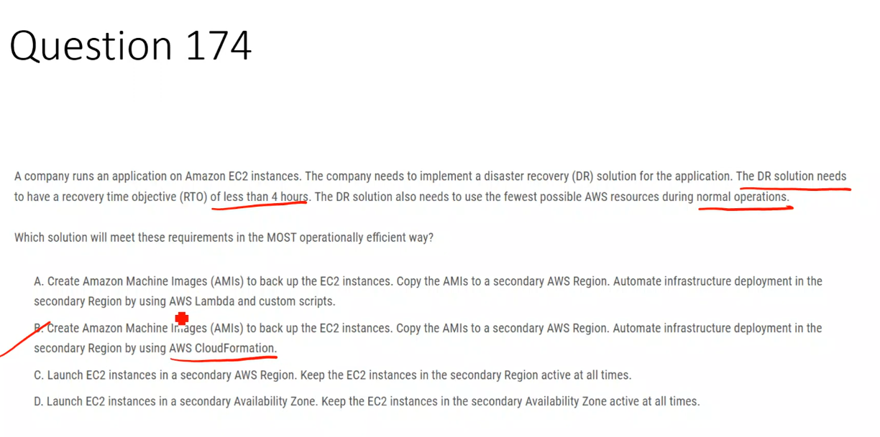

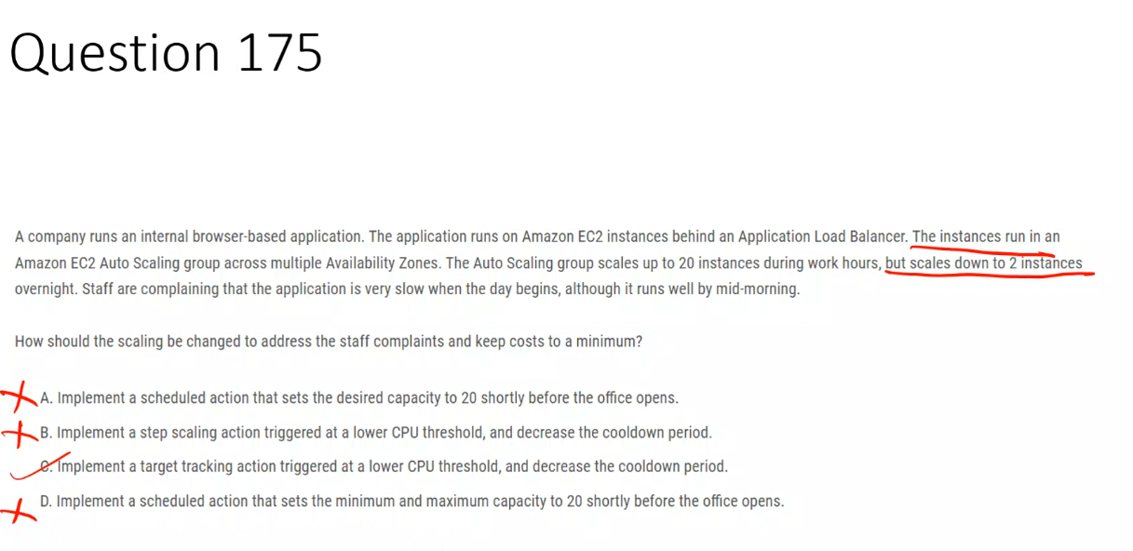

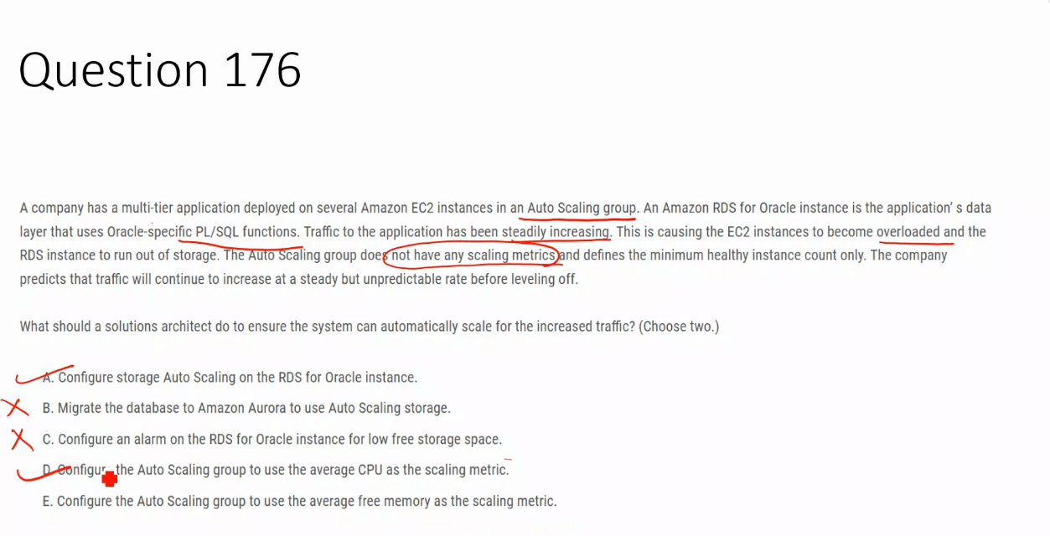

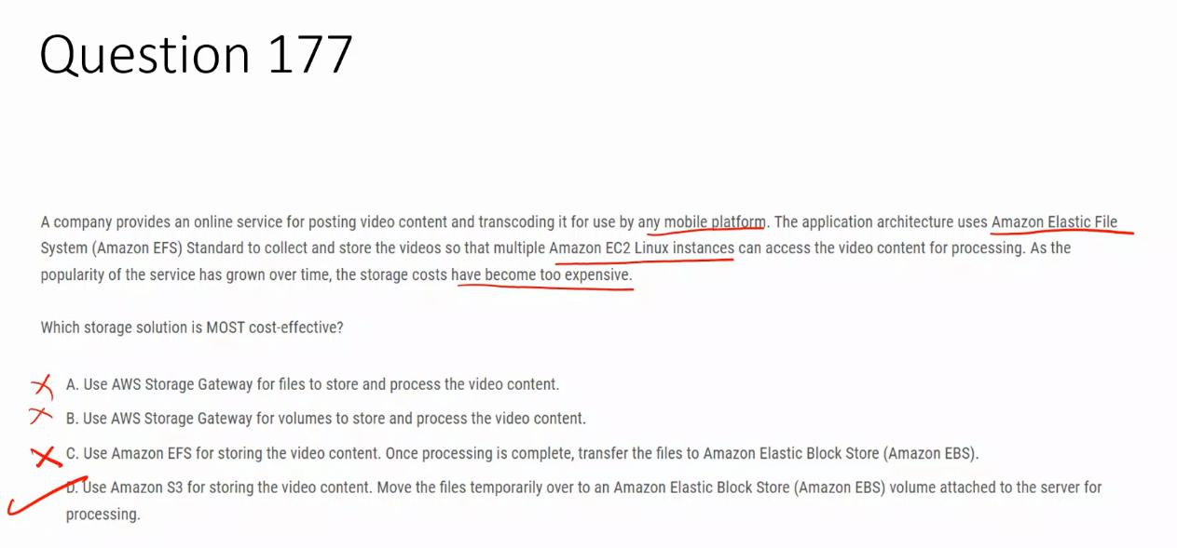

## **✅ Correct Answer: D**

**D. Use Amazon S3 for storing the video content. Move the files temporarily to an Amazon EBS volume for processing.**  
 S3 provides **low-cost, scalable storage** for large video files, while EBS offers **high-performance temporary storage** during transcoding, making this the most cost-effective design.

## **❌ Incorrect Options**

**A. Use AWS Storage Gateway for files**  
 Storage Gateway is meant for **hybrid on-premises environments**, not cloud-native workloads, adding unnecessary cost and complexity.

**B. Use AWS Storage Gateway for volumes**  
 Volume Gateway is for **block storage integration with on-premises systems**, not for sharing data across multiple EC2 instances in AWS.

**C. Use Amazon EFS and then transfer to EBS**  
 EFS Standard is **expensive for large, growing datasets**, and moving data from EFS to EBS does not reduce overall storage cost.

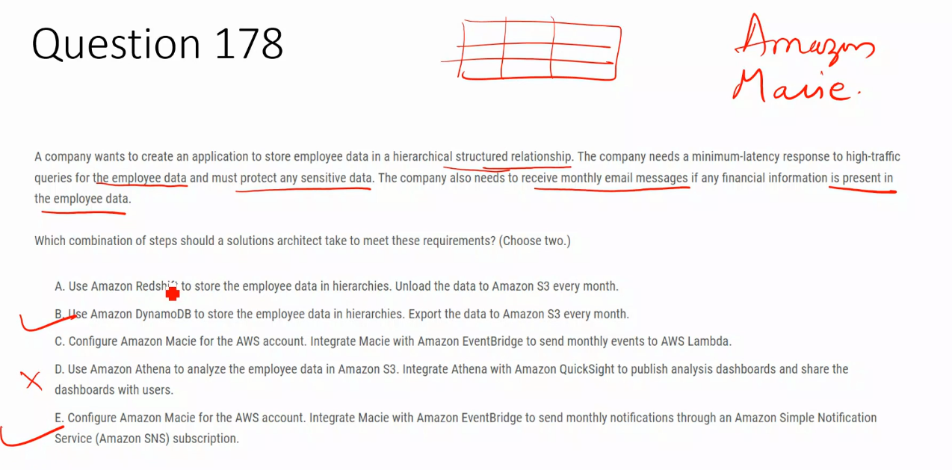

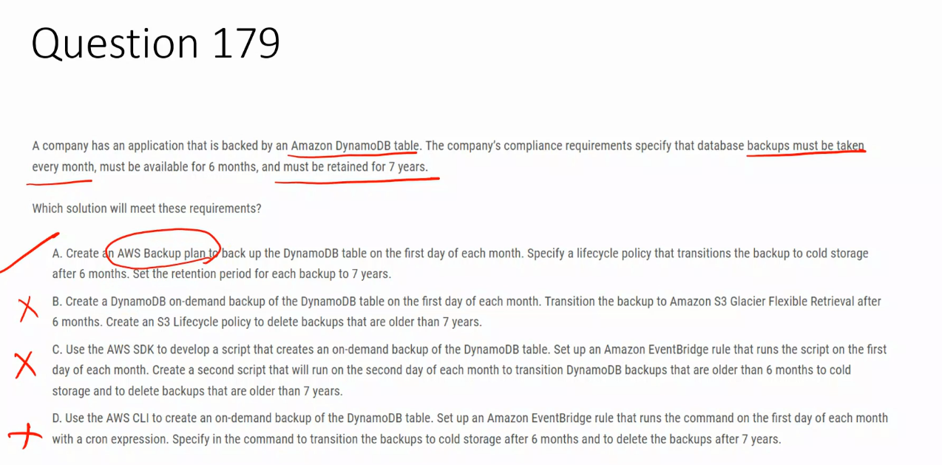

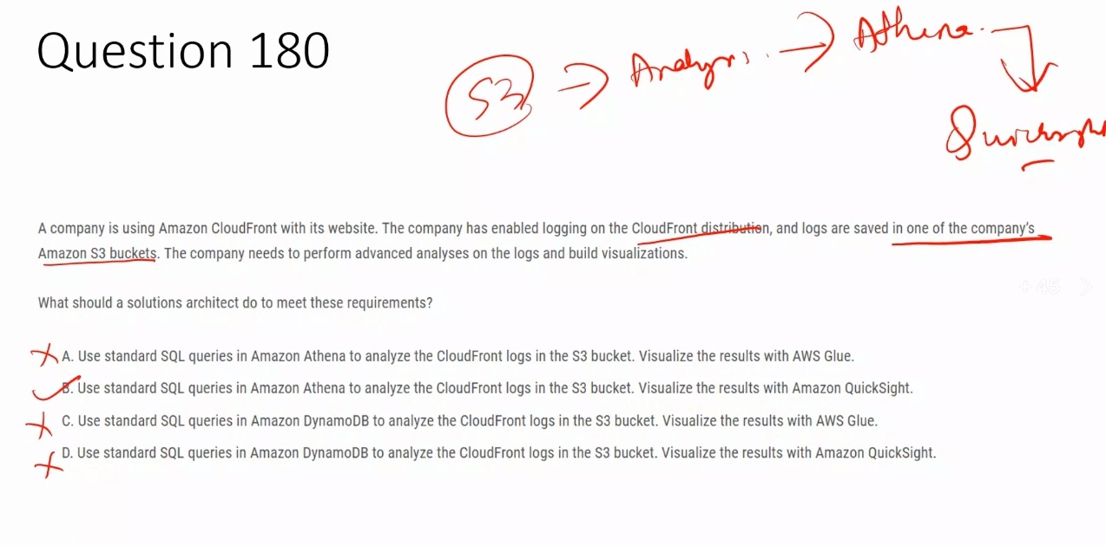

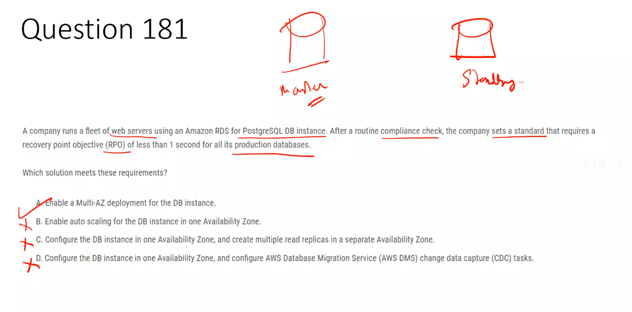

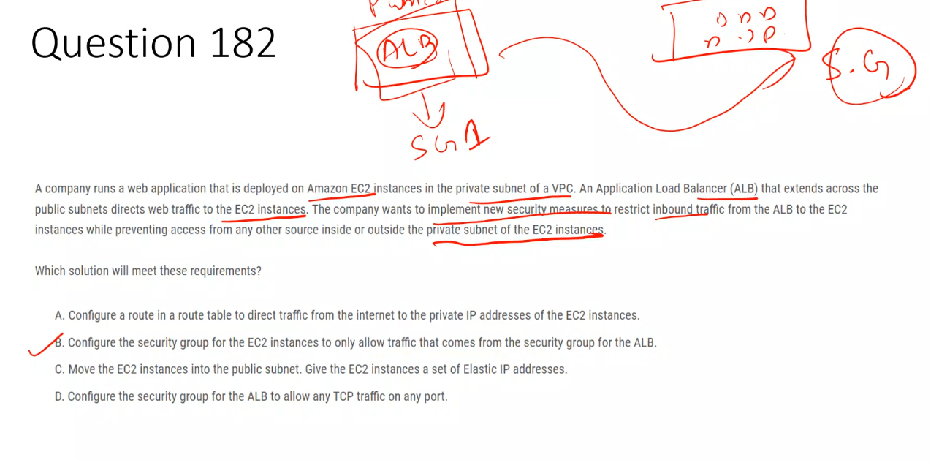

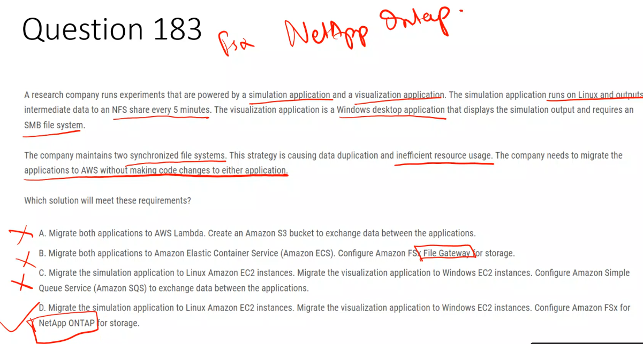

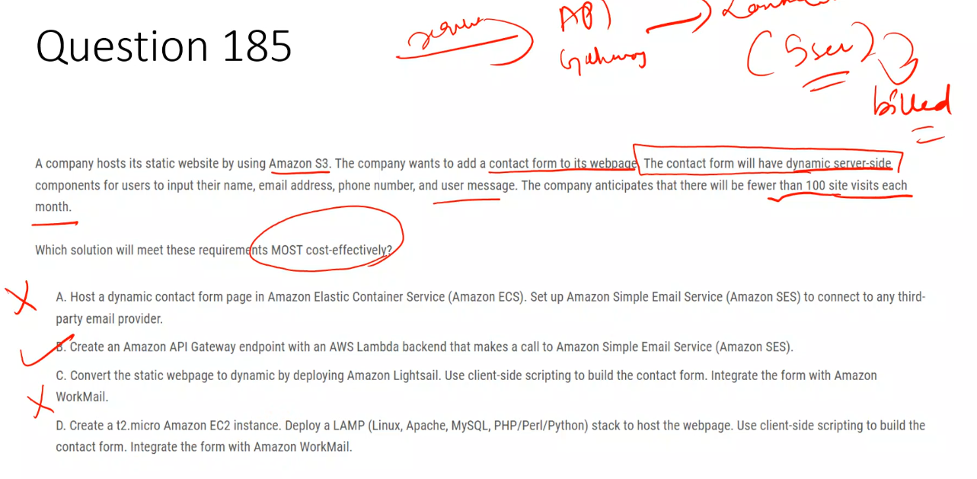

Amazon Lightsail is an easy-to-use cloud platform that provides everything you need to build websites or web applications at a low, predictable monthly price.

What's Included:

* Virtual private servers (instances)
* Container services
* Managed databases
* Content delivery network (CDN) distributions
* Load balancers
* SSD-based block storage
* Static IP addresses
* DNS management
* Resource snapshots (backups)

Key Features:

* Simple Management: User-friendly interface that abstracts infrastructure complexity
* Pre-configured Options: Ready-to-use instances optimized for WordPress, Drupal, Joomla, and other applications
* Predictable Pricing: Bundled resources in single, simple monthly plans
* Automatic Configuration: Networking, access, and security environments set up automatically

Who Is It For:

Ideal for small businesses, startups, individuals, and anyone new to AWS who needs simpler workloads and quick deployments.

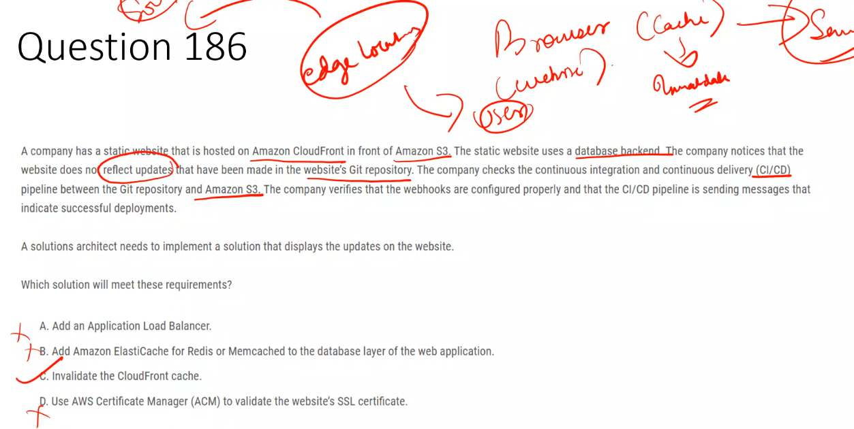

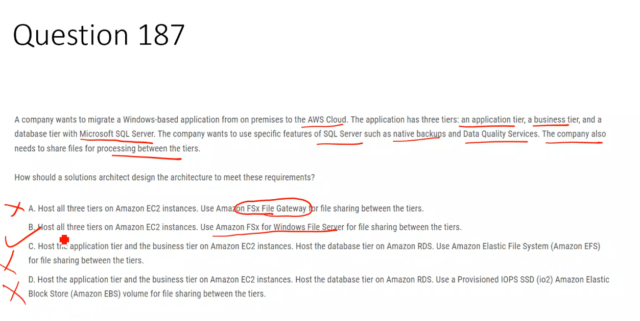

## **✅ Correct Answer: B**

**B. Host all three tiers on Amazon EC2 instances. Use Amazon FSx for Windows File Server for file sharing between the tiers.**  
 Running SQL Server on EC2 provides **full native SQL features (native backups, DQS)**, and FSx for Windows File Server offers **managed SMB file sharing** for Windows-based tiers.

## **❌ Incorrect Options**

**A. Host all three tiers on EC2. Use Amazon FSx File Gateway for file sharing.**  
 FSx File Gateway is designed for **on-premises to AWS integration**, not for file sharing between EC2 instances inside AWS.

**C. Host app and business tiers on EC2, database tier on RDS, use EFS for file sharing.**  
 Amazon RDS for SQL Server **does not support native backups or Data Quality Services**, and EFS is not optimized for Windows SMB workloads.

**D. Host app and business tiers on EC2, database tier on RDS, use EBS for file sharing.**  
 EBS cannot be **shared across multiple EC2 instances**, and RDS again **does not support required native SQL Server features**.

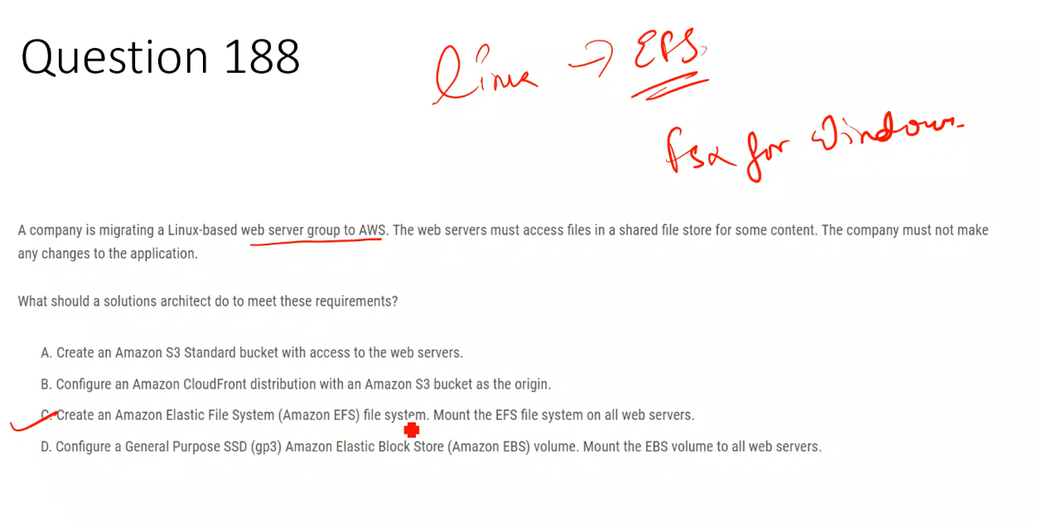

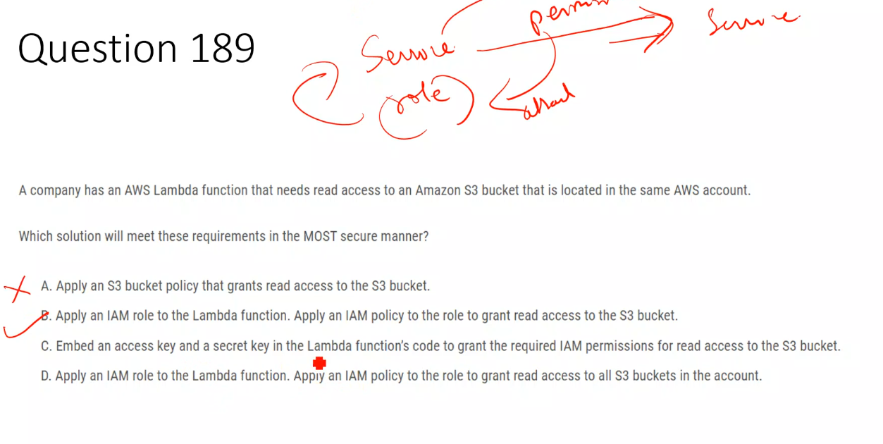

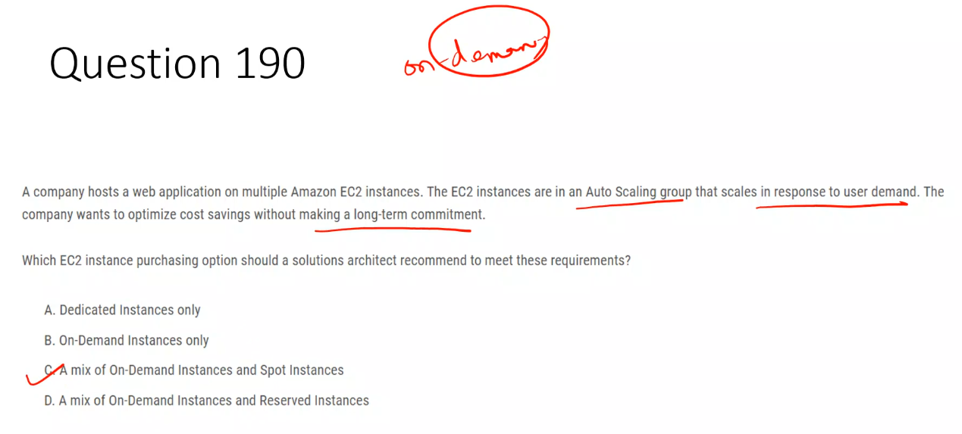

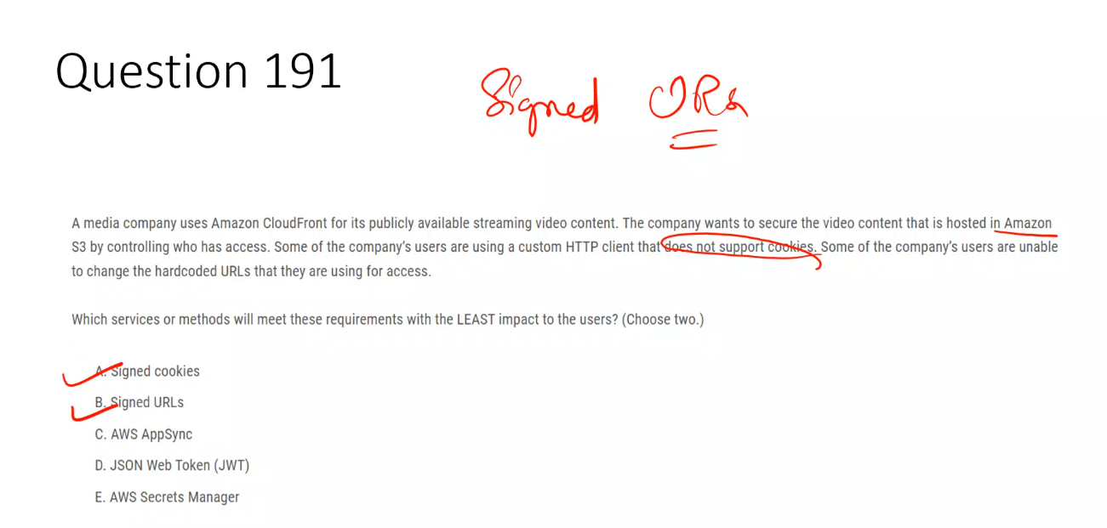

## **✅ Correct Answers: A and B**

**A. Signed cookies**  
 Allow access control **without changing the URL**, making them ideal for users who cannot modify hardcoded CloudFront URLs but can use cookies.

**B. Signed URLs**  
 Embed authorization directly in the URL, making them suitable for clients that **do not support cookies** but can accept dynamic URLs.

## **❌ Incorrect Options**

**C. AWS AppSync**  
 Used for building GraphQL APIs and has **no role in securing CloudFront or S3 media content**.

**D. JSON Web Token (JWT)**  
 CloudFront does **not natively validate JWTs** for access to S3-backed content, so it does not meet the requirement.

**E. AWS Secrets Manager**  
 Stores and manages secrets but **does not control access to CloudFront distributions or S3 objects**.

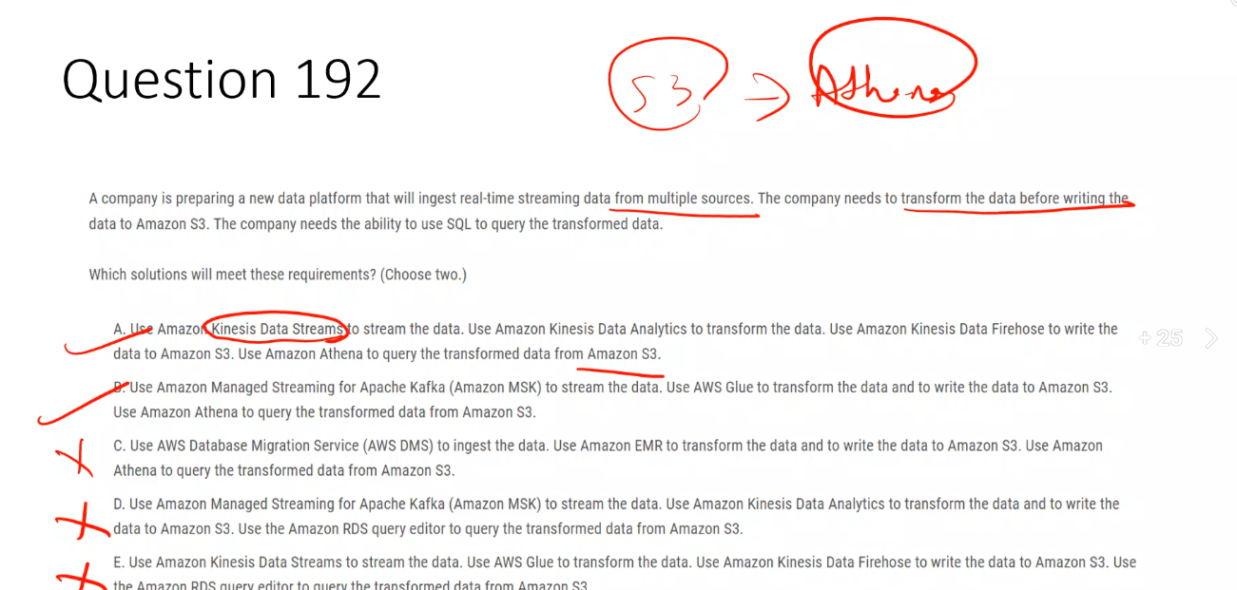

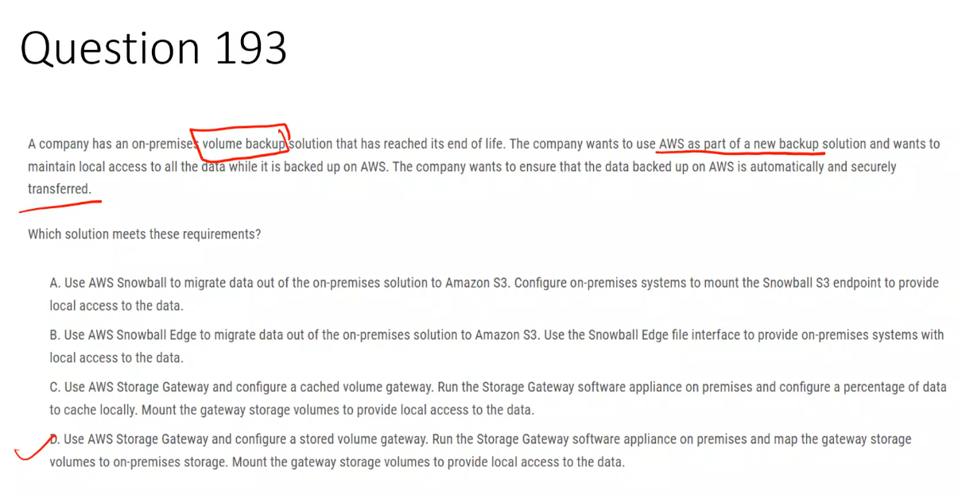

## **✅ Correct Answer: D**

**D. AWS Storage Gateway – Stored Volume Gateway**  
 Keeps **all primary data on-premises** while **automatically and securely backing it up to AWS**, meeting local access and cloud backup requirements.

## **❌ Incorrect Options**

**A. AWS Snowball + mount S3 endpoint**  
 Snowball is for **one-time or bulk data transfer**, not continuous backups, and cannot provide live local volume access.

**B. AWS Snowball Edge with file interface**  
 Snowball Edge is a **temporary migration device**, not designed for ongoing automated backups or permanent hybrid storage.

**C. AWS Storage Gateway – Cached Volume Gateway**  
 Stores **primary data in AWS with only a local cache**, which violates the requirement to maintain **local access to all data**.

